**The Very Handy Manual 2.0:**

**How to Catch and Identify Bees and Manage a Collection**



A Collective and Ongoing Collaborative Effort by Those Who Love to Study Bees in North America

Last Revised: July 2024

This manual is a compilation of the wisdom and experience of many individuals, some of whom are directly acknowledged here and others not. We thank all of you. The bulk of the text was compiled by Sam Droege at the USGS Bee Inventory and Monitoring Lab (BIML), Patuxent Wildlife Research Center, Beltsville, Maryland, over several years from 2004-2008. We regularly update the manual with new information, so, if you have a new technique, some additional ideas for sections, corrections, or additions, we would like to hear from you. Please email those to Sam Droege ([sdroege@usgs.gov](mailto:sdroege@usgs.gov)). You can also email Sam if you are interested in joining the “Bee Inventory, Monitoring, and ID” discussion group. Many thanks to Dave and Janice Green, Gene Scarpulla, Liz Sellers, Tracy Zarrillo, Sydney Shumar, and Clare Maffei for their many hours of editing this manual.

"They've got this steamroller going, and they won't stop until there's nobody fishing. What are they going to do then, save some bees?" – Mike Russo (Massachusetts fisherman who has fished cod for 18 years, discussing environmentalists) – Provided by Matthew Shepherd

**Table of Contents**

Where to Find Bees (Hint: Plant Diversity = Bee Diversity) 6

Killing Bees to Study Them 6

Bees vs. Non-Bees 6

Other Tips 6

In The Field 7

Collecting Data in the Field 7

Templates for Wet Labels 7

Field Trip Checklist 8

Conditions for Catching Bees 8

Collecting Bees 8

Bee Bowls 9

Painting Bowls 10

Guerra Paint and Pigment 10

How to Set a Bowl Trap 11

Where to Set a Bowl Trap 12

Collecting Bee Specimens from Pan Traps 13

Glycol Traps 13

Where to Set a Glycol Trap 14

Glycol Traps and Trap Fluid 14

Collecting Bee Specimens from Glycol Traps 15

Hand-netting 15

Nets 16

Zip Net 16

Netting Technique 17

Removing Bees from the Net 18

Kill Jars 19

Soapy Water 19

Alcohol 20

Ethyl Acetate 21

Potassium Cyanide 21

Bee Vacuums 22

Considerations 22

BioQuip Alternative 23

Cordless Handheld Vacuum 23

Adapting a Handheld Vacuum 25

Tips for Collecting Bees with the Vacuum 26

Plexiglas Bee Observer and Pollen Picker 26

Bees Through Binoculars 26

Photographic Surveys 27

Bee Preservation 28

Processing Bees for Pinning 28

Washing Techniques 28

Strainer Washing 28

Mosquito Netting and Net Bag Washing 28

Drying Techniques 29

Mason Jar Drying 29

Using Compressed Air 30

95%+ Alcohol 30

Bycatch 30

Pinning 101 31

Types of Insect Pins to Use 31

Pinning Board 31

Traditional Pinning Techniques 32

Re-hydrating Pinned Bees 32

Gluing Small Specimens 33

Gluing to Points 33

Minuten Double Mounts 33

Gluing Directly to Pins 33

Storing Pinned Bees 34

Pizza Bee Boxes 35

Labels 36

Importance of good specimen labels 36

Making Labels 36

Using Discoverlife.org (Bee Lab) 36

Using Microsoft® Word Mail Merge 37

In Microsoft® Word 37

Writing by Hand (Pen) 38

Cutting Labels 39

Pest Management 39

Cleaning Pinned Bees 40

Moldy Bees 40

Dirty, Dry Bees 40

Organizing Specimens for Identification 41

Stylopized Bees 42

Microscopes 43

Purchasing 43

Magnification 43

Measuring Reticle 44

Using the Microscope 44

Holding Specimens and General Microscope Setup 44

Lighting 44

Taking Photographs 45

Specimen Manipulators 45

(DIY) Ping Pong Ball/Plaster of Paris Specimen Holder 45

Adjusting, Cleaning, and Storing Microscopes 46

Entering Specimen Data 46

Shipping 47

Pinned Bees 47

Immersed Bees 47

Hand-netted Bees 48

International shipping 48

Receiving shipped bees 48

Specimen Donations and Income Taxes (United States, as of 2015) 48

Bee Inventory, Monitoring, and ID Discussion Group and Announcements 49

Appendix 50

Theodore Mitchell’s Guide: Bees of the Eastern United States 50

Mike Arduser’s Midwest Keys 50

Canadian Identification Guides 50

A Guide to Identifying Bees Using the Discover Life Bee Keys 50

Worldwide Checklist of Bees and Bee Synonymies 54

Stylopized Bees 54

Affixing bee wings to microscope slides – (Contributed by Tulay Yilmaz and Gökce Ayan) 55

Introduced and Alien Bee Species of North America (North of Mexico) 56

Mini-summary of the Genera of Eastern North American Bees 58

Pronunciation Guide to the Bee Genera of the United States and Canada (and Selected Subgenera) 64

Glossary of Bee Taxonomic Terms 68

Bee Body Part Figures – Drawn by Rebekah Nelson 72

# Where to Find Bees (Hint: Plant Diversity = Bee Diversity)

Bees are nearly ubiquitous; they occur essentially everywhere. However, in any given landscape there are usually a few good places to collect bees where they are concentrated, diverse, abundant, and easy to capture and there are many, many places where bees are difficult to find and collect. If you are interested in biodiversity, and taxonomic surveys, it will be important to discover these hotspots.

In North America, in general, good collection locales will be places where floral composition is concentrated or unusual. If you are unfamiliar with an area, then exploring road/stream/river crossings, power line rights-of-way, railroad track rights-of-way, sand and gravel operations, open sandy areas, and wetlands are good places to start. In areas with a lot of development, the industrial sector often contains weedy lots and roadsides that also can have good numbers of bees. If the plant community is mostly invasives and a few common weedy natives, then bee diversity will likely also be low.

Just because there are few or no plants blooming (to your eye!), this doesn’t mean that there are no bees present. A good collecting strategy is to put out bee bowl traps (see sections below) in the morning, and return mid-day to good potential collecting sites that you spotted earlier that morning.

# Killing Bees to Study Them

In bee work, we almost all are confronted by the issue of having to kill the things we study and explaining that to the public as well as to land managers. A good essay on that topic is titled “Why we kill bugs—the case for collecting insects” (Pohl, 2009).

Pohl, G. R. (2009). Why We Kill Bugs – The Case for Collecting Insects. Newsletter of the Biological Survey of Canada (Terrestrial Arthropods), 28(1), 10–17.

Summary: Bees are extremely abundant, it is essentially impossible to collect enough of them to impact the next generation, you cannot identify most bees on the wing, to capture most species in a region requires collecting thousands of specimens, and sample size requirement for bee studies (and other insects) are large due to the variability of the populations.

# Bees vs. Non-Bees

The table below is a simple table of bee/non-bee differences - borrowed from Heather Holm’s Bees: An Identification and Native Plant Forage Guide. See full page in the Appendix.

|  |  |  |  |
| --- | --- | --- | --- |
|  | **BEE** | **FLY** | **WASP** |
| Shape | compact | compact | elongate |
| Hairy | usually | sometimes | rarely |
| Antenna | long | short | long |
| Wings | 2 pairs | 1 pair | 2 pairs |
| Eyes | side | large | side |
| Hover | rarely | often | no |
| Pollen-collecting structures | most females | no | no |

## Other Tips

While both bees and wasps have a constricted waist - this is much more accentuated in wasps, some with an elongated thread-like portion; making bees more compact in comparison. Wasp legs may be spiky … while even bees without pollen carrying hairs will not have noticeable weapons on their legs.

Fly eyes will be large and bulging, often touching at the top of the head. The antennae will be short stubs while bee and wasp antennae are thread-like and reach past the head if folded back.

Many of the characters described here can be seen by eye even in the field. However, we recommend catching anything that might be a bee and checking it back in the lab. We can all use the practice and do not want to miss bees just to avoid mimics.

# In The Field

## Collecting Data in the Field

Recording metadata in the field is a key step in conducting surveys. Information that should be recorded include location (country, state, and site), latitude and longitude, start and end dates and times, and the method of how bees were collected. Other information that can be helpful to include are notes about weather and flora. Formal labels like this can help ensure that station staff and volunteers include all of the required information on the label at the time the sample is collected (rather than later when memories fade).

“Sample Labels” are small pieces of paper that contain all of the information stated previously and are placed in each Whirl-Pak. To save time in the field, prepared labels can be placed beforehand in the appropriate Whirl-Paks. They should either be printed using a laser printer or written in *dark lead* *pencil* on paper or heavy cardstock. **Do not** use pen or marker (including Sharpie brand) on the label or Whirl-Pak because the ink can dissolve from the preserving solution.

The same data recorded on the ‘sample labels’ that are placed inside the Whirl-Pak with the specimens must be recorded (duplicated) in a field notebook or on separate data sheets. Field notebooks and/or data sheets provide a separate and original written record of the samples’ data and sampling effort even after the specimens, their ‘sample label’ and their associated data have been processed, digitized, and/or distributed to other staff/locations for processing, storage or further study.

Information recorded in field notebooks can help reconcile sampling effort/events with samples and associated data, helping to keep track of samples and their status. Field notebooks (preferably with water-resistant paper such as Rite in the Rain®) can also be used to record additional notes about site conditions observed at the time of sampling and allow you to follow up with collectors in case there are questions. It is also advisable to photocopy field notes and keep them in a separate notebook or file.

Be sure to note any traps that have been disturbed, tipped over, dried out, or destroyed such that their contents are gone or unusable or they collected no specimens, and record this information (including exactly how many traps were affected) in your field notebook so that you can correct for different numbers of traps during any analyses.

## Templates for Wet Labels

Located in the appendix of this manual is an example of a field data sheet that can be printed and filled out both before and during field work. We encourage everyone conducting surveys to use the template provided.

## Field Trip Checklist

Bowls/ Other Traps

Dawn Dishwashing Liquid

5-Gallon Water Jug

Gallon Jugs

Plastic Spoon

Brine Shrimp Net

Whirl Pak Bags

Ziploc Bags

Aerial Net

Replacement Nets

Replacement Net Bag

Collecting Vials

5-Gallon Bucket

Killing Jars

Ethyl Acetate

Humidors

Alcohol

Eyedropper

Enamel Sorting Pan

Location Log

Field Data Sheets

Blank Paper

Notebooks

Pencils

Clipboard

Maps

Scissors

Tweezers

Paper Triangles

Matches

Collecting Permits

Plant ID Material

Boots

Sunscreen

Insect Repellant

Drinking Water Bottle

Backpack/ Hip Pack

Watch

Reading Glasses

Sunglasses

Hat

Toilet Paper

GPS Unit

Smart Phone

Charger

Two-Way Radios

Camera

Hand Lens

## Conditions for Catching Bees

Bees can be captured with a net under most weather conditions with the exception of rain or moderate to high winds, and temperatures below which bees are not active. Netting is most productive in the morning in North America usually from 9:00 AM until 2:00 PM. Depending on the location and the temperature, bees can be out prior to and after these times. In very cool areas, bees may not become active until midday or after temperatures reach 60 degrees F or higher, winds die down, and/or fog or overcast conditions dissipate.

Sunny days are best when setting out bee bowls. The effects of temperature are often unclear, but catch appears to be greatly reduced in the spring if temperatures are in the 50’s (F), or below, during the day. In the fall, temperature seems to have less impact. Cloudy days catch few bees, and rainy ones never catch bees.

# Collecting Bees

In very broad terms, small bees (e.g., sweat bees, mason bees, 5 to 14 mm long) are sampled well in pan traps, but larger bees (e.g., bumble bees, carpenter bees, 15 to 25 mm long) often need to be collected with sweep nets to create the most complete inventory. Individual bee mobility, activity periods, trap color, trap height, and placement all influence the ability to capture certain bee species (Cane et al. 2000, Toler et al. 2005, Roulston et al. 2007, Tuell and Isaacs 2009, Droege et al. 2010, Gollan et al. 2011). Pan trapping will provide the most repeatable way of surveying bees across years, personnel, and sites, while for a more complete inventory, netting or malaise traps can be added (Campbell and Hanula 2007).

Campbell, J. W. and J. L. Hanula. 2007. Efficiency of Malaise traps and colored pan traps for collecting flower visiting insects form three forested ecosystems. Journal of Insect Conservation 11:399-408. DOI: [http://dx.doi.org/10.1007/s10841-006-905](http://dx.doi.org/10.1007/s10841-006-9055-4)5-4

Cane. J. H., Minckley, R. L., and L. J. Kervin. 2000. Sampling bees (Hymenoptera:Apiformes) for pollinator community studies: pitfalls of pan-trapping. Journal of the Kansas Entomological Society 73:225–231. Available from: <http://www.jstor.org/stable/25085973>

Droege, S., Tepedino, V. J., Lebuhn, G., Link, W., Minckley, R. L., Chen, Q., and C. Conrad. 2010. Spatial patterns of bee captures in North American bowl trapping surveys. Insect Conservation and Diversity 3:15-23. DOI: <http://dx.doi.org/10.1111/j.1752-4598.2009.00074.x>

Engler, J. 2012. 2012 Pollinator Monitoring Program, U.S. Fish and Wildlife Service, Region 1. U.S. Fish and Wildlife Service.

Gollan, J. R., Ashcroft, M. B., and M. Batley. 2011. Comparison of yellow and white pan traps in surveys of bee fauna in New South Wales, Australia (Hymenoptera:Apoidea:Anthophila). Australian Journal of Entomology 50:174-178. DOI: <http://dx.doi.org/10.1111/j.1440->6055.2010.00797.x

Roulston, T. H., Smith, S. A. and A. L. Brewster. 2007. A comparison of pan traps and intensive net sampling techniques for documenting a bee (Hymenoptera: Apiformes) Fauna. Journal of the Kansas Entomological Society 80:179–181. DOI: <http://www.jstor.org/stable/25086376>

Toler, T.R., Evans, E.W., and V. J. Tepedino. 2005. Pan-trapping for bees (Hymenoptera: Apiformes) in Utah's west desert: the importance of color diversity. Pan Pacific Entomology 81(3/4):103-113

Tuell, J. K., and R. Isaacs. 2009. Elevated pan traps to monitor bees in flowering crop canopies. Entomologia Experimentalis et Applicata 131:93-98. DOI: <http://dx.doi.org/10.1111/j.1570->7458.2009.00826.x

## Bee Bowls

Pan traps (bee bowls) are apt tools for the sampling of bees as they are inexpensive, easily obtained/readily available, need not be deployed by someone with entomological training, and capture most of the bee species present in a community. In general, small bees are sampled well in pan traps, but larger bees often need to be netted.

Bee bowls are small colored plastic bowls or cups that are filled with soapy water. Bees are attracted to these colors, fly into the water, and drown. Several manufacturers make such cups. If you go to a party store or look online you will find that many colors are available in 6 oz and 12 oz but all the smaller soufflé, deli, portion style cuts are currently primarily translucent. While smaller cups need to be painted they have the great advantage in that they can be held in groups in one hand and with a little finger dexterity a cup can be made ready as you walk along the transect, the bowl can then be placed on the ground and in your other hand a jug of soapy water can be poured without having to put anything down on the ground. The bee lab prefers the 3.25-oz soufflé cup; large enough to be seen in the field and not lost in the grass, and small enough that it can be held in one hand.

For travel, 0.75-oz. and 2-oz. cups are niceto carry in your luggage as they minimize water use. However, they will lose water very quickly in hot, low humidity environments. The 1-oz. cups are usually steeper-sided and narrow (and therefore more unstable); however, this model may be worth investigating for use in desert areas. Surprisingly, loss or upsetting by the wind is rarely an issue with bee bowls as ground topography keeps wind speed low and the water in the cup is usually sufficient to weigh the cup down.

As the smaller bowls seem to come only in their native translucent color, they will have to be painted in order to attract bees. Larger salad bowl and dinner bowl plastic where can be used, however it is cumbersome to deploy large numbers of them and the exact color of the bowl can vary over time depending on the manufacturers when, and ultimately manufacturers will disappear. How much variation in capture rates is associated with different shades of color is unknown.

Droege, S., Tepedino, V. J., Lebuhn, G., Link, W., Minckley, R. L., Chen, Q., & Conrad, C. (2010). Spatial patterns of bee captures in North American bowl trapping surveys. Insect Conservation and Diversity, 3(1), 15–23. <https://doi.org/10.1111/j.1752-4598.2009.00074.x>

Shapiro, L.H., Tepedino, V.J. & Minckley, R.L. Bowling for bees: optimal sample number for “bee bowl” sampling transects. J Insect Conserv 18, 1105–1113 (2014). <https://doi.org/10.1007/s10841-014-9720-y>

Wilson, J.S., Jahner, J.P., Starley, L. et al. Sampling bee communities using pan traps: alternative methods increase sample size. J Insect Conserv 20, 919–922 (2016). <https://doi.org/10.1007/s10841-016-9914-6>

### Painting Bowls

Whatever color or paint you use for your study or monitoring program you should document thoroughly so that subsequent researchers can re-create your color scheme. The most often used trap colors for bowls are yellow, white, and blue.

Small tests around the native bee lab indicate that fluorescent colors work better than plain blue and plain yellow, again it’s not known how significant the fluorescent coloration is to trap captures. Direct comparisons, side-by-side, the fluorescent colors capture most of the bees. Each of these colors captures bees at different rates at the species level, some bee species only or primarily being caught in yellow or blue. It is rare that white has such strong preferences, but in the many color studies that are done white often appears to add additional species to the list. Fluorescent colors are not reflecting ultraviolet colors (which we cannot see) but are translating ultraviolet reflectance into visible reflectance and thus creating "brighter" colored bowls.

Many commercial spray paints have added compounds that do help with adhesion to plastic. However, if many bowls are being painted, cans of spray paint become both expensive and wasteful. We have experimented with using liquid paint in compressed air spray guns, but the paint inevitably clogged the sprayer (even when thinned) and it was difficult to coat the sides and bottom of bowls uniformly. That said, when it was working, spraying was fast. If you figure out a good spray system, please let us know. If spraying the cup directly with your chosen color does not work, you can use a plastic spray primer.

*Note that if you use spray paint and spray too much paint into the bottom of the bowl, the solvents in the spray can eat through the small trough that usually lines the bottom*.

People often have a difficult time finding fluorescent blue colors in local stores so you may have to special order (see next section). Additionally, there is the problem of changes in brands and pigments that would occur over time.

In general, yellow colors of all types fade quickly compared to blue colors. Over time, plastic bowls become brittle and need to be replaced. However, they can last for several rounds of painting and several months of exposure to the sun.

#### Guerra Paint and Pigment

Commercial fluorescent spray and brush paints vary in their color characteristics and availability by brand and location. In 2004, we experimented with some different formulations and found a fluorescent combination from Guerra Paint and Pigment that works better than the system we had tried earlier. The liquid pigments mix much more readily than the dry pigments and can be mixed into base paints.

However, many types of plastic, including the translucent plastic cups, are difficult for paint to stick to. We have found that the best primer to use as a base color is a flat white latex primer. When ordering from Guerra (212-529-0628), specify:

* Yellow Fluorescent
* Blue Fluorescent

You can order online at <https://www.guerrapaint.com/>

To get to the fluorescent pigments, click on “Search by Group”. Run the scroll bar down to the bottom and click on “Fluorescent.” Choose “Fluorescent Blue” or Fluorescent Yellow” in the size and quantity you desire.

The ratio is 16 ounces of pigment to 1 gallon of primer. You can mix it with a stick without difficulty. However, if you leave the pigment sitting around for white a while much of the pigment will settle to the bottom and you may have to cut the bottle open and do something more heroic to get it to merge with the primer.

For future reference, their Fluorescent (water-dispersed pigments) formula is:

* Water 47.5%
* Methocel – KMS – Thickener – Methyl Cellulose 0.45%
* Defoamer – Drew -647 0.80%
* Tamol 731 – Dispersant (soap) 1.25%
* Fluorescent Pigment 50.0%

No percentages were given, and these are only listed as the major components; there are likely to be surfactants and other things in here as well. The carrier of the dye is not as important as the dye itself.

### How to Set a Bowl Trap

A bowl trap is set when it is filled with soapy water and left outside. The soap decreases the surface tension, permitting even small insects to sink beneath the surface. Most insects stop moving within 60 seconds of hitting the water. However, we have found that if pinned right away after being trapped, some will begin to do a slow crawl, it is best to wait for several hours prior to pinning. Unpinned insects that do begin to move after being in a bowl never regain full functionality and should be put into the freezer overnight.

Most researchers put multiple pan traps out in transects rather than as single traps. Capture rate per unit of trap field time is much higher this way. Once a location has been chosen in which to place pan traps, it takes relatively little additional time to place many pan traps as compared to just one, particularly when compared to the cost of traveling to a new place. 30 bowls (10 of each color) is recommended.

Pan traps placed immediately adjacent to one another have been shown to have reduced individual per/trap capture rates. Studies in Maryland using three separate trapping webs in open fields showed a distance of 3 to 4 meters to be the threshold below which bowls competed with one another for capture. They did not compete above that level (e.g., at 5 meters distance from each other). Therefore, a transect consisting of 30 bowls, spaced approximately 5 meters apart (as measured out by a person’s stride) is effective. Without infringing on the 5-m spacing rule, pan trap transects can also meander around vegetation and other obstacles and don’t need to be laid out in a strictly straight line. Traps of different colors should be alternated along the transect such that no two traps are next to one of the same.

We have found that the amount of water in a bowl does not affect the capture probability. However, in hot and arid climates, bowls can dry out, sometimes within a day, if not completely filled, or if the bowl is too shallow. *We suggest that people use Dawn Ultra® blue dishwashing liquid for a surfactant*. It is readily available and appears to function similar to other brands.

Be aware that citrus-scented detergents and ammonia mixed with water will decrease the bee catch compared to other detergents. Laundry soaps have been tried and do work but contain so many fragrance chemicals we fear that changes in formulation could easily affect the capture rate. We have tried adding salts, floral oils, sugars, honey, and other compounds to bowl trap water, but found that captures were either the same or lower than those with Dawn dishwashing liquid.

While some bee bowlers add detergent directly to each bowl, we have found it easiest to add a big squirt of dishwashing liquid directly to a gallon jug of water and pour it from there. Standard milk jugs are prone to leaking, we suggest using thicker walled plastic jugs and in particular looking for jugs that have nice pouring characteristics. For example, jugs that are more rectangular in shape seem to pour easier and are often associated with sweet tea and orange juice products.

When using bowls in a collecting, rather than an inventory or monitoring situation, it is often convenient to leave bowls out for longer than a day if the water doesn’t completely evaporate. Specimens appear to not suffer any substantial deterioration for at least 48 hours, perhaps more. Laurence Packer has found that propylene glycol can be left in bowls for well over a month without substantial loss even in early summer in the low rainfall southern Atacama Desert. A bit of formalin in the bowls decreases the attraction to vertebrates and acts as a preservative but is difficult to obtain. Digging the bowl into the substrate may be necessary when bowls are left out this long. When bowls are placed near the level of the surface, beetles, scorpions, and the occasional lizard may also be collected in some circumstances. Be sure to add detergent to the glycol to decrease surface tension.

Propylene glycol is often found at veterinarian supply houses (mostly online), companies providing supplies for do-it-yourself soaps and lotions, RV centers, swimming pool, auto and livestock supply stores, and heating and cooling supply houses. Heating and cooling suppliers have glycol with a few additives, usually come only in blue, but are mostly not diluted with water (which evaporates). RV and swimming pool glycols are usually red (the red can be eliminated by adding a tablespoon or two of household bleach) and are diluted to some unknown extent with water and thus will need to be recharged. Veterinarians use food-grade propylene glycol that is not diluted and is readily available online. It is more expensive but would be the best to use. You can also order large drums of propylene glycol directly with no added colorants.

Tracy Zarrillo and Kim Stoner use quinine sulfate (a common fish medication sold in pet supply stores) in their glycol traps to prevent animal disturbance. Most of the time disturbance to glycol traps comes not from animals that are trying to drink the liquid or eat the contents, but from animals attracted to the traps themselves, perhaps simply to chew on.

### Where to Set a Bowl Trap

The best places to put bee bowls are exposed open settings where bees are likely to see them (e.g., fields, roadsides, grassy areas, barrens, sand, etc.). In North America, this also extends to deciduous woodlands prior to leaf out. Within these habitats, bowls left in the shade and/or under any dense vegetation (e.g., thick cool season grasses, leafy shrubs) will catch few bees. The general rule of thumb is that if you can easily see the bowl, then bees can too.

Flowers need not be apparent in an area in order for catches to be quite high. However, the presence of a superabundant nectar and pollen source much taller than the traps (e.g., creosote bush, mesquite, a field of blooming mustard) often appears to lead to low bowl capture rates. All that said, it has been the experience of many that small openings, rabbit paths, trails, open tree canopies etc. can be places where you will find bees, so experiment even if the habitat is not completely open. Beware that placing pan traps on trails frequented by rabbits, deer and other wildlife can lead to destruction or loss of the pan trap, liquid, and specimens.

### Collecting Bee Specimens from Pan Traps

At each bowl, it is best to remove all moths, butterflies, skippers, slugs, and very large-bodied non-Hymenoptera (e.g., grasshoppers and crickets). These groups tend to contaminate the other specimens when placed in alcohol. Following their removal, the remaining specimens can be dumped along with the water in the bowl into an aquarium net, strainer, or net bag. It is very important to choose a strainer with extremely fine mesh in order to retain the smallest of bees, some of which may only be 2-4mm. If using an aquarium net, look specifically for brine shrimp rather than regular nets. In general, most kitchen sieves are too coarse, while most tea strainers have nice fine mesh. We put our bees directly into a drawstring bag made from mosquito netting, so we can wash and dry with the same receptacle. See “washing” section for more information and the appendix for pattern.

Pool all of the specimens from all of the pan traps in one transect or plot into an individual Ziploc or Whirl-Pak bag rather than keeping individual trap data separate. Handling time increases greatly when collecting and documenting separate samples from individual pan traps. If you have time you may wish to use a separate squeeze-bottle of alcohol to wash the soapy water from the specimens while they are in the net bag or filter before you transfer them to the Ziploc or Whirl-Pak bag. When using pan traps filled with propylene glycol, alcohol can be used to store the specimens.

## Glycol Traps

Glycol traps have the following advantages:

* They catch bees continuously, thus circumventing problems of shifts in phenology from year to year;
* Once deployed they are easy to tend and the times for tending the traps can be scheduled rain or shine;
* The traps can be associated with weather stations where other devices are also tended regularly;
* They provide a continuous record of bee species occurring in the area.

Although they may require more effort and materials for installation, stations may choose to use glycol traps because they are less intensive in terms of personnel time required for monitoring them and tend to be more structurally stable and better able to withstand extended periods of time exposed to weather and wildlife. Smaller and non-glycol traps require less effort and materials for installation but need to be checked/refreshed more often because they are more susceptible to evaporation, rain, and disturbance by wildlife or livestock. So they may be better suited to sampling sites that are more frequently visited, more accessible, and less likely to be trampled by wildlife or livestock.

In addition to ground placement, pan traps can also be set into stands to elevate them off the ground where terrain (e.g., shifting sand on dunes) or thick vegetation prevent stable positioning or obscure pan traps from sight. Traps can also be placed into stands for long term survey efforts (Fig. 1). Set the hoop or cup-holding loop high enough so the cup rests at ground or the desired level or if in the desert slightly off the ground so that the cup doesn't absorb the heat of the surface of the earth. The importance of placing traps at the flower level has been demonstrated by Tuell and Issacs (2009) and by Wilson, Griswold, and Messinger (2008).

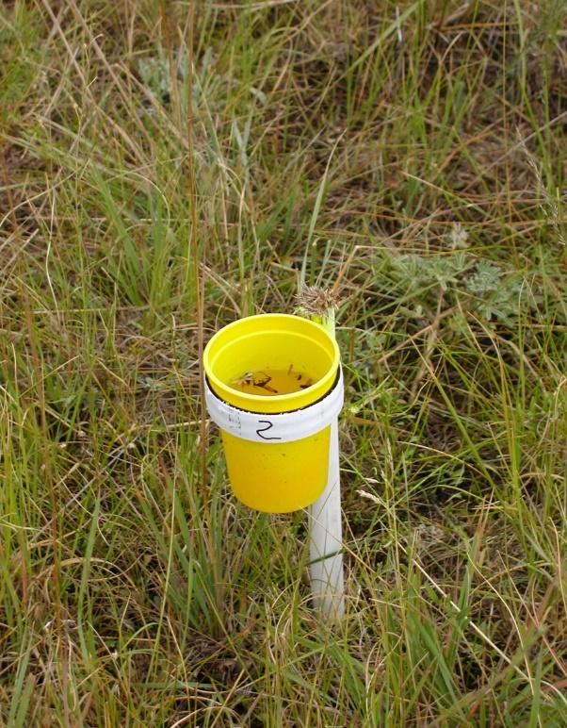

Fig. 1. Propylene Glycol Cup Trap

You can view a video for how to deploy these at: <http://youtu.be/z0DAY7bNOR4>.

You can view how to make the stands at: <http://youtu.be/x87CXM7mq54>.

Tuell, J. K., and R. Isaacs. 2009. Elevated pan traps to monitor bees in flowering crop canopies. Entomologia Experimentalis et Applicata 131:93-98. DOI: <http://dx.doi.org/10.1111/j.1570->7458.2009.00826.x

Wilson, J. S., T. Griswold, and O. J. Messinger. 2008. Sampling Bee Communities (Hymenoptera: Apiformes) in a Desert Landscape: Are Pan Traps Sufficient? Journal of the Kansas Entomological Society 81(3):288–300. <http://www.jstor.org/stable/25086445>

### Where to Set a Glycol Trap

Traps need to be placed in the open, exposed to full sunlight and not overhung by trees or grass and forbs during the trapping season. Bees see things differently than we do and don’t resolve things in the shade very well. Bottom line: Traps in shade = no bees, so do not put traps in the shade.

Glycol traps can be kept in grassy mown areas, but care should be taken not to let them get filled with grass clippings during mowing operations. If the traps are to be set up in an area such as a field of very close-growing tall grass that would completely obscure the trap when viewed from above, taller stands may be used to position the glycol traps higher off the ground but still (e.g., 15-20 cm) below the vegetation canopy (including grass canopies). The idea is to position the traps within the vegetation but at height where they will be visible to insects flying above (not necessarily above the vegetation canopy. The height of the glycol traps should be positioned so that the bottom of the cup is just (e.g., 2.5 cm) above the level of the ground or underlying substrate (e.g., matted down grass; see Fig. 1).

As with 3.25-oz pan traps, glycol traps should also be spaced approximately 5 m apart in any configuration that is convenient. Keep in mind that these sites should be considered permanent throughout the season and perhaps into upcoming years, so think ahead about vegetation growing and other activities that might interfere with the glycol traps into the future.

### Glycol Traps and Trap Fluid

After the pan trap stands are positioned or pounded into the ground, place a trap in each stand (alternating the colors). Fill each trap up to the holes under the rim with diluted propylene glycol (50% water:50% propylene glycol) mixed with a squirt of blue Dawn Original Scent dishwashing detergent. Traps filled 3/4 with the 50% industrial-grade propylene glycol (50% water: 50% propylene glycol: one squirt of blue-colored Dawn Original dishwashing liquid) will easily last for a week. Check the traps once per week to ensure that they remain full of liquid and top off with the diluted propylene glycol mixture if necessary.

If you are using premixed propylene glycol used in RV antifreeze solutions then DO NOT dilute the mixture as it is already diluted. This premixed propylene glycol lasts for weeks in even dry conditions; however, some evaporation of the water component can be expected so once a week check and top off (with the same premixed propylene glycol) as needed (lower fluid levels decrease the catch).

### Collecting Bee Specimens from Glycol Traps

Although glycol traps should be checked on a weekly basis to ensure that they do not dry out, bee specimens should be collected from glycol traps once every 2 weeks. Strain the sample and put the specimens and a sample label into a Whirl-Pak, using the following procedure.

Remove each cup in the array from the hoops or trap stands and pour their contents into a net bag or strainer, under which is another empty glycol trap cup that re-captures the strained propylene glycol that can be poured back into the now empty trap that is returned to the pan trap stand. Replenish the propylene glycol in all of the traps in the array so that they are filled to the top or to the drainage holes for continued operation (or if it has become cloudy or dirty, replace the liquid solution completely). Pool all specimens from a single array of glycol traps into one sample. Pouring the solution of multiple traps over the specimens collecting in the strainer will not damage them.

Transfer the specimens from the net or strainer into the sample bag using your fingers or a white plastic spoon also works well. Fill in (using PENCIL) and insert a sample into the bag with the specimens and fill the bag with enough alcohol to cover the specimens. Clamp your fingers across the bag, just above the specimens while flattening the sides of the bag against each other, and slide your fingers up towards the bag opening to eliminate air bubbles before sealing the bag up.

## Hand-netting

Capturing bees with a net is the most traditional way to sample bees. However, because it requires a skill that evolves and improves with practice (unlike the deployment of traps) there is a great deal of variation among individuals in their ability to collect and find uncommon and rare bees using a net. Even if time and location are well documented, there are still many factors affecting capture efficiency such as eye sight, strength, speed of handling a net, speed of taking bees out of a net and/or transferring to a specimen container (e.g., a ‘kill jar’ containing cyanide, ether, alcohol etc.), preferences for detecting and capturing or locating large bees versus small bees, where to watch or listen for bees, speed and timing of a person in traversing a site, the amount of time spent netting at an individual plant or clump of plants or in locating plants in flower, accessibility of flowers (e.g., netting canopy foraging bees), and preferences for capturing bees from certain types of plants.

Such preferences and skills lead to significant differences between and among individuals in total number of individuals and species of bees captured. These captures or sampling events are consequently not often representative or repeatable, making their use in detecting changes in the number and taxonomic composition of bees over time or among sites difficult. Instead the variation reflects differences in the collector’s skill. Thus the data are often not comparable and effectively negate the use of netting as a standardized approach to surveying bees. Furthermore, netting can only occur when weather conditions are appropriate. Additionally, throughout the day the probability of detecting and capturing bees changes, further complicating the use of nets in standardized surveys.

### Nets

Almost any type of insect net will catch bees. However, bee collectors do have preferences. Most people now use aluminum handled nets rather than wood. Some prefer the flexible strap metal netting hoops, as these work well when slapping nets against the ground to capture low flying or ground resting bees. Others prefer the more traditional solid wire hoops. Hoop size varies from about 12” to 18.” The larger the hoop, the greater the area of capture, however, larger hoops are more difficult to swing quickly due to air resistance, and there is more netting to snag on branches. A fine mesh net bag rather than the traditional aerial net bag can keep the smallest *Perdita* from escaping. We prefer nets that have muslin around the hoop for long term durability.

Forestry Suppliers manufacture insect nets that meet high-quality specifications. Before closing their doors, BioQuip products sold a net that is very portable for travel or backpacking. The pole disconnects into three small sections and the hoop can be folded into itself with additional sections able to add on. If you can find these used, they are a good choice.

Telescoping poles are also available but must be treated with care or their locking mechanisms will jam. An inexpensive long pole can be rigged by attaching a net hoop to a section of bamboo with hose clamps. Aerial nets, rather than beating or sweep nets, are normally used around the hoops.

### Zip Net

Sol Sepsenwol has created a great net which he calls the “Zip Net” (Fig. 2; Sepsenwol, 2014). He has modified collecting nets so that you can attach sandwich baggies to the end of a cloth sweep or beater net. Such a modification permits you to sweep or capture an insect or group of insects and easily inspect them through the baggie walls. If warranted, you can then simply remove the baggie with the insect for further processing.

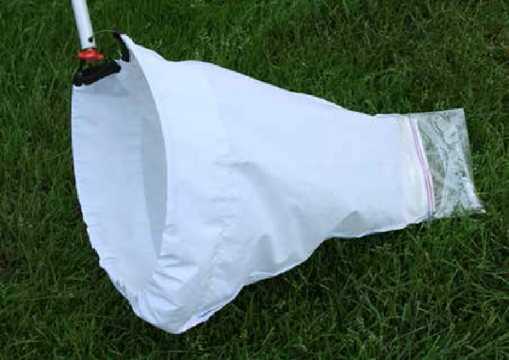

Fig. 2. The Zip Net

Since net handling time and the inconvenience of trying to determine what you have captured is often a bottleneck in field work, particularly for the new technician, this is a productivity boon. For those doing plant pollination studies, one simply has to sweep up the insect and, “Boom,” pull the bag off to complete an uncontaminated collection. In his paper, Sol also demonstrates how baggies can have kill canisters inserted and how to transfer specimens to alcohol or kill jars from the baggie. This is also a great way to show people insects and bees without having to wrangle them out of nets.

Sepsenwol, S. (2014). The Zip Net : An Insect Sweep Net with Removable Capture Pouch for Serial Collecting. American Entomologist, 60(4), 207–209. <https://doi.org/10.1093/ae/60.4.207>

### Netting Technique

When in the field, always hold your net in a “swing-ready” position. One hand should be below the head and the other towards the back or middle of the pole. Hold the tip of the net lightly against the pole with the hand near the head so that it does not drag in vegetation. When you start your swing drop the tip of the net.

Bees are best detected by their motion, rather than their size and shape. The mind detects motion much faster than it can process colors and shapes into bee/not bee categories. Train yourself to key in on movement; over time you will become more adept at separating bee motion from plant and other insect motion.

Bees are lost when you hesitate or check your swing. If you see something that looks like a bee, capture it in your net. Once in your net you can decide whether or not to keep it. If you spend any significant time thinking about whether you should or should not swing, the capture opportunity will be missed as the bee will have moved on.

Always keep a mental check for the presence of thorny plants in the area where you might swing - for the obvious tearing consequences to your net. Additionally, in some areas, some plants have clinging seeds that can implant themselves directly into the netting; if that is the case then you might try moving from the usual coarse weave net bag to the fine weave design.

When swinging a net, speed is important as well as follow-through. Bees are very visual and very fast. If you are timid in your swing or cut your swing short, bees will evade the net. Center your net on the bee if at all possible, even if it means having to plow through some vegetation. When a bee is flying low to the ground, it is better to slap the net over the bee than it is to try to catch it with the edge of your net by swinging just above the ground.

All else being equal, it is better to swing at a bee that is just flying into or away from a flower than a bee that is actually on a flower. Particularly if you are trying not to damage the plant, a less than vigorous swing of the net will simply push a bee clinging to a flower under the net and it will fly away afterwards. After some practice you can bring your net up to a bee on a flower, wait for the bee to just begin to leave the flower, push the flower out of the way with your net and still easily capture the bee.

When looking at a clump of flowers that could contain bees, stand 4-8 ft (1.2-2.4 m) away and try not to let your shadow fall across the flowers. Most people stand too close to the flowers, which could scare away some of the bees you might be interested in, limit both the number of flowers (and therefore bees) in your field of view, and limit your depth of field. Standing further back permits you to view large expanses of flowers, spot a bee, and either lean forward or take one step to put that bee into your net. If you have to take two steps or more, you are too far away.

On any flower patch, concentrate on the difficult to obtain bees first. In particular, look for bees that are moving very quickly, from flower to flower, and try to predict where they will move next. Usually there is some pattern to the quickly-foraging or flower-visiting bee and often they will return to the area after making their circuit. Some of these individuals never really come to rest and you have to swing ahead of where you think you are going to catch them. It also pays to look below flower clumps for low-flying bees. Some of these are nest parasites, while others simply prefer to move between clumps of flower just above the ground or grass.

Open soil of any kind and, in particular, south-facing slopes, overturned root masses, clay banks, and piles of construction dirt or sand should be scanned both for bee nests and their inhabitants, as well as for low cruising nest parasites. Nest parasites (in particular *Nomada*) usually fly just above the soil in erratic flight paths. The best way to capture them is to slap the entire head of the net over the bee and quickly lift the net bag up while leaving the rim on the ground. The bee will fly upwards rather than trying to sneak under the rim. Often this can take several seconds, so patience should be applied.

There are two ways to catch multiple individuals in a net. One way is to turn your net head sideways after capturing a bee, allowing the net bag to close over the head and hoping that the bee will not find a way out. The other is to physically hold the bag closed above the tip containing the bees (in between swinging at bees, you will be holding the closed net against the pole as you carry it from place to place). In both cases you will have to periodically snap the contents of the net to the bottom. Do this vigorously or some wasps (in particular) may not go to the bottom, and, if you're not paying attention, you could end up grabbing them through the net with obvious consequences to your hand.

In general, it is easier to see bees through the mesh if you go into the shade or if you shade the net with your body. Some people favor green nets over the traditional white ones to reduce this phenomenon to reduce the glare from the white net making it difficult to focus on the bee inside. However, some collectors also prefer white nets because they contrast strongly with usually dark-colored bees and other insects. See the above section regarding the "zip net" for an alternative.

Two videos that demonstrate how to use a net to collect bees can be viewed at:

<http://www.youtube.com/watch?v=n6ZFlz3uA7E>

<https://www.youtube.com/watch?v=SwYbv5bySPQ>

### Removing Bees from the Net

Time spent removing bees from the net is time spent not capturing bees; therefore, think about how you are removing bees from your net to see if you can speed the process up.

In the beginning, there is usually a great fear of being stung by your subjects. In reality, in North America, only *Apis*, *Bombus*, Pompilidae, Polistinae, Vespinae, and perhaps a few of the other wasps have significant stings. These are large insects and can be readily distinguished from your target species. However, even these species almost never sting while caught in a net unless they are physically grabbed or trapped against the net. Thus, over time you should concentrate on diminishing your fears, and spend more time sticking your hand and kill jar directly into the net. If you are putting your net on the ground to remove bees, you are taking too much time. Kill jars should be fully charged to quickly kill your specimens, and it helps to have multiple jars.

The most efficient means of collecting large numbers of bees is to use vials or containers of soapy water. In that way you can fill your net with bees and empty the net only periodically rather than after catching an individual bee or small numbers of bees. However, cleaning and processing bees killed in liquids requires some care to do properly (see section on washing and drying bees).

Once you have captured a bee or bees in the net, there are several ways to remove them. In all cases, it is best to vigorously snap the net to drive the insects to the bottom. You can then safely grab the net just above where they are resting. Even the larger and more aggressive bees can’t get at the hand that is closing off the net, due to the bunching of the netting.

In general, bare hands are recommended when removing bees from nets. Bees and wasps will almost never sting in a net, if you don’t trap them in your hands or against the netting. Use of a centrifuge tube filled with soapy water makes removal easy, as you can keep well away from the bees. Some people will use gloves, such as handball gloves, welder gloves, latex dishwashing gloves (though stinging can occur through latex), and goatskin beekeeper gloves; but this is the sign of a beginner.

If you are worried about the specimen(s) escaping, or have numerous insects in the net, you can kill, or at least pacify your catch, by stuffing the specimens and the netting into your kill jar and closing the lid loosely, also a sign of a beginner. Keeping your jars well charged with cyanide or ethyl acetate will ensure that the specimens quiet down quickly, and you will not waste a lot of time waiting. Once your specimens are immobilized, you can open up the net and drop them directly into the kill jar without worry.

Most collectors take a more direct approach and bring the open kill jar and its lid into the net, trapping the bee against the netting. Slapping the hand on top of the kill jar through the netting is at times useful to drive the bee to the bottom of the jar. Replacing the cap onto the jar inside the net can also help prevent bees from escaping.

A video that demonstrates how to remove bees from a net can be seen at: http://www.youtube.com/watch?v=n6ZFlz3uA7E

## Kill Jars

Bees collected from hand nets are usually killed using an insect kill jar -- a clear lidded container with a small amount of ether, ethyl acetate, alcohol, soapy water, or prepared cyanide inside. Several companies make chemical based kill jars that use either ethyl acetate or potassium cyanide as the killing agent. There are advantages and disadvantages to all types.

Bees are usually transferred directly from the inside surface of an insect net to the kill jar opening, so a clear container whose lid is easy to remove and replace works best. Any small clear container such as a plastic film canister, medium to large centrifuge bottle, pharmacy pill bottle, or specimen jar with a snap on or half to ¾ turn screw-on lid; or corked glass or plastic test tubes will work. Glass containers must be used if ethyl acetate is used as a killing agent; plastic containers will be damaged by this chemical. Clear containers allow you to confirm that you’ve successfully transferred bee specimens from the net to the container. *Ethyl acetate, which has historically been used in kill jars, denatures the DNA from specimens and is, therefore, less desirable.*

**CAUTION: Use extreme caution if using cyanide, wrap glass jars in tape to prevent breaking.**

### Soapy Water

An alternative to chemical-based kill jars are containers filled with soapy water (a mix of water with any common dishwashing detergent) or alcohol. These are particularly useful for those of you who store specimens in alcohol or wash them prior to pinning. The best jars/vials have a tight-fitting lid and are large enough to hold a fair number of bees. They should fit in your pants pocket and be easy to hold in one hand along with the lid. Fill the vial about half full with soapy water.

The jar will form a constant head of suds while riding around in your pants pocket. Using it in the net has the great advantage of immediately trapping any insect in the suds, thus permitting you to clean out the net of as many specimens as you wish. With a chemical based (cyanide, ethyl acetate) kill jar, you can accumulate 2-4 specimens with some effort, but at some point, more would be leaving than going in. The soapy jar is particularly nice when dealing with large, nasty specimens. At BIML, we favor using the large centrifuge tubes, as they slip into the pocket easily.

You have to be a bit more aware of how you carry the jar when open (water seeking its own level and all that), but such jars can also easily be used to directly collect off of flowers without a net.

Specimens can be readily left in the soapy water for 24 hours and, while a bit soggy, will even last for 48 hours without too much degradation. Afterwards, specimens can be either dried and pinned, drained and put into alcohol for long-term storage, or drained, wrapped with a piece of cloth (to soak up excess moisture and to prevent breakage) and frozen in a plastic bag. Specimens look best if cleaned and dried within 24 hours of capture in bowls or soapy water, if cleaned immediately after capture some specimens can “wake-up.” However, this can readily be checked by freezing any specimens that do begin moving.

|  |  |
| --- | --- |
| Advantages:   * Don't have to lug toxic chemicals around * Soap and water are readily available * Restrains specimens immediately * Can collect all specimens in a net at one time * Inconspicuous to the general public * Pollen and gunk are washed off while in the vial * Inexpensive | Disadvantages:   * No pollen analysis * Specimens are wet * Jar needs to be held a bit more upright when open than a normal killing jar * If cap not on correctly, the water can leak * Specimens have to be dried prior to pinning (see section on properly drying specimens below) |

### Alcohol

Isopropyl, ethyl, or denatured alcohols are all appropriate for storing insects, but isopropyl should never be mixed with the other alcohols. You can go to the pharmacy and almost always find pint bottles of ethyl alcohol, ethanol, or denatured alcohol (be aware that alcohol names are not consistent). If not readily available in the store, it is possible to have the pharmacy order what you want. Hardware stores carry gallon and pint cans of denatured alcohol. We find that drug store alcohol is easier to work with, as it is made with a smaller amount of methanol.

Often alcohol needs to be diluted to achieve the right percentage (70%). All hardware store alcohol should be considered to be 95% alcohol. Drug store alcohol can be close to 100%, but usually is something less. You will have to read the bottle’s label to check. Most cheap dollar type stores sell isopropyl that is only 50% alcohol. To add confusion to the matter, drugstores often label the percent alcohol in terms of “proof.” Proof is a simple doubling of the percentage. Therefore, 100 proof is 50% alcohol and 190 proof is 95% alcohol. To dilute from 100% alcohol to 70%, choose a convenient sized container, such as a pint bottle, then fill it ~70% full with alcohol and the rest with tap water. This measurement doesn’t need to be exact.

Miriam Richards from Brock University has found that specimens stored and processed as above retain high quality DNA for at least several years. However, for highest-quality DNA extraction from specimens, they should be stored in 95-100% ethyl alcohol.

|  |  |
| --- | --- |
| Advantages:   * See above re: soapy water * Maintains integrity of DNA if diluted correctly * Prevents rotting of specimens | Disadvantages:   * See above re: soapy water * Need to be careful about dilution percentages * Can make for “crunchy” specimens * Shipping challenges |

### Ethyl Acetate

Traditional kill jars are made of glass with a layer of plaster of Paris at the bottom. Newer models may have the plaster in the lid; this helps prevent specimens from coming in contact with the ethyl acetate directly if one can manage to keep the jar upright. At the start of the collecting day, pour enough ethyl acetate into the jar so that it soaks into the plaster, but leaves no liquid on top. If you use the jar regularly, then the ethyl acetate will need to be recharged every couple of hours, as it will evaporate.

|  |  |
| --- | --- |
| Advantages   * Less toxic than potassium cyanide * Not a controlled substance * Relaxes the specimen, which is useful if the genitalia are being pulled | Disadvantages   * Needs to be replenished often (requiring either that ethyl acetate be brought into the field or that several charged kill jars remain available) * Can cause the jar to “sweat” inside which may mat a specimen’s hairs * Significantly degrades DNA * Outgas in a hot car which is probably not good for you |

### Potassium Cyanide

Most collectors eventually use a cyanide-based kill jar. Cyanide jars can be made from any glass or plastic container. Place a layer of cyanide crystals in the bottom of the container. Next add a layer of sawdust. Finally, pour wet plaster of Paris over the sawdust. Leave the jars open for a few hours outside or in a hood, and then close them. Alternatively, a combination of cotton balls and tightly rolled paper towels can be used in place of the plaster and sawdust.

Cyanide jars usually work immediately in the field, but if they don’t knock down specimens right away, a drop of water or a bit of spit (don’t lick!) will cause the crystals to begin giving off gas. Many collectors use test tubes or narrow vials with a cork top as collecting vials. These are useful when there is a need to keep collections separated in the field, such as when collecting off different plant species. Tubes can also be handled easily with one hand while in the net. Vests, aprons, hip packs, and carpenter belts are useful ways to keep a number of collecting vials handy. Most people will wrap the bottom of glass jars and vials with duct tape to reduce the chance of breakage in a fall. Additionally, it is handy to place a bit of paper towel in the bottom of each jar to absorb the extra moisture and regurgitated nectar from the bees collected.

After bees have been placed into a well-charged kill jar, they usually quiet down in just a few seconds. If the specimens are taken out of the jar too soon, some may “wake” back up and begin to move again, albeit usually only very slowly. Usually thirty minutes or so in the kill jar will prevent this.

|  |  |
| --- | --- |
| Advantages   * Knocks down insects quickly * Does not significantly degrade DNA * Can remain effective for over a year * Does not add moisture to the jar | Disadvantages   * Relatively toxic * Is a controlled substance * Can change the color of some bees (particularly yellows become orange or reddish), if bees are left too long in the jar. |

## Bee Vacuums

Bee vacuums are a versatile solution to the conundrums of novice field techs performing surveys and the desire to capture bees or other insects for simple non-lethal viewing. They also are used in surveys that are targeted to specific flower species. Several researchers have commented that vacuums are particularly useful when minimizing flower damage is important. Neil Cobb has noted that his bug vac (instructions below) is also effective “for situations where it is really windy or habitats where swinging a net is challenging (e.g., Acacia, chaparral). Also, it does not have to be for just pollinators, you can use it to catch ground-dwelling bugs, bugs in caves, and a lot of habitats where swinging a net is not great.”

Every collection method will have biases to consider, but vacuum sampling has been shown to capture “similar numbers of both large and small bees to those recorded during timed observations at the same flowering plots by trained individuals” (Julianna K. Tuell). Essentially, vacuum sampling is a “point-and-shoot” operation that can be adapted to mortal or catch and release surveys.

### Considerations

BioQuip’s InsectaVac was the standard insect vacuum on the market prior to the company's closing in March 2022. Until another supplier fills this gap, scientists need to devise their own insect vac solutions using household handheld vacuums; we include a few suggestions below. You may discover your own method of modification of a vacuum or leaf blower. Please share these with the BeeMonitoring ListServ for the benefit of the pollinator science community.

You will clearly need a cordless product. A lightweight vacuum with replaceable/rechargeable battery packs may also be a priority for long field days. You will want a product you can quickly turn on and off.

Hand-held aspirators for small insect work (e.g., wasps, mosquitos) are not a good fit for pollinator sampling. They require too much precision and are too small for most bees.

There are “bug catch and release” vacuums available for purchase from big box retailers. These are typically marketed as toys for children or for spider removal and may be sufficient for citizen science events. A benefit of these is that they typically use easily replaceable alkaline batteries. There are also kits that will connect the chamber to a larger viewing box. Be aware there are similarly marketed bug vacs on the market intended to kill the insect.

Handheld vacuums intended for domestic work are popular and customizations are described below.

### BioQuip Alternative

Contributed by Neil Cobb, [Neil.Cobb@nau.edu](mailto:Neil.Cobb@nau.edu) Thursday, April 20, 2017

“In 2010 I made my own handheld bug vac because the only other vac like it (BioQuip) did not meet our project needs. We needed a setup that allowed us to use lots of sample tubes and battery power to last the whole day for four or more people.

I chose to reconfigure the Ryobi battery vac. [available for purchase as of March, 2022]. The primary limitation of this vac is that it is loud but we have used it for years and it does not seem to have any effect on the insects. Movement by the collector is the most important factor in limiting capture success. But you can go with a vac that is not as loud (e.g., Dewalt) but they will be more expensive. If you go this route of making your own vacs then I would suggest that any other power tools you use should also be able to use these batteries. We have 6-7 different Ryobi tools & lights that use these same batteries, especially the bright LED shop lights for night lighting.

To make it feasible you should plan on making at least 4 vacs, I shoot for having at least eight vacs.

I made several videos (Bug Vac playlist) and a list describing parts and cost. <https://www.youtube.com/playlist?list=PL7cBgVs7p2owbpvjaZ1pVlx-djPa3iArz>

### Cordless Handheld Vacuum

Small, handheld vacuums are useful right off the shelf (Fig. 3). If purchasing a lightweight handheld vacuum (e.g., DirtDevil, Hoover) you may consider a model with a long tube (either an attachment or a “crevice” design) in which the collection chamber is closed (by filter or other means) when detached from the vacuum. This will ensure bees remain trapped until transfer to storage. Alternatively, you may modify the design with a mesh barrier (see DIY below by H. Glenn Hall). You will also need to consider the size of the entry tube will accommodate larger bees and that the suction is strong enough to pull them past the one-way flap valve. A transparent dust chamber is also very helpful.

Cheryl Fimbel and Priya Shihani use a Dirt Devil® Detailer® and observe that “it is especially useful for the tiny bees that would get lost in a net, or are foraging among flower parts that preclude capture with a net.”

Clare Walker suggests the BLACK+DECKER dustbuster AdvancedClean Cordless Handheld Vacuum (CHV1410L) [available for purchase as of March 2022]. “It has the crevice tool built in which is important to stop bees escaping and you can separate the motor while still keeping bees contained to pop into a cooler or fridge/freezer. About 5-10 mins depending on temperature is enough to cool bees so you can pour into another container to collect … It is also handy for using [to collect] on woodland spring ephemerals … This model, with its transparent chamber, has been very good for doing demonstrations with the public.”

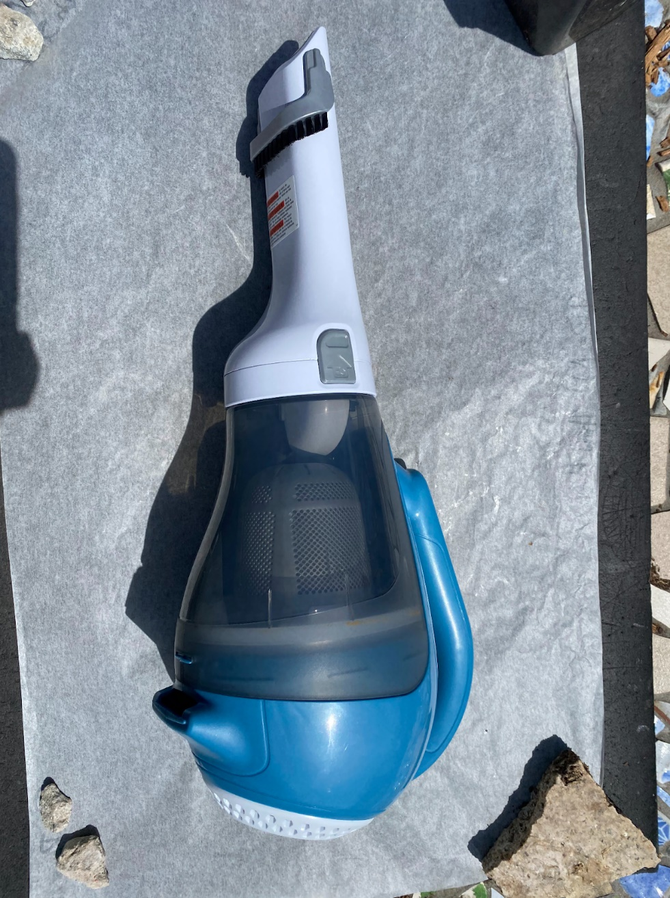

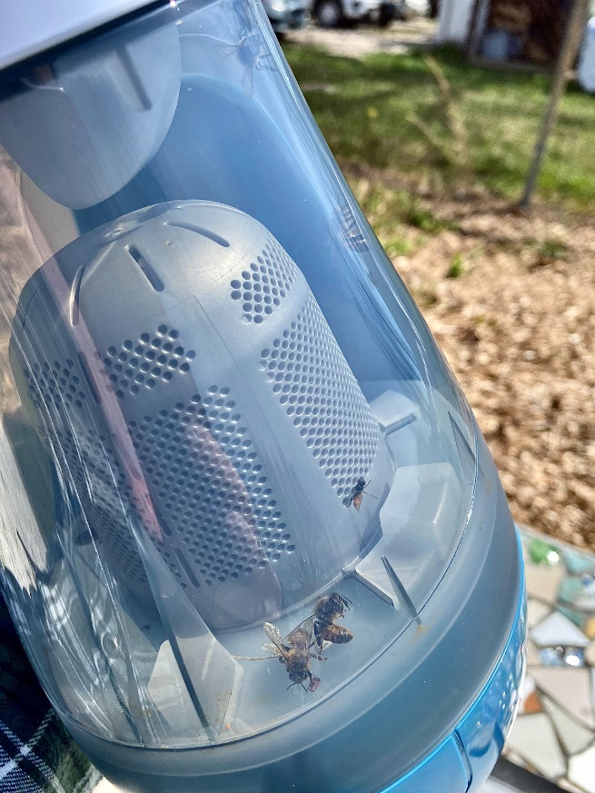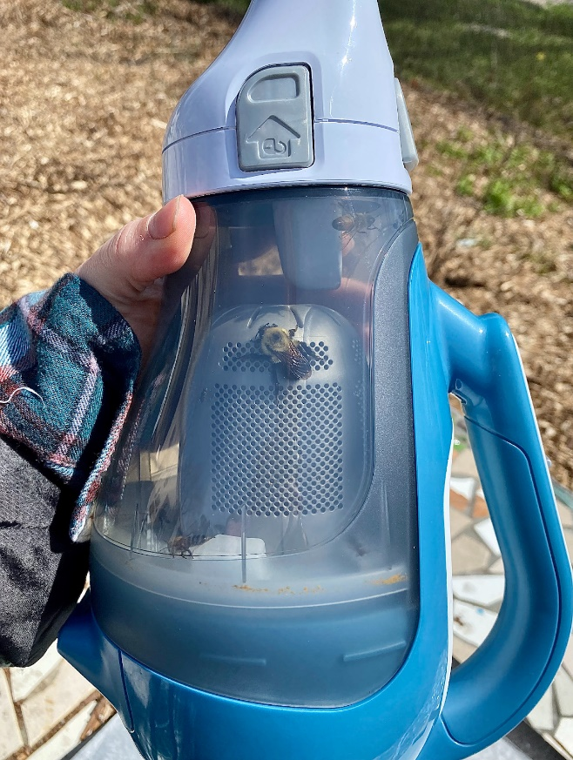

Fig. 3. Bug vac collecting with a Black & Decker CHV1410L. Photos by USFWS 2022.

#### Adapting a Handheld Vacuum

A Cordless Hand Vacuum Adapted for Collecting Bees (contributed by H. Glenn Hall)

“The recommended vacuum is a Black+Decker® 18 Volt Platinum Series Cordless Hand Vac, Model # SPV1800 [Fig. 4; model no longer manufactured or sold]. It is a strong vacuum with a removable battery that is charged separately. With one or more extra charged batteries on hand, the vacuum does not become unavailable when it depletes the charge.

An adaptor for round tubes (a 1¼" opening) is pushed onto the end of the vacuum. Three sections of acrylic tubes of decreasing diameter are added. A 4" to 6" long, 1¼" OD, 1" ID, piece is slid into the adaptor opening, followed by a 4" to 6" long, 1" OD, ¾" ID, piece, and finally a 3" long, ¾" OD, ½" ID, piece (with a screen on the inside end [see next paragraph]). Each tube is pushed about ½" into the adaptor or tube before it [Fig. 4]. The fits should be tight between the adaptor and first tube and between the first and second tube. If the inside tube is slightly too large, some sanding may be needed at the edges. If it is too narrow and loose, it may need to be glued. The fit between the last two pieces of tubing should be snug, enough to hold the last tube in place, but not so tight that it cannot be easily removed. These lengths of the tubes increase the reach of the vacuum, without making the entire length too awkward.

A disk of stainless steel screen is cut (as close to ¾"diameter as possible) and glued (epoxy is recommended) to one end of the last tube [Fig. 4]. Screen material is used that has a mesh small enough to catch small bees and thin wires that do not greatly restrict air flow. The screen can be purchased from McMaster-Carr (High-Volume Lightweight-Particle-Filtering Stainless Steel Wire Cloth Woven, 316 stainless steel, 22 x 22 mesh, 0.0075" wire diameter). After the screen is glued to the end of the tube, the overlapping edge is filed off (file strokes toward the tube are best, as they tend not to pull up the screen). It may be tempting to use a nylon fabric mesh rather than metal screen, because it is easier to remove the overlapping edge. However, some bees, particularly *Megachile*, easily cut through nylon. It is useful to have several of these end tubes made.

When a bee is caught, the open end of the last tube is covered with a finger, before turning off the vacuum. Several bees can be caught in succession, if, during the waits in between, the end is kept closed while the vacuum is kept off (to save power). The end tube is removed and the bees are transferred to a holding tube/bag or killing tube/jar. Alternatively, if several end tubes have been made and are available, they can be closed with a cork to hold the bees until they can be transferred at a later time.”

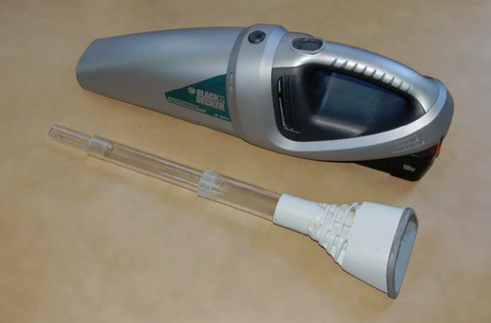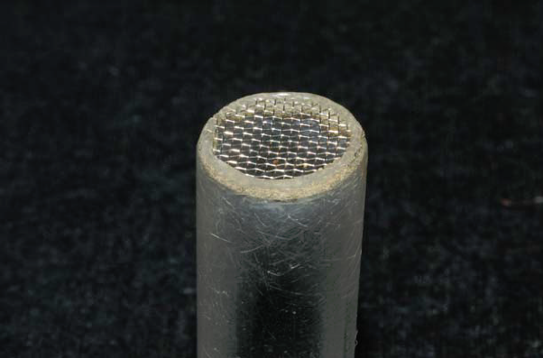

Fig. 4. Bee vacuum with close-up view of end of collecting tube.

### Tips for Collecting Bees with the Vacuum

Bees cannot be collected off of flowers with big floppy petals, such as squash flowers, which tend to get caught in the vacuum. The big petals of sunflowers are avoided by taking good aim at the bees on the flower disk. To catch bees under foliage and avoid catching leaves, the open end of the vacuum tube may need to be quickly moved close to the flowers before the vacuum is turned on. Sometimes the bees hit the screen with such force that they appear stunned but not damaged” (H. Glenn Hall).

David Almquist provided an additional modification to the Dirt Devil that seems to increase their ability to hold specimens following capture. He painted the clear parts of the Dirt Devil black and took out some of the internal structure so that the bees were more likely to move to the back which is now the lightest part of the device and thus became easier to remove and place bees into a vial.

While a bee vacuum is point-and-shoot, it does require the user to have developed a search image for bees and to move quickly.

## Plexiglas Bee Observer and Pollen Picker

Brian Dykstra wanted to catch, photograph, and release bees, wasps, and other insects for identification following net captures in the field without killing them. With help from a colleague, he created a Plexiglas container with a slide top and a foam plunger (Fig. 5). This device is similar to the queen marking cage and plunger used by some in honeybee keeping practices, except this has a square shape and a clear top for ease in quality photography without distortion. This one also has an optional screen slide for the top for collecting pollen with toothpicks. This is an excellent tool for citizen science and school groups.

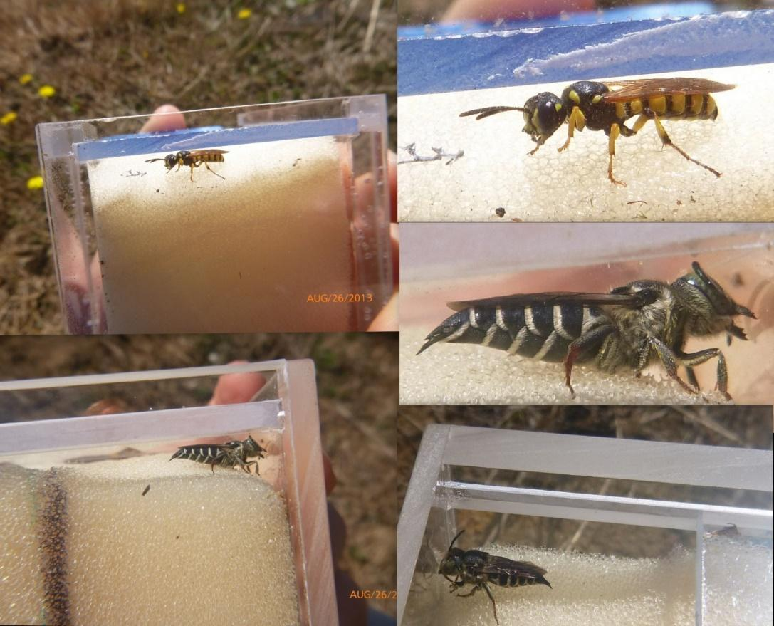

Fig. 5. Plexiglas bee observer and pollen picker.

## Bees Through Binoculars

For those investigators who do observations of bees on flowers or around nest sites, the Pentax Papilio II 8.5x21 binocular is ideal. It has high magnification and focuses down to 0.5 m (1.6 ft), permitting sight identifications and detailed behavioral observations (once you have learned to identify specimens under the microscope).

## Photographic Surveys

Taking photographs of live bees has low systematic repeatability but can be used to document presence of species. As with any photography-based monitoring, there will be varying degrees of success and accuracy depending on the quality of the photograph(s), photographer(s), photography equipment, and the entomological and melittological identification skills of those providing the identification service. However, there are communities actively conducting and researching to improve bee identification through photography as a non-lethal sampling/monitoring method. Some quite sophisticated though expensive techniques have already been developed for taking higher quality photographs of bees in the field (see Thomson and Zung, 2015).

Important bee identification characteristics can include colors and patterns and the presence or absence of hair on the bee’s face; upper or under side of the thorax and/or abdomen; and legs; the positioning of physical features and appendages; and the wing venation pattern (the patterns of the wing veins and cells). It’s important to try to include as many of these characters in focus, in a photograph of a bee. It is often necessary to take multiple photographs of the same individual in order to capture good quality, sufficiently focused photos showing enough of these characters.

Some existing programs and projects focusing on using photography to identify live bees follow:

1. The Bumble Bee Watch project (<http://www.bumblebeewatch.org/photo-tips/>) a citizen science project supported through a partnership of The Xerces Society, the University of Ottawa, Wildlife Preservation Canada, BeeSpotter, The Natural History Museum, London, and the Montreal Insectarium, offers tips on taking good quality photographs for successful identification of bumble bees.
2. The BeeSpotter project (<https://beespotter.org/topics/photos/>) supported through a partnership among the Office for Mathematics, Science, and Technology Education, College of Education, University of Illinois; Department of Entomology, University of Illinois; and the University of Illinois at Urbana-Champaign, also provides instructions for what characters to capture in a good bee photograph.
3. BugGuide.net, hosted by the Department of Entomology, Iowa State University, is “an online community of naturalists who enjoy learning about and sharing our observations of insects, spiders, and other related creatures” and offers tips on taking good quality insect photographs (<http://bugguide.net/node/view/137046>). BugGuide.net is also supported by a highly qualified and active community of volunteer entomologists and mellitologists (scientists who study bees).

For more guidance on taking field photographs of bees and using iNaturalist, refer to this video by well-known Native Bee expert, Heather Holm: <https://www.youtube.com/watch?v=x3kjvererpo>

The USFWS has also set up a project page on iNaturalist, where bee photos taken on refuges can be uploaded and bee experts will periodically visit and attempt to identify the bees in the photos. Use the “Bee & Wasp” link on the NWRS page: (<http://www.inaturalist.org/projects/usfws-national-wildlife-refuge-system>).

In order to identify observations that were made as part of a formal survey (as opposed to casual observations of refuge visitors), please add the keyword “IMBeeSurvey” in the Tags field on the Observation Submission page. These observations can then be selected with a query using that tag. If you would like to send a notice to Sam Droege that photos have been uploaded, so that he might attempt to identify when he has the opportunity, add the comment “@sdroege” to the observation (below the “Activity” panel).

# Bee Preservation

Bees caught by netting can be placed into a whirl-pak or zip lock bag, stored in the freezer and then immediately pinned. If the use of a preserving liquid such as alcohol or propylene glycol is needed, then refer to the instructions below on how to wash immersed bees.

Specimens immersed in alcohol or propylene glycol should be double bagged using a combination of whirl-pak then plastic bag or two plastic bags. They can be kept refrigerated for up to two months or frozen if it is needed to store them for longer. It is true that if the alcohol and propylene glycol content is sufficient they do not require freezing, however, freezing slows down any evaporation that might occur (particularly a problem in alcohol immersed specimens), and it also removes any threat of improper dilutions of alcohol or propylene glycol resulting in specimen deterioration or rotting while waiting to be processed or shipped.

Due to both postal regulations associated with the shipping of alcohol and the difficulty in securing the liquid and the specimens in their bags, *please* refer to the shipping section for the proper procedure to prepare specimens for mailing.

# Processing Bees for Pinning

Washing and drying the bees will result in better looking, easier to identify specimens. If the pollen load is not going to be analyzed, then washing the specimens also has the advantage of eliminating the pollen from the scopal hairs and diminishing the “dustiness” of the specimens, making other morphological characters easier to see. Pinning bees directly from water, glycol, or alcohol usually results in matted hairs and altered colors, along with a good coating of pollen, scales, and other detritus picked up from the sample. Many bee species are identified by hair characteristics that cannot be examined or properly identified if the hairs are matted and stuck together.

**Note:** We do not sort out bycatch until after washing and drying. See section below.

## Washing Techniques

### Strainer Washing

Fill your specimen Whirl-Pak with water and then dump the contents into the strainer (tea strainers work well because of their fine mesh, brine shrimp nets also have sufficiently small mesh, but it is more difficult to remove specimens because of the flexibility of the netting). Dump the specimens into a plastic container with a lid (put a small hole in the lid to let out the foam). Add warm water and dishwashing liquid (more if the specimens are stored in glycol), and very vigorously shake the specimens around for 60seconds. Place specimens back into the strainer and rinse under warm to hot tap water until no suds are present. Use your hand to break the force of the water to protect the specimens.

Rap off loose water and use a towel to blot out as much excess water on the bottom of the strainer or brine shrimp net as possible. A cloth towel is more environmentally friendly than using paper towels. Then use any of the drying techniques below

### Mosquito Netting and Net Bag Washing

Mosquito netting makes for a great vessel to wash bees. The first way to do so is to cut a square of mosquito netting that is at least 12 in by 12 in. Lay the mosquito netting into a large metal strainer (preferably one that has a flat base and is self-standing). Dump the bees into the very center of the square of fabric and fold the fabric around the bees until you have a small pouch, with the bees at the bottom and all of the excess fabric at the top. Use a reusable zip tie to seal the bees in the fabric. We recommend using more than one zip tie in the event that one fails. Make sure that you are not securing the zip tie too close to the pocket of bees, you want them to be able to bounce around, and that there are no holes for the bees to escape.

Alternatively, Net Bags for Bee washing and drying were created using the same mosquito netting, ¼ inch cotton dress makers tape, and polyester or cotton/polyester thread. The instructions to make the Net Bag are located in the appendix of this manual. To use the net bag, dump the specimens into the net bag so they land at the very bottom of the bag. Secure the bag using the tie that is attached top. Make sure it is very secure and there are no holes for the bees to escape.

*Using the mosquito netting and net bag has the added benefit that the bees do not need to be transferred to another container for drying. The lab uses a small clothes drying machine on the lowest/cool setting for 10-15 minutes.*

## Drying Techniques

### Mason Jar Drying

We have found that you can obtain beautifully coiffed hair on even the longest-haired bumblebees, if you spend the time shaking them around in a paper towel. Unfortunately, that can take a while. Most people shake them only until their wings unfold and then pin them, leaving the specimen less than presentable. That need not be, as you can use a hair dryer to speed things up.

You will need the following: A small clear glass pint or half pint jar (a quart will do, but Morgan Lowry reports that smaller ones dry things faster) that has a canning jar lid of the kind with a removable central metal disk. Replace the center of the canning jar lid with a similar sized section of fiberglass screening. We use the fiberglass type, but metal might be okay, though they could be too stiff or may unravel. You can leave the screen loose and let the lid clamp it to the top or you can glue it with waterproof glue.

Follow the same procedure as listed under the strainer section above but just do a quick blot of the specimens on the paper towels to get the bulk of the alcohol off. Dump the specimens from the paper towel into the canning jar (we use a homemade funnel from the end of a large plastic soda bottle to help with this. Put the lid back on the killing jar with the screen in the middle; make sure the screen is snug around the entire lid. Tracy Zarrillo has had good success in extra fluffy bees by adding small rolled up bits of paper towel in with the specimens.

Turn on the hair dryer. We use high heat, although heat is not always necessary, particularly if the specimens are rinsed in quick-evaporating alcohol. Place the jar on its side on the folded hand towel and place the hair dryer pointing into the jar as close as possible, without causing the hair dryer to cut out (usually about 1 inch). This can be handheld or set up in a wide variety of ways so that you don’t need to hold the blower. Apparently, as we have found, if you put many hair dryers right up to the screen, they will overheat and turn themselves off (stick them in the freezer if you want them to come back on quickly). While drying, shake the specimens back and forth vigorously, hitting the sides on the towel periodically to dislodge them if they stick to the glass. Specimens, when wet, are very flexible and tough, so they can take a moderate amount of bumping around.

Once the specimens are all loose, shift the jar slightly downward so that the specimens slide towards the screen and whirl around in the dryer’s wind; continue shaking the specimens. Small short-haired specimens are done once their wings are flexed away from their body and their hairs are not matted. Bumblebees and long-haired specimens take longer. Depending upon your hair dryer and your technique, this may take anywhere from 1.5 to 3 minutes.

### Using Compressed Air

We have found that using compressed air results in the quickest drying of wet bees. Compressed air can come from a small air compressor, a paint sprayer device (without the paint) or a compressed air duster for computers. When using compressed air, be aware that there can be moisture in the air lines. Run the air wide open for a few seconds to get rid of any loose moisture.

Also be aware that at high pressure, compressed air can blow apart specimens, particularly their abdomens. Direct the air stream to the side of the jar and let it swirl the specimens around in a vortex (if the pressure is too high or they are bouncing violently around, you can rip some abdomens off). Small specimens with short hair take less than 1 minute. Bumblebees take about 2 minutes to have all the hair on their thorax fluff up.

### 95%+ Alcohol

Either squirt 95%+ alcohol onto the specimens, dip the strainer into a bowl of 95%+ alcohol, or drop them into a jar of 95%+ alcohol and blot again. Dump the specimens onto a set of 3-6 paper towels and fold the paper towels over the specimens and roll them around with your finger, pencil, or tweezers and refold a few times to remove the bulk of the alcohol.

At this point, you can fold the corners of the paper towel up and shake the specimens around inside to further dry them. Stop shaking once their wings are no longer stuck together or folded up on themselves and all bee hair is nice and fluffy. You will likely have to hold the corners and the towel area between the corners in your fingers or the specimens will jump out while you are shaking them.

After the specimens have been dipped in alcohol you can leave them lying on the paper towel for a bit (up to 45 minutes or so) before further fluffing if you aren’t in a hurry. The best looking bees are those that are cleaned within 24 hours of capture. The paper towels can be reused many times.

# Bycatch

We sort out bycatch when pinning, and to do so, you need to be able to identify bees and non-bees on sight (see earlier section). We do not keep any other bycatch, practices may vary at other labs. When collecting specimens from bowl traps, we will pull out butterflies and large obvious non-bees (butterflies, grasshoppers, spiders…) that fell victim to the trap. Other bycatch is washed and dried with the bees and sorted during the pinning process.

Beetles and true bugs (the most common bycatch) can easily be pushed to the side. Bees, wasps, and flies can be trickier. With practice, most bees can be sorted out of bycatch for pinning by eye alone. Some may appreciate using a standing magnifying light such as are commonly used for detailed crafts and electrical work.

We lay all the specimens out on our sorting surface - simply a pinning board with parchment paper placed over it. Parchment paper is slippery and allows us to scoot specimens around without damaging them. Then we will use a pair of tweezers or something similar to sift through the specimens and make piles, pulling out the bees from the rest of the collection.

When in doubt, pin it up. Be aware there is much mimicry in the bee world, especially in coloration. Also, male, parasitic, and oil collecting bees do not have scopa (pollen carrying hairs) which can be deceiving.

# Pinning 101

## Types of Insect Pins to Use

Bees should be pinned using size 2, stainless steel insect pins. Anything smaller, is prone to bending when pressed into traditional hardboard lined trays and boxes. Larger sizes are generally too large for anything other than bumble bees. In humid environments, stainless steel pins should be used to prevent rusting. There are various online sources for pins, such as Home Science Tools.

## Pinning Board

For someone new to pinning, use of a purchased insect pinning block is helpful to determine the correct height a specimen should be placed. With experience, one can use pieces of foam of the correct depth, or even adjust specimen height by eye, which will be the quickest. Remember to leave enough room at the top of the pin so that the specimen can be safely picked up by the largest of fingers. Equally important, leave enough room at the bottom for two or more labels and room for the pin to go into the foam of a collection box.

To make a pinning board, we use a sheet of the Ethafoam and glue it to a piece of plywood or corrugated piece of plastic like those found in outdoor signs, which will form a sturdy pinning surface (Fig. 6). Expanded polyethylene foam (often referred to as Ethafoam®) or cross-linked polyethylene foam (our preferred foam) is better than polystyrene foam (usually referred to as Styrofoam™) for pinning purposes.

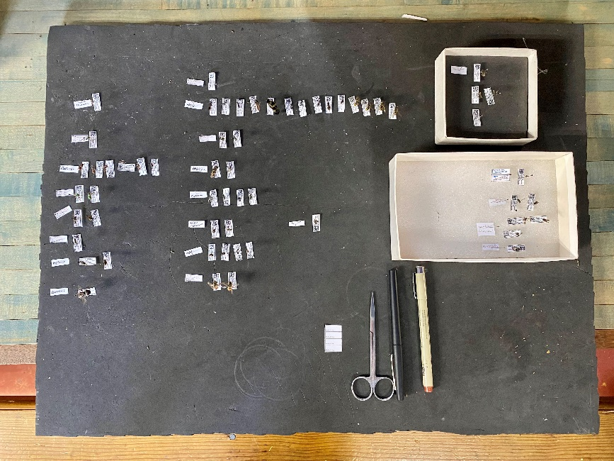

Fig. 6. Pinning board with sorted specimens.

## Traditional Pinning Techniques

Specimens are best pinned through the scutum between the tegula and the mid-line. The midline of the scutum often contains characters that are very useful in identification, which can be destroyed by a pin. Most museums prefer specimens be pinned on the right side (Fig. 7). Another way of thinking of this is to pin the insect directly through where a human heart would be.

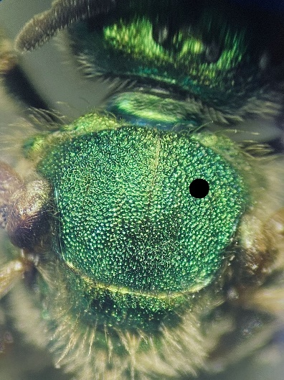

Fig. 7. Black dot indicating correct pin insertion site.

Each person develops his or her own process when pinning bees. Some pin under the microscope, which usually results in very accurate placement of the pin, but many pin by eye. One technique is to hold larger specimens between the thumb and forefinger with the pin ready in the other hand. Use another finger from the hand holding the pin to help hold the specimen steady while inserting the pin accurately into the bee’s scutum. Others pin larger bees using a pair of forceps or tweezers, trapping the specimen on a foam pad.

A video demonstrating how to pin bees can be viewed at: https://www.youtube.com/watch?v=V2F8LBQV5L0.

If you are interested in neatly spreading the specimen, this is the time to do that. These techniques can only be employed on very fresh and/or relaxed specimens (see next section for more information on relaxing/re-hydrating specimens). You may hook a pin into a bees’ back end and pull gently to extend the abdominal segments and pull the gonads on the males. Some may also spread the wings, mandible, tongue, legs, and/or antennae for museum-quality specimens. These body parts can simply be nudged into place carefully with a pin and supported in place with pins around the area until the specimen fully dries.

### Re-hydrating Pinned Bees

At times, there is a need to re-hydrate bee specimens in order to remove them from the pin or to pull the tongue or genitalia. (Pulling open the jaws on specimens is difficult after they have dried, even with extensive re-hydration.)

Place bees into a rehydration container, a humidor or a covered Petri dish with a moist paper towel inside. It can take anywhere from a few hours to several days for larger specimens to relax. John Plant and Andreas Dubitzky found that you can speed the process of rehydration by adding boiling water to a small container, floating the specimens in the container on a small piece of Styrofoam, and closing the container with a tight-fitting lid.

To prevent mold, add a few drops of ethyl acetate, a few mothballs, or a large dose of alcohol in the water. A useful technique (learned from the Packer Lab) is to affix foam into the bottom of a small plastic food container, put specimens you would like to rehydrate into that container, invert the container and place a slightly wet paper towel or two on top of the lid of the now inverted container and leave overnight. This rehydrates the specimens quickly, but you don’t have to worry about water dripping down from above onto the specimens or labels. However, if the paper towels are too wet then you can still get some beading of water on the specimens.

Laurence Packer observes that the longer the bee has been pinned, the longer it takes to relax and the more fragile it becomes. Thanks to Laurence Packer, Jack Neff, and Jason Gibbs for their contributions on this topic.

## Gluing Small Specimens

If specimens are too small or brittle to be pinned, they can be placed on a point, glued to the side of a pin, or attached as minuten double mounts. Reversible glues, such as Elmer’s Glue Gel, tacky glue, clear nail polish, shellac, hide glue, and others should be used.

### Gluing to Points

The use of points is traditional. Points are very small, acute triangles cut from stiff paper using a special punch, which can be ordered from entomological supply houses. Place the pin through the base of the point. Elevate the point on the pin to the same height as a pinned specimen. Glue the small bee to the tip of the point. The tip should slide between its legs and attach under the thorax so the head and abdomen can be viewed from all angles.

### Minuten Double Mounts

Minuten double mounts are not used very often but do create the best-looking mounts. A tiny bit of crosslinked polyethylene foam is pinned to the same height as a regular specimen on an insect pin. A minuten pin is added to the right side of the specimen and then inserted into the foam block. On the downside, this takes a lot of time to accomplish.

General Videos on how to mount and work with insect collections are available at:

<http://nau.edu/Merriam-Powell/Biodiversity-Center/Museum-of-Arthropod-Biodiversity/Instructional-Videos/>

### Gluing Directly to Pins

When gluing a specimen directly to a pin, rather than to a point, the specimen is glued on its side or the underside between the thorax and abdomen. Again, most museums prefer that specimens be glued on the right side. Specimens should be glued to the pin at the same height as those that are traditionally pinned. Gluing specimens to the side of the pin has the advantage of speed, better prevention of glue hiding useful characters, and a specimen that is easier to view under the microscope. Its axis of rotation is minimized and the paper point is no longer there to hide the view or block the light.

Clear glue gels are recommended over white, tacky glues because they have a longer work time, dry crystal clear and are easily reversible. Because the set-up time is longer than tacky glue, leave the pin resting on the specimen on your pinning board or tray for at least 5-10 minutes prior to picking it up. Parchment paper is very helpful to have around when gluing bees. It is a silicone impregnated piece of paper that can withstand the heat of an oven but is super slick. It provides a “non-stick, Teflon®-like” substrate on which to work, because glue does not adhere well to it. Another nice thing about parchment paper is that dried specimens can be easily re-positioned. They will slide smoothly on the paper without sticking or breaking.

Run a small line of glue along the back of your non-dominant hand. Glue can also be placed on a work surface, such as the lid of a petri dish. Touch a pin to the line of glue at the height at which you want the specimen to be glued. Roll the bee specimen over so that its right side is facing upwards (or so that the specimen is lying on its left side). Touch the pin to the specimen that is laying on parchment paper so that the glue makes contact with the specimen. Be sure that the glue is adhering to the side or underside of the bee and not to just the hairs, legs, or wings (Fig. 8). Let the glue set by resting the pin on top of the specimen for at least 15 minutes. After the glue has dried, pins are then transferred to boxes. In some instances, that transfer can be combined efficiently with the attachment of labels, saving another step. Jane Whitaker has found that magnetizing her tweezers helps in picking up glued specimens on pins.

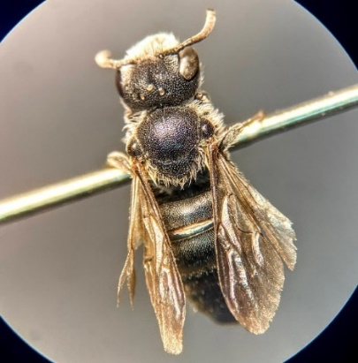

Fig. 8. Specimen glued to pin by underside.

A video that demonstrates how to glue a bee to a pin can be viewed at: <https://www.youtube.com/watch?v=9KfLCmYOKtA>

General Videos on how to mount and work with insect collections are available at: <nau.edu/Merriam-Powell/Biodiversity-Center/Museum-of-Arthropod-Biodiversity/Instructional-Videos>

# Storing Pinned Bees

Cornell drawers/cabinets are the classic insect storage solution (Fig. 9). Cornell drawers are standard sized wooden boxes (outer dimensions 48.3 x 42 x 7.7cm) with tight-fitting lids with a glass top. Insects are pinned onto foam glue to the bottom of the drawer. Alternatively, unit pinning trays (small boxes with foam on the bottom) will be used to orient and organize specimens in drawers. Cornell drawers are the highest quality storage solution and protects against infestation by pests.

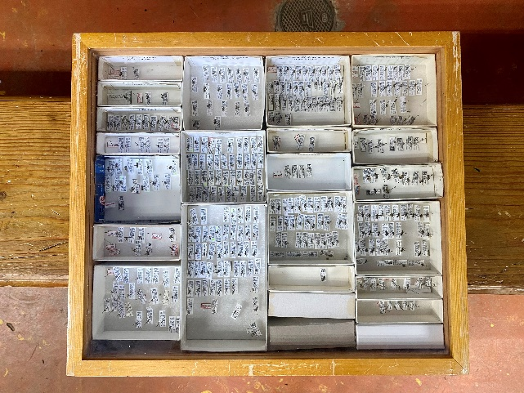

Fig. 9. Cornell-style storage drawer.

If such a professional (and expensive) storage system is excessive, there are many other solutions available. Products specifically marketed for insect storage range from a basic cardboard box with a clamshell or removable lid and foam in the bottom, to professional display cases such as Rikers displays. We’ve seen colleagues use assorted craft storage boxes to hold their bees. The basic requirement is a box with a lid and foam on the bottom to hold pinned bees.

## Pizza Bee Boxes

Because of the volume of insects collected at BIML, we have begun using pizza boxes as an inexpensive alternative to traditional field boxes. We use a pizza box with a completely detachable lid and a crosslinked polystyrene bottom to store everything except our synoptic collections. These boxes are stackable, the date and location can be written on the outside in pencil and then erased when reused (or organized with Post-it® notes), are relatively inexpensive, and, unlike hinged lid boxes, are convenient to use in cramped spaces on a desk or worktable.

|  |  |
| --- | --- |
| Advantages:  Inexpensive  Saves shelf space  Holds more specimens. | Disadvantages:  Materials have to be purchased separately and assembled  Box not as sturdy as others  Pest insects have greater access to specimens. |

Blank pizza boxes can be ordered online from many sources. Pizza shops may also be willing to donate cartons. We use crosslinked polyethylene foam for our pinning base within the boxes, as it seems to have superior pin holding properties to that of Ethafoam, but either could be used. If you order foam in bulk you will save a great deal by going directly to a local manufacturer (look under "foam" in the Yellow Pages). We have them cut the foam to 3/8-inch thickness and ship as 2-ft x 4-ft sheets. Often these manufacturers have blocks of foam that are scrap or overruns in their building, so you might ask them if any are available and have them cut that scrap into 3/8-inch pieces for you for a discount.

Cut a square of foam large enough to fit snuggly along two opposite sides but that leaves room along the other two parallel sides so the box top flaps will slide in neatly, keeping the lid edges from knocking into the specimens.

Hot glue the foam to the bottom of the box. We use low temperature glue guns but have not tested higher temperature guns to see if they melt the foam. To make sure the glue does not dry before you finish applying, glue the central third of the foam first and affix it inside the box. Then lift the sides and glue. Be sure to place a glue line close to all the edges of the foam. Use good quality glue sticks and avoid the generic types whose gluing abilities can be quite low.

# Labels

## Importance of good specimen labels

Following pinning, labels are produced for each batch of specimens. Unique specimen numbers are required for effective specimen and data management and for referencing and integrating digital data. Many beginner students have rued the day that they did not give their specimens unique numbers. Each batch or site should be assigned a unique site number and each specimen should be assigned a unique specimen number. It is important that a specimen can be moved from box to box by both the person who is conducting the ID’s and the collector of the specimen and know where the specimen originated from. Identifying specimens will go more efficiently if that is the case.

On each specimen label, the specimen number and site number should be listed, as well as the date and site. Even if the use of barcodes or data matrices are employed, there should still be some information, such as the date and site, printed on the label to ease in locating specimens. If there is only a barcode or matrix on the label, you would have to scan the label each time you want to know where the specimen originated from.

We suggest recording dates as in this example (15 SEPT, 2013) to avoid confusion with regard to international numerical date formats. Do not abbreviate the year to a 2-digit number. Capitalizing the abbreviated month name (e.g., SEPT) can improve readability and interpretation both on printed and hand-written specimen labels, ‘wet labels’, and field notes and data sheets.

In a good museum cabinet, specimens deteriorate only very slowly and can last for well over 100 years. That is not true of the paper used in making labels. Paper that is not archival or acid free gradually deteriorates. Fortunately, archival paper is readily available in office supply stores. A heavier weight paper is also important to use so that the label stands up to handling and the pinning process. A 35-pound paper is good label stock.

## Making Labels

Labels need to provide the user with, at minimum, quick access to the date, location, and specimen ID number to refer back to identification and metadata. Here we present two basic methods. If processed or semi-identified bees are being sent to us, we appreciate when the Bee Lab method is used, so that the data can easily be cataloged and shared on DiscoverLife. We will easily pull your data out of the database in return.

We recommend that both the collection event number and the specimen number be completely unique and not repeated in any of your collections. This will minimize errors where numbers are inadvertently used more than once. When experimenting with your labels we suggest you start by looking at a font size around 4 and to not use fonts that have serifs since you will be printing very tiny letters. Additionally, you will want to make sure that your printer is printing at maximum resolution (given as dpi) so that your tiny labels are as visible as possible.

### Using Discoverlife.org (Bee Lab)

BIML uses a label generating program available on the Discover Life website. Each batch or site is given a unique site number and each specimen is given a unique specimen number. On each label, the specimen number and site number are listed, as well as the country, state, county, latitude, longitude, date of collection, and collector (Fig. 10). A small data matrix is present on the label that encodes the specimen number and permits the specimen to be scanned with a hand-held scanner directly to a database while remaining in the box. For more information on creating labels with Discoverlife, contact Sam Droege ([sdroege@usgs.gov](mailto:sdroege@usgs.gov)).

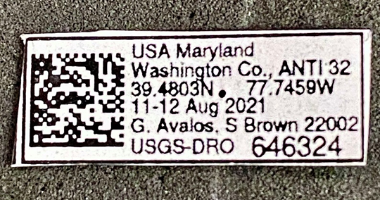

Fig. 10. Label with QR code generated via Discoverlife.org.

### Using Microsoft® Word Mail Merge

Microsoft® Word ‘Mail Merge’ feature is used by a number of groups who make their own labels to increase the efficiency of generating specimen labels. In general, the way that Mail Merge works in label making is that a Word document is created with collection information (Location, Latitude, Longitude, Date, Collector, etc.) and associated with an Excel or Access file that has numbering information. Alternatively, the Excel or Access file could have ALL the collection information, and you simply use the Word document to do the collating and printing of the labels.

It is possible to simply use features in Excel or Access to create labels, but often people are more comfortable using Word, there are many ways to do this. The numbering system used could be a single unique number for every specimen or a separate number for the collection event along with a number for individual specimens.

### In Microsoft® Word

(Contributed by Gretchen LeBuhn)

Open up a new Word document and just type the label as you want to see it, i.e.,

CALIFORNIA: Napa Co.

Rector Reservoir, 60m

3.2 km NE Yountville

38º26'13"N,122º20'57"W

17 March 2002, ex: Vicia sativa

G.LeBuhn, R.Brooks #2002001

As a numbering system, make the bees collected at a single species of plant an individual collection record. For example, bees collected on Vicia sativa at Rector Dam are collection #1 and those collected on Lupinus bicolor are collection # 2. Keep this system going or some similar system so that you can identify and talk about each collection separately each year. You can use #2002001 for this year, and then start over next year with collection #2003001, etc. The point is to adopt some system by which you can talk about any particular collection event in a multi-year study and that it has a numerical identifier.

I make a label log which I actually type directly into my database and then extract and put into Word. I cut and paste a copy of each collection event the number of times needed to label the bees in each lot. I do this in one long continuous roll. When I am finished, I put it into column format to fit more per page.

Now I have all of my labels duplicated like this:

CALIFORNIA: Napa Co.

Rector Reservoir, 60m

3.2 km NE Yountville

38º26'13"N,122º20'57"W

17 March 2002, ex: Vicia sativa

G.LeBuhn, R.Brooks #2002001

CALIFORNIA: Napa Co.

Rector Reservoir, 60m

3.2 km NE Yountville

38º26'13"N,122º20'57"W

17 March 2002, ex: Vicia sativa

G.LeBuhn, R.Brooks #2002001

CALIFORNIA: Napa Co.

Rector Reservoir, 60m

3.2 km NE Yountville

38º26'13"N,122º20'57"W

17 March 2002, ex: Vicia sativa

G.LeBuhn, R.Brooks #2002001

The above was for 3 bees collected in Collection #1. Leave a blank line between collection events to see where each collection event starts.

* Click "Edit"… select "select all".
* Click "Format"… select "Font"… type into the "Size" window the number 3 ( for 3 point font) and click okay.
* Click "Format"… select "Paragraph"… select under "Line Spacing" the word "Exactly"… under "At", select "3 pt." (this sets the leading or space between lines)
* Click "Format" … select "Columns"… under "Number of Columns" start with 8… under "Width and Spacing" set the "Space" (that is space between columns) to 0.00. Check with Print Preview, which is selected after pulling down the "File" menu. The trick here is to get the columns as close as possible to each other without any lines wrapping around. Sometimes I can get 9 columns, and other times when the label lines are longer I can only get 7 columns. 8 columns is my usual maximum column width.

You are done and can now print onto your acid free or archival, 100% linen ledger #36 white paper. Cut the labels out neatly, not leaving white around the edges, and place the labels on the specimens with the top of the label on the right with the specimen's head going away from you.

### Writing by Hand (Pen)

When writing locality or determination labels by hand, archival ink should be used. Technical pens in sizes 01 and 005 are the best and are available from art and entomological supply stores. Be sure that they state that they are using archival ink.

## Cutting Labels

Labels are oriented along the same axis as the specimen (Fig. 11). Prior to putting labels on specimens, do a quick check to make sure the label information matches the row tag.

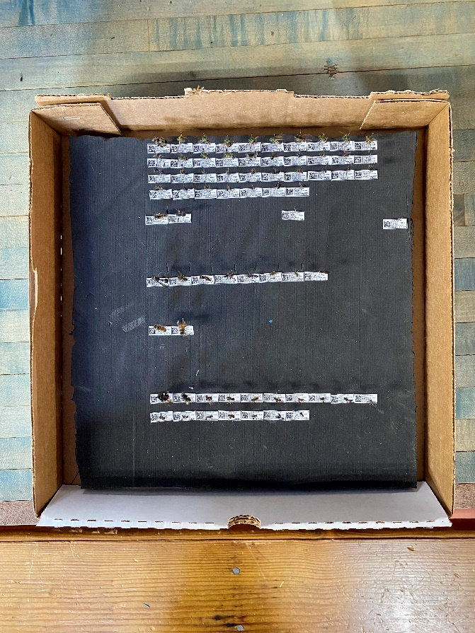

Fig. 11. Pinned and labeled specimens with head facing the QR code.

Cutting out labels can be a time-consuming aspect of any project. We speed up the process by cutting out rows of labels; placing them in their box and then cutting the individual labels apart with scissors. See:<http://www.slideshare.net/sdroege/preparing-insect-labels-a-faster-way> and<http://youtu.be/HqxrkC6xe40>. Ray Geroff uses a surgical/dissection scalpel and handle. He prefers the #4 handle with a #21 or #22 blade. It works well for cutting the strips but works really well when cutting the individual labels apart once they are in single strips.

# Pest Management

Simple cardboard boxes are not pest proof. Dermestid beetles are the primary pest of insect collections. Fortunately, infestations are usually small. An infected specimen is usually easy to spot, as small black powder and shed skins are visible below the specimen.

Control and prevention take place, according to the literature, by freezing the box at -20 C (~ 0 Fahrenheit) for three days, thawing for a day, and then freezing for another three. In a pinch, kitchen freezers appear to work too. Spring is a good time to freeze your entire collection, as that is when dermestids appear to be most active. Quarantine and freeze bees from elsewhere as well.

Mothballs and pest strips can be effective but carry some apparent health risks with long-term exposure. These methods may not protect a collection from mice. Mice tend to go after the large bees - bumble and carpenter bees.

An excellent means of keeping your collection pest free (particularly if using small cardboard boxes) is to keep each box in a large ziplock bag. You should have let the specimens dry out thoroughly after pinning (one month or so) before enclosing them in the bag. We also use large plastic bins with snap lids to deter mice.

In humid conditions (such as July and August in Maryland), unprotected specimens in non-air-conditioned spaces, particularly those just caught, can turn into balls of mold (see Cleaning Moldy Bees section previous). Either move them into an air-conditioned space or put them in plastic bags or tightly closed bins that contain active desiccants. Keeping specimens in a refrigerator or cooler without moisture control will ultimately lead to mold too.

# Cleaning Pinned Bees

## Moldy Bees

Leif Richardson has put together a method of removing most of the mold on bee specimens that have gotten moldy due to storage in high humidity conditions. Richardson writes, “First, I cut a piece of foam board (like the foam you find in a standard insect box; I got mine from BioQuip) to fit snugly in a small plastic food storage container. I wedged this into the bottom of the container, stuck pinned specimens (labels removed) into the foam, and added warm, soapy water to submerge the bees. With the top on I gently shook the container for about five minutes, then drained it and repeated. I next filled the container with 70% ethanol and shook for five minutes. I used two additional alcohol rinses, then removed the foam board from the container and used a hair dryer to dry and fluff the bees.

The bees emerged from this treatment with most of their body parts intact. Some pollen was removed from the scopae. Most of the fungus was removed, but some still clung to hairy places and the tight spaces between body segments. I think you could use a soft children's watercolor paintbrush [to scrub] away more of the fungus during one or more of the rinses. One caveat: the foam board has a tendency to break free and float, causing the specimens to get pressed up against the top of the container. I think this could easily be avoided with the right container, foam, glue, etc. Finally, the dimensions of the container will determine how many bees you can clean at one time and how much alcohol you will have to use.”

## Dirty, Dry Bees

Below is a process that is used at BIML for reconditioning old dry and dirty bees. The age of the specimen does not seem to matter and material that is decades old has been successfully reconditioned. Hair that has been matted down by nectar or internal “juices” from the insect itself may or may not be completely recoverable. In general, short sparse hair recovers more readily than long hair. Testing is best with old *Bombus* specimens as their long hair is often a challenge.

Rehydrate the specimens at least overnight (we use the inverted food container mentioned in the previous section). Take a Falcon® tube/centrifuge tube/small container and add a small amount of VERY HOT water and a drop of dishwashing detergent. Drop the specimen STILL ON THE PIN but without the labels into the tube and shake VIGOROUSLY for about a minute or two – don’t be shy about shaking, these specimens are tough. Take the specimen out and rinse under gentle running water. Quickly blot on some paper towels and drop into a tube of ACETONE (this replaces the remaining water with something that evaporates quickly and acts as a further solvent of goo, alcohol IS NOT as effective). Shake for only a few seconds. Remove and drop onto a paper towel to blot off excess acetone and immediately pick up and blow compressed air over the specimen.

Compressed air is important because you need a high speed, precise air source or the hair will remain matted. Be aware that while you can use quite a strong air flow the wings are quite fragile and the tips will readily shred if the air passes directly over them, thus you will want to work on your technique with a few expendable specimens initially. We set the air flow to a moderate rate and hold the specimen directly in front of the compressed air nozzle, holding the specimen (still on the pin) with our fingers. In this way air can be precisely directed onto the specimen without impacting the wings (which we will often hold together with our fingers).

Depending on the specimen, a pin or tiny brush can help serve to un-clump unruly hair during the process. Photographically, this also has the advantage of darkening the eye and making for a better-looking picture, if taken right away.

There are now many ways to take incredibly detailed pictures of bees using stacking software and either dedicated commercial systems or high quality camera equipment (see:<http://www.youtube.com/watch?v=4c15neFttoU>). Such techniques reveal minute structural details of bees, but also reveal hair matting, dust, and clumps of pollen that can detract from the specimen - hence, post processing tidying up.

# Organizing Specimens for Identification

After the specimens are labeled and those labels checked against the original row labels in the box, the specimens can be freely moved about for identification. We can pick up any specimen and very quickly find all its meta-data. This saves time by allowing us to morpho-sort entire projects and efficiently identify all of a group at a time rather than try to work through each sampling event individually.

When identifying specimens, we make a first pass through the box without using a guide. First we will scan the box and sort out characters by sight (e.g., pulling out honeybees, bumblebees, green bees etc. as one feels comfortable). Following that initial pass, we do it again running the specimens quickly under the microscope and refining the sorting.

As new species are detected, a determination label is created (available as a modifiable Microsoft Excel file from [clare_maffei@fws.gov](mailto:clare_maffei@fws.gov)). The determination label is pinned to the board separately from the specimens, so that it can be easily viewed when entering the data. All subsequent specimens of that genus/morpho-species/species are then placed to the right of the label.

Bees that cannot be immediately identified are kept separate and identified at the end using computer and paper guides. If you have a large number of unidentified species, then morpho-sorting them to species or species groups is a big timesaver. In general, it is best not to struggle with the identification of any individual specimen; instead, set it aside and return to it after you have looked at the other specimens and much of the time you will find that the identification of that specimen was partially resolved by looking at the other specimens.

Within a box, bees are placed in the box in loose rows starting at the upper left corner, and going from left to right, top to bottom with determination labels interspersed at the beginning of a new group of species. Females are placed so their label is positioned vertically (within the box), while males are positioned so that their labels are horizontal (Fig. 12). Positioning the sexes this way permits those who enter the data to quickly ascertain the sex without having to check the label and saves time for the person who has to do the original labeling.

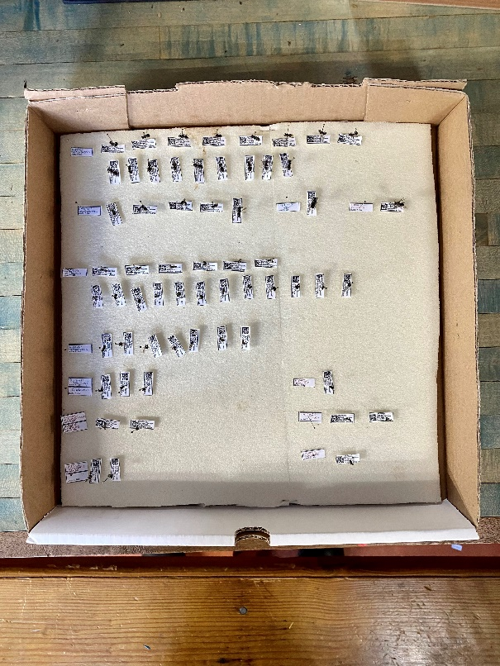

Fig. 12. Sorted specimens with labels oriented according to sex.

## Stylopized Bees

As you identify bees you will, at times, come across bees that have an infestation of mites and more rarely bees that have been parasitized (i.e., stylopized) by a strepsipteran (Fig. 13). The Order Strepsiptera is a mysterious taxon of unclear position within the holometabolous insects. They are endoparasites of various other insect orders including a diverse array of Hymenoptera. Families Andrenidae, Halictidae, and Colletidae are the most frequently parasitized bees.

One can find male puparia (MP), empty male puparia (EMP) and adult females (F) in bees. MP are usually very large spherical extrusions, however findings of these are quite rare. More frequently you can find EMP, these are sometimes hidden and difficult to recognize. In some cases, EMP appears as an obvious deformation. Female cephalothoraces are most commonly encountered in bees and appear as small orange/brown plate-like extrusions that emerge from beneath the rim of the tergites of the abdomen (Fig. 14). Upon seeing one you will have the impression of a small head peeking out from beneath the rim. Sometimes the apical rim of the tergite covers most of the parasite's body (in most Halictidae) and will appear almost invisible from the dorsal view. However, the rim of the tergite is usually lifted upwards and the strepsipteran can be viewed when looking under the rim.

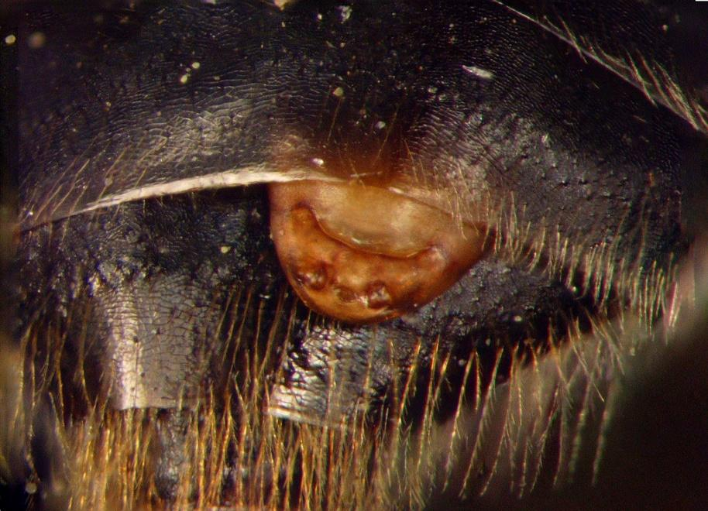

Fig. 13. Stylopized *Andrena vicina*; The female strepsipteran cephalothorax is the pale rounded extrusion poking out between the tergites. (Photographed by Ellen Bulger)

Strepsipterans can modify not just the morphological features of the site where they are attached, but the morphological characteristics of the entire bee, including the sexual characters of bees. At times the characteristics of the bee are changed enough to partially disguise the species identity of the specimen. Deformations occur among all bee hosts, but they are quite rare. Sexual character changes are manipulated by the parasites and occur only in some groups – most bees of the family Andrenidae and some *Hylaeus* (Colletidae).

Jakub Straka, a researcher from the Czech Republic, is working on the taxonomic and ecological facets of Strepsiptera. He is very interested in collecting host records for this group, parasitism rates, and specimens for DNA analysis. If you come across any stylopized specimens in your collecting activities, please contact Jakub ([straka-jakub@vol.cz](mailto:straka-jakub@vol.cz)). This group occurs uncommonly, so even single records are of great interest.

# Microscopes

When using bowls or nets, it is easy to quickly amass a large collection of bee specimens. Unfortunately, unlike most butterflies, bees (even the bumble bees) need to be viewed under a stereo or dissecting microscope to see the small features that differentiate among the species. While even inexpensive microscopes and lights can be of some use, in the long run they lead to frustration. Inexpensive microscopes usually have poor optics, very low power, small fields of view, are difficult to set to fixed heights, and their stands are usually lightweight and often designed in such a way that makes specimens difficult to manipulate.

## Purchasing

Unfortunately, a good microscope is not cheap. New, our experience is that an adequate microscope costs over $1000, and good ones run over $2000. That said, microscopes with even moderate care are a one-time investment. There are many used microscope sites; we have purchased microscopes from several of them, and if there was a problem, it was fixed free of cost. Usually, used prices are about half the cost of new. There are many reliable microscope brands on the market.

When purchasing a microscope, new or used. Here is what you should look for:

* Heavyweight base: Will ensure balance even when the microscope is fully extended and not topple with the addition of lighting.
* Working distance (distance between specimens and the objective lens): This will ensure that while you manipulate your specimens you have plenty of space to bring them in and out of focus without fussing too much with the height of the microscope
* Magnification: Minimum maximum of 30x, preferable max of 60x.
* Adjustable and removable oculars: Important for individualized settings to accommodate vision differences, to facilitate cleaning, the addition of reticles, or to increase maximum magnification.
* Zoom nob placement: recommend a side nob for easiest use
* Field of view: 20mm at 10x magnification or wider.
* Customer Service: Returns, repairs, or adjustments available? Important to know before shipping.

### Magnification

Magnification is determined by multiplying the magnification of the eyepiece lens (AKA ocular) by the magnification level that is listed on the zoom knob. The ocular magnification is written on the rim - it is most commonly 10X. Some manufacturers list the zoom levels multiplied out with the assumption that you are using 10X oculars. However, it is a simple matter to increase the magnification by purchasing a higher power set of ocular pieces. Oculars simply slide into tubes on top of the scope and are readily removed.

Any adequate to good scope will have variable power settings. A useful scope should be able to go from about 5x - 60X power with or without secondary ocular. Most higher-end microscopes come with a continuous zoom magnification. In some scopes, powers are available only in steps, though viewing in increments is not any major hindrance.

### Measuring Reticle

Some microscopes come with a measuring reticle in one of the oculars, but most do not. A measuring reticle is a very small ruler etched into a piece of glass. These are useful for taking precise measurements or, more often the case, taking relative measurements.

This piece of glass is inserted into the bottom side of one ocular. Almost all oculars are built in a way that they can be taken apart for cleaning. Often there is a threaded tube inside the body of the ocular that holds the lenses in place. Measuring reticles can be ordered online. You can also order oculars that have the reticle built in that can be switched out when measuring. For simple measurements of total body length, it is easier just to have a ruler handy that you can lay your specimen next to.

## Using the Microscope

### Holding Specimens and General Microscope Setup

Most people, when viewing specimens under the microscope, place them on a piece of clay, foam, cork, or some sort of stand. We avoid this, as it is far faster to view specimens when held in the hands of the observer. To hold specimens, pick up the head of the pin using the thumb and forefinger of your dominant hand. This allows you to easily spin the specimen around the axis of the pin. The point of the pin is then either lightly pressed against the middle or forefinger of the other hand or held between the thumb and forefinger allowing you full 360-degree rotation.

It is important to place the bottom sides of your hands on the base of the microscope; this stabilizes one’s hand so the specimen is held steadily even under high magnification. With hands in place, the specimen can be quickly and efficiently rotated in all directions while the observer looks into the microscope. To take full advantage of this, the focal plane of the microscope should be raised such that the specimen is roughly in focus (usually about 3 inches above the base of the microscope), when the hands are in place. Once this focus is set on the microscope, it does not need to be moved again, as any change in focus is accomplished by moving the specimen rather than moving the focus knob. If the magnification level needs to be changed, the hand holding the head of the pin can retain the specimen while the other hand changes the magnification without having the eyes leave the oculars.

The final part of microscope setup is to adjust your chair or the table holding the microscope such that you do not have to bend or strain your body to look into the microscope.

Acknowledgements: John Ascher, Harold Ikerd, Gretchen LeBuhn, Jack Neff, and Karen Wetherill provided valuable additions to this section.

### Lighting

Optimal microscope lighting is a matter of personal preference. A variety of lighting options exist:

* Some microscopes come with a light attached to the stand. We find these limiting.
* Ring lights attached around the objective are another solution. These are usually LED and many are dimmable and/or offer different degrees of warmth of light. A common complaint with ring lights is that they can create distracting glare.
* External lighting gives the most control. Purchasing from a microscope manufacturer, you will find LED dual gooseneck illuminators. There are also small LED gooseneck reading lamps that will perform the function just as well. (Ikea’s NÄVLINGE and JANSJÖ lamps are used in the lab, but do cast warm). The advantage of external gooseneck lighting is that it is fully adjustable and dual light sources will help manage glare and improve the ability to detect fine texture.

All lighting can create glare depending on the bee and the position of the lighting. Metallic bees are obviously more susceptible to challenging reflection. You can diffuse light by placing tissue paper or similar over the bulbs. A combination of lighting solutions can be useful for photography.

### Taking Photographs

There are two main ways you can photograph through a microscope. If budget allows, there are trinocular microscopes available for purchase specifically designed for photography. These will have a third eyepiece that has a camera attached or has adapters available to connect a DSLR.

However, there are adjustable mounts that allow one to take photographs with a cell phone through the regular binocular microscope. These adapters simply clip to the ocular and adjust the x, y, and z axes until the image focuses. These are sufficient for most needs in snapping shots of particular characteristics.

Using diffused light sources and simple photo editing apps can create crisp photographs adequate for most purposes.

#### Specimen Manipulators

These are primarily useful for taking photographs or videos through the microscope. You can purchase a specimen manipulator or make your own. You want something that will allow easy positioning and will keep the specimen stable once placed. Keep in mind that the size of the manipulator should not interfere with your lighting. Ultimately, clay or foam does just as well for keeping a specimen in place.

#### (DIY) Ping Pong Ball/Plaster of Paris Specimen Holder

(Contributed by Gary Alpert) – You place the plaster-filled ping pong ball in a large heavy washer of some sort and like a trackball you can swivel it around to get the best look at your bee. This inexpensive solution has been vetted by several users.

General steps:

1. Buy a ping pong ball.
2. Drill a small hole in said ball.
3. Mix a fairly liquid batch of plaster of paris.
4. Quickly transfer plaster into the ping pong ball using a syringe or eye dropper.
5. Wash equipment immediately.
6. Wait for the ping pong ball to dry.
7. Drill a small hole in plaster.
8. Plug hole with clay.
9. Optional: paint gray.
10. Set the ball in a washer.
11. Put the specimen in clay.
12. Pivot as desired.

## Adjusting, Cleaning, and Storing Microscopes

Most good scopes are fairly sturdy and don’t go out of adjustment without suffering some sort of blow. In our experience, we have come across two primary adjustment issues: the oculars don’t focus in the same plane, or the images the oculars are processing are out of alignment. If the images do not completely align no matter how much you play with the width of adjustment of the eyepieces, the scope probably has significant problems and will have to be repaired professionally.

Differential focus is usually something you can fix. Small differences in the focal distance of the oculars can be accommodated by your eyes, but at some point, the eyestrain will become apparent and uncomfortable. In most scopes, one or both of the tubes that the oculars slide into are adjustable. These focusing eyepieces are easy to determine as there are zero, plus, minus, and tick marks to align.

To adjust the focus so that both eyepieces are in the same focal plane, place a piece of graph paper or something similar on the base of the scope and shine a good light on it. Adjust eyepieces to zero. If there is one eyepiece that is fixed, then open that eye and close the other. Change the focus of the microscope so that the grid is in sharp focus. Now close that eye and open the other. If the grid is not in alignment, then adjust the focus of that eyepiece until it is.

If, as it sometimes happens, after adjusting in both directions you still cannot get the eyepiece in focus, try sliding the eyepiece(s) up slightly using the same focusing method above. If the microscope has set screws, you can use them to fix the height; if not, you will have to work out some other mechanical means.

Usually, however, such an extreme situation indicates that something is generally wrong with the scope or the oculars. You might check the oculars to see if a lens is loose or if you have mismatched oculars from some other scope.

The objective lens of a microscope almost never needs to be cleaned. However, the top lenses of the oculars often do. Use lens paper and window cleaner as needed. When the scope is not in use, put a microscope cover or a large baggie over both ocular lenses to keep the dust out.

# Entering Specimen Data

In the system that we use, each specimen has a scannable data matrix on its label. Data entry consists of scanning each specimen directly from the box into a Microsoft Access database. The scanner has a feature that sends a linefeed character at the end of scanning in the number, thus moving the cursor down one line to the next cell where the next specimen can be scanned … and so forth until that species is completely entered.

Access has a nice feature that permits default values for database fields. Thus, genus and species field defaults can be set to the current species being processed, and as the scanner enters a number and drops down a line, the data for the other fields are automatically entered. Data entry becomes simply as a matter of pulling the scanner trigger and periodically resetting species and sex information either by hand or by changing the defaults. Access has another nice feature that sets off an alarm or sound if a number is entered twice – something that can easily happen in a crowded box of specimens.

After the data are entered by one person, another person cross-checks the specimens with the database entries. After that final check, pins with tiny squares of colored paper are interspersed into the box designate which bees should be dispersed to final resting spots in museums, sent to other colleagues, or their pins are recycled for reuse.

# Shipping

Shipping bees is simple. We use the US Postal Service, but you may opt for other carriers. The instructions remain the same. Pay close attention to shipping immersed specimens - shipping alcohol has restrictions and in any case, liquid storage will inevitably leak. The other important things about shipping are to keep un-prepared specimens in the freezer until the last moment before shipping to prevent rotting; and to notify the Bee Lab - or whomever you ship to - to be expecting the specimens.

## Pinned Bees

The box you ship bees in should have the specimens firmly pinned into the foam so that they do not come loose during shipping and destroy other specimens. Cut a piece of cardboard that will fit snuggly inside of the box and rest that cardboard on top of the specimens. (Do not use foam for this layer as it can engulf the tops of the pins and cause problems when removed.) Place empty pins in all four corners of the box to support the cardboard. Some people will also pin loose cotton wadding in the corners of the box so that if a specimen comes loose, it will be trapped by the cotton.

Two pieces of tape can be affixed to the top of the cardboard in such a way as to form handles that will help remove the cardboard without upsetting the specimens below. Simply press one end of the tape to the cardboard and then fold the other end back on itself so the sticky sides meet. If there is space between the top of the cardboard and the lid of the box, put in some bubble wrap or packing peanuts there, so that when the lid is closed it slightly compresses the cardboard to the tops of the pins keeping them in place during travel. Tape or rubber band the lid of the box closed.

Put the box of specimens into a larger box with at least 2 inches of free space on all sides. Fill the box with packing peanuts, bubble wrap, etc. and ship. In the United States, we have found parcel post to work fine, albeit not as fast as Fed Ex or UPS. For valuable specimens, all companies provide tracking and confirmation of receipt services.

## Immersed Bees

If the lab is preparing immersed bees (cleaning, drying, pinning, labeling…), before shipping the following procedure needs to be followed.

Immediately prior to shipping, drain the liquid while retaining the damp specimens in the bag. Remember that if the bees are stored in alcohol, the alcohol should be disposed of properly and not poured down the sink. Be careful when draining to not lose the smaller specimens. Use a brine shrimp net or tea strainer to catch any specimens that might accidentally come out with the drained liquid.

Press the remaining air out of the bag and if using a Whirl-Pak bag, roll the wire top down until you reach the bolus of specimens collected together in the bottom of the bag, at which point you will take the free ends of the wires and twist them together. That twisted section of wire should then be tucked in towards the bag to minimize the wire ends poking holes in other bags.

Once the bags are drained and prepared they should remain in the freezer until the actual shipping moment to minimize drying out and rotting. Prior to shipping, the bags of specimens should be placed inside another larger Ziploc bag that also contains a paper towel to soak up any possible leaking liquids. That Ziploc bag should then be placed in another Ziploc bag just to be sure that any spilled liquids are contained.

If there are only a few specimens to be mailed then the specimens can be placed in a padded envelope for shipping to save costs. If there are a large number they should go into an appropriately sized cardboard box and any open space not filled with specimens or specimen bags should be filled with packing material to minimize jostling.

## Hand-netted Bees

To prepare hand-netted specimens, follow the same instructions as for immersed specimens, ignoring the irrelevant guidance about liquids.

## International shipping

International shipping of insects has a more complex process than can be covered here. Any wild animal, alive or dead, must be filed with the U.S. Fish and Wildlife Office of Law Enforcement.

https://www.fws.gov/program/office-of-law-enforcement/information-importers-exporters

Following is an excerpt of the filing instructions which emphasizes the critical nature of this process:

*Filing instructions for Electronic Declaration (eDecs) for Importation of Fish or Wildlife.*

*Failure to file a declaration for importation or exportation of fish or wildlife when required by the regulations in 50 CFR Part 14 is a violation of the Endangered Species Act of 1973 as amended (16 U.S.C. 1531 et. seq.). Regulations concerning the importation and exportation of wildlife may be found in 50 CFR Part 14. Form 3-177 must be filed with the appropriate wildlife inspection office, U.S. Customs and Border Protection office or regional law enforcement office as required under 50 CFR Part 14.*

## Receiving shipped bees

It is good practice to quarantine any bees that you have received. It is recommended to freeze the entire collection for 3-7 days to kill off any dermestids or other pests that may have contaminated the specimens.

# Specimen Donations and Income Taxes (United States, as of 2015)

Doug Yanega nicely researched the following advice to the United State collector who wishes to donate specimens to museums and write-off those donations on their income taxes. If your specimen donation is above $5000, you evidently must have a certified appraisal performed. Below that amount, you must demonstrate "fair market value" from an independent pricing guide – and, to my knowledge, there is only one such guide that lists miscellaneous insects, and the price there is a flat $5.00 per specimen. If you go to<http://www.bioquipbugs.com/Search/WebCatalog.asp?category=1110>, you will see the catalog listings for Hymenoptera, and if you click on any of the bee families, you will see that the minimum price for any bee (identified or unidentified) is $5.00 per specimen. Note that BioQuip recently closed (March 2022) and the website may not remain active. If you know of other similar references, please share with the BeeMonitoring ListServ and Sam Droege ([sdroege@usgs.gov](mailto:sdroege@usgs.gov)).

# Bee Inventory, Monitoring, and ID Discussion Group and Announcements

If you are interested in bee monitoring or identification issues, you might want to sign up for the bee monitoring listserv. It is a good way to alert you to interesting developments. Email Sam Droege ([sdroege@usgs.gov](mailto:sdroege@usgs.gov)) to sign up. Archives can be read at: <http://tech.groups.yahoo.com/group/beemonitoring/>

If you are interested in learning how to identify bees, you might want to sign up for the Bee ID Weekly classes hosted by BIML. Email Clare Maffei ([clare_maffei@fws.gov](mailto:clare_maffei@fws.gov)) to sign up. Archives can be watched at: <http://bio2.elmira.edu/fieldbio/beemovies/index.html>

# Appendix

## Theodore Mitchell’s Guide: Bees of the Eastern United States

While published in 1960 and 1962, Theodore Mitchell’s 2-volume set on *Bees of the Eastern United States* is still a very valuable reference book and source for identification keys, illustrations, and species accounts. These two volumes are now quite expensive to purchase via rare book dealers, however they are available for free as a series of PDF files from the Insect Museum, Department of Entomology, North Carolina State University. They can be accessed at:

<http://www.cals.ncsu.edu/entomology/museum/easternBees.php>

Additionally, Glenn Hall scanned the indices. They can be accessed at:

[http://xa.yimg.com/kq/groups/17598545/896478426/name/Mitchell index.pdf](http://xa.yimg.com/kq/groups/17598545/896478426/name/Mitchell%20index.pdf)

Note that Mitchell’s taxonomy is out of date. All identifications made with this book should be cross-referenced against the list of bees of North America available at [www.discoverlife.org](http://www.discoverlife.org/) and within the bee identifications guides located at that same site. You can cross-reference names for synonymy by either going to one of the genera guides directly or, better, going to the world bee checklist home page of Discover Life (<http://www.discoverlife.org/mp/20q?guide=Apoidea_species&flags=HAS:>). The world checklist of bees can be filtered by country, genus, subgenus, family, and subfamily and has been put together by John Ascher and John Pickering. To locate synonymies go to the “**Checklist**” link in the blue banner at the top of the page and then use your browser’s “find” function to locate synonymies, note that the checklist always shows all of the species around the world and is unaffected by any of the filters that you may have applied at an earlier stage.

## Mike Arduser’s Midwest Keys

Mike Arduser has been creating keys to the genera of bees from the Midwest. Those can be viewed at:

<http://www.pwrc.usgs.gov/nativebees/Keys.html>

## Canadian Identification Guides

Laurence Packer’s Lab has produced a guide to “The Bee Genera of Eastern Canada”:

<http://www.biology.ualberta.ca/bsc/ejournal/pgs_03/pgs_03.html>

They also have a “Key to the Bee Families of the World”:

<http://www.yorku.ca/bugsrus/BFoW/Images/Introduction/Introduction.html>

And an image database of the “Bees of Canada”:

<http://www.yorku.ca/bugsrus/bee_canada/Bee_Genera_Canada.html>

And a pictorial catalog of the “Bee Tribes of the World”:

<http://www.yorku.ca/bugsrus/bee_genera_of_the_world/Bee_Tribes.html>

## A Guide to Identifying Bees Using the Discover Life Bee Keys

Discover Life keys cover all the bee species in North America east of the Mississippi; coverage extends to all of North America for some genera, with the objective of covering the entire region eventually. All of the bees in the Caribbean, Mexico, United States, Canada, and the British Isles are covered in the genus identification guide.

he section below provides guidance for the use of online Discover Life guides or keys. These instructions are designed for use with the guides to the genera and species of bees, however, these instructions will largely hold true for any of the non-bee guides also available at the site. Be sure to also see the section at the end regarding the use of already identified specimens. A set of identified specimens that you can practice with can be obtained at no charge from Sam Droege ([sdroege@usgs.gov](mailto:sdroege@usgs.gov)). Note, that using already identified specimens is the best way to learn how to identify bees.

All of the Nature Guides are located at:

<http://www.discoverlife.org/mp/20q>

However, the consolidated links to the bee guides and associated materials are located at:

<http://www.discoverlife.org/mp/20q?search=Apoidea>

**Hint:** If you are just beginning to learn how to identify bees we suggest that you look at the glossary of terms, vocabulary, identification tips, and pronunciation materials that we have in this manual.

Discover Life guides differ from traditional dichotomous keys in that characters that help differentiate species are evaluated and scored for all or almost all of the species. Think of it as a matrix, with species as rows and character states as columns. That matrix is employed by answering questions regarding the presence or absence of characters for a specimen. As questions are answered the list of possible species is narrowed until, in most cases, the list resolves to a single name.

On the bee page at Discover Life, there are a series of guides listed for **Eastern North American** bees (states and provinces east of the Mississippi River). Many of these guides have been expanded to include Western species and over the coming years we will expand all guides to include the western states and provinces. Guides are constantly being updated with pictures, corrections, and better wording.

Most guides deal with a single genus of bees. If there are a large number of species present, these guides are often divided into two guides, one for each sex, as characters useful for identifying species are often gender specific.

**Hint:** If you are unfamiliar with the bee genera we suggest that you start your identification process by using the guide to bee genera to divide your collection into genera.

The instructions that follow apply equally to the bee genera guide or to each individual bee genus guide.

Each guide has questions on the right, a species list on the left, and navigation tools across the top. The list of species and the list of questions interact with each other. Answering any question (**in any order**) narrows the list of candidate species, when any “**search**” button is clicked. Similarly, one can flip the process, by clicking the “**simplify**” button, and have the computer narrow the set of questions based on the species that remain on the list.

Clicking on any pictures present within the guide will display an enlarged or version of the picture. Many species names can also be clicked on to reveal species specific pictures and often have associated text material on the nature history or identification of that species.

**Hint:** Answer ANY NUMBER of questions IN ANY ORDER. You do not need to answer all questions. Initially answer ONLY questions where you are certain about your answer.

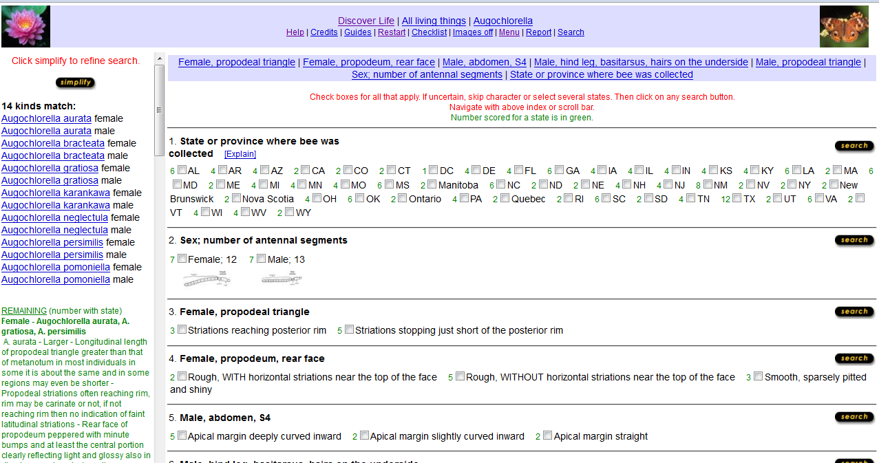

The **initial page** presents a subset of all the questions in the guide. These questions are both easiest to understand and most likely to separate out large numbers of species.

There is no need to answer the questions in the order presented.

At least initially, you will find that there are some questions that are clearer in your mind than others. These should be answered first.

Leave questions you are unsure of blank! Don’t guess!

We recommend that you spend more time reading and learning about the morphological characters in the questions before providing your answer, or simply skipping the question.

Not all characters will have been scored for all species. If both sexes are present in a guide then characters that only apply to one sex will obviously not be scored for the other sex. Similarly, if we have been unable to obtain a specimen of a rare species, we may not be able to score some characteristics from the available literature. The consequence of this is that any species that has not been scored for a particular question will remain on the list of possible candidate species, regardless of whether it actually has that character or not, simply because it cannot be eliminated from the list of possibilities.

**Hint:** While using a guide, there are two types of species that remain on the list: 1) Those species that have the characters you have indicated, and 2) Those species that have not been scored for some or all of the characters you chose in your answer. The second type of species will stay in the list simply because we do not have enough information about its characters to eliminate it.

**Hint:** For many characters, you are given three or more choices of states. If you are not sure which of the states your specimen’s character fits into, don’t hesitate to click on all possible correct combinations rather than trying to narrow it to the one that best fits.

At any point you can press any of the “**search**” buttons that are located throughout the page. Doing so will update the species list on the left based on the characters you have chosen.

At any point you can also click on the “**simplify**” button that appears in the left hand column above the species list. Doing so eliminates both questions and states within questions that do not help resolve the identity of the species remaining on the list. Clicking this button also adds those appropriate questions that were not included in the initial list of questions present when the guide was first opened. Additionally, hitting the “**simplify**” key will also reorder the questions alphabetically.

Both the “**search**” and “**simplify**” buttons can be clicked as often as you wish. We usually click on the “**search**” button after answering a question, just to get a sense of the questions that best help eliminate species the quickest and to make sure that we haven’t made some fatal error. We suggest waiting to click on the “**simplify**” button until you have a reasonably small list of species left or have answered most of the questions you are comfortable with on the first page. If you hit the “simplify” button earlier in the process it will bring up a potentially very large list of additional questions that may not be as useful or as easy to use as the initial ones.

Strategy – Especially when you are unfamiliar with the species within a genus, it is very useful to take some extra time to double-check your initial identification. In many cases, there will be pictures and extra information stored as a link to the species name. Those can be compared to your specimen (be aware that males and females often look quite different from one another).

The next step to verifying your species identification is to compare your specimen to the complete list of the scored characteristics of that species. To get a list of those characteristics, click on the “**Menu**” link at the very top of the page. At the top of the left hand column, click on the “**characters**” option. Next, click on the species you wish to review. Finally, hit the “**submit**” button to get a list of scored characteristics.

One nice feature of the Discover Life guides is that there are many paths to the final answer of correct species identification. This feature can be exploited when checking your identifications. By hitting the “**simplify**” button at the very beginning, you will display ALL the questions for the guides. By answering a different set of initial questions, a different species will remain on the list. These new questions and species may expose some flaw in your initial identification that will become obvious if you don’t return to the same species identification at the end.

**Hint:** These guides are easier to use than dichotomous keys. However, answering questions incorrectly will still yield WRONG IDENTIFICATIONS, so be careful and conservative in your answering.

The “**Restart**” link, located at the top of the page in the header, restarts the guide at the beginning.

Advanced Uses of These Guides *–* B y pressing the ”**Menu**” link at the top of the page, the simple species list found normally in the left hand column is replaced with a set of new options used by individuals building or editing guides. Some of these features are also useful when exploring the identity of a species. Don’t worry about exploring any of the features found in the “**Menu**” page, as only the guide developers have permission to make permanent changes.

The “**characters**” option will give you the scored characters for any of the species you have checked.

The “**differences**” option will give you the differences in scoring among any two or more species you click.

Clicking the “**has**” key restarts the guide but brings up ALL the characters for that guide in alphabetical order. Additionally, a new set of 2-3 buttons has been added at the top of each characters section; the “**only**”, “**has**”, and “**not**” buttons (sometimes the “**not**” button may be turned off). If you don’t click any of these 3 buttons the guide acts as it normally does. If, however, you click on the “**has**” button along with one of the character states … hitting the “**search**” button will generate a list of species on the left that will include only those species that have been scored as having that character. What will be missing are those species that were never scored for that character at all. Similarly the “**only**” button provides a list of species that have been scored for that character alone. This means that if a species was scored as possibly having all or more than one of the possible states, it will not be displayed if the “**only**” button was clicked. The “**not**” button provides a list of species have not been scored for the selected character state(s).

The Discover Life website also has a “**Help**” link, which takes you to even more details on some of the more advanced features.

If you have questions about any of the bee guides please contact Sam Droege at [sdroege@usgs.gov](mailto:sdroege@usgs.gov) or 301.497.5840. Sam’s lab is open to anyone who would like to come learn to process and identify their collection of bees. Most of the time we have space, computers, and microscopes available as well as access to our synoptic collection.

**Final Hint:** If you find any errors or can think of a better way to do anything with these guides, please contact Sam.

Using Previously Identified Specimens as an Aid in Learning Your Bees – When first starting out, you will learn how to identify bees far more quickly if you use pre-identified specimens than if you try to immediately key out the bees you have collected. Because you already know the identity of the specimen, you can track your progress and reflect on your errors while using the guide and the mind/eye/guide learning loop will take place more quickly. If you use unidentified specimens, you may find it difficult to initially feel 100% confident that your identification was correct.

There are two ways to approach the situation. One is to use the guides directly. After selecting each state of each character you believe your specimen expresses from the selections available on the computer screen, click the search button. You can then watch the list of matching specimens on the left side of the screen to see if your species or genus remains on the list. If it does not, you know which state of which character you entered that led to the incorrect match.

Alternatively, you can go to the “**Menu**” section of the guide and call up the entire list of scored states/characters of the species or genus you have on hand. Once you are in the “**Menu**” section, you click the radio button next to “**score**”, then click the box next to the species you want to investigate, and finally click the “**submit**” button. All the information for that species will appear onscreen and you can compare every scored character in the guide to the characters you see on your specimen, thus familiarizing yourself will all the characters in the guide. You will also find that you can “see” certain characters easily and others may remain difficult for you to interpret or find, thus helping you decide which characters you will preferentially use when keying out that group.

Feel free to contact Sam Droege for a set of free identified specimens that you can keep and use.

Worldwide Checklist of Bees and Bee Synonymies

A list of the bee species of the world that lets you sort them by country, various taxonomic units, and some life history traits is available from John Asher and John Pickering at:

<http://www.discoverlife.org/mp/20q?guide=Apoidea_species&flags=HAS:>

A list of all the known synonymies for each of the species is similarly available at:

<http://www.discoverlife.org/mp/20q?act=x_checklist&guide=Apoidea_species>

**Acknowledgements:** - Many thanks to Liz Sellers for the many helpful edits to this section.

## Stylopized Bees

As you identify bees you will, at times, come across bees that have an infestation of mites and more rarely bees that have been parasitized (i.e., stylopized) by a strepsipteran. The Order Strepsiptera is a mysterious taxon of unclear position within the holometabolous insects. They are endoparasites of various other insect orders including a diverse array of Hymenoptera. Families Andrenidae, Halictidae, and Colletidae are the most frequently parasitized bees.

One can find male puparia (MP), empty male puparia (EMP) and adult females (F) in bees. MP are usually very large spherical extrusions, however findings of these are quite rare. More frequently you can find EMP, these are sometimes hidden and difficult to recognize. In some cases, EMP appears as an obvious deformation. Female cephalothoraces are most commonly encountered in bees and appear as small orange/brown plate-like extrusions that emerge from beneath the rim of the tergites of the abdomen (see figure below). Upon seeing one you will have the impression of a small head peeking out from beneath the rim. Sometimes the apical rim of the tergite covers most of the parasite's body (in most Halictidae) and will appear almost invisible from the dorsal view. However, the rim of the tergite is usually lifted upwards and the strepsipteran can be viewed when looking under the rim.

Strepsipterans can modify not just the morphological features of the site where they are attached, but the morphological characteristics of the entire bee, including the sexual characters of bees. At times the characteristics of the bee are changed enough to partially disguise the species identity of the specimen. Deformations occur among all bee hosts, but they are quite rare. Sexual character changes are manipulated by the parasites and occur only in some groups – most bees of the family Andrenidae and some *Hylaeus* (Colletidae).

Jakub Straka, a researcher from the Czech Republic, is working on the taxonomic and ecological facets of Strepsiptera. He is very interested in collecting host records for this group, parasitism rates, and specimens for DNA analysis. If you come across any stylopized specimens in your collecting activities, please contact Jakub ([straka-jakub@vol.cz](mailto:straka-jakub@vol.cz)). This group occurs uncommonly, so even single records are of great interest.

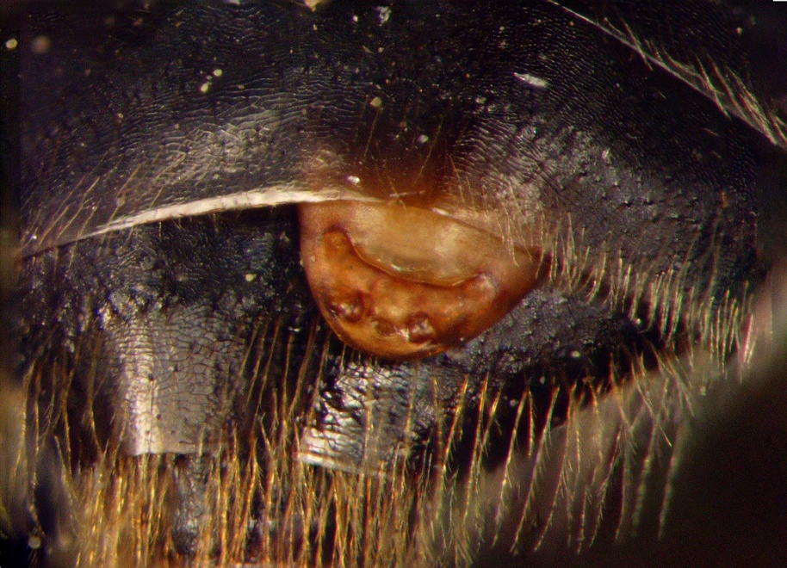

**Stylopized *Andrena vicina* – The female strepsipteran cephalothorax is the pale rounded extrusion poking out between the tergites.** (Photographed by Ellen Bulger)

## **Affixing bee wings to microscope slides** – (Contributed by Tulay Yilmaz and Gökce Ayan)

Materials:

* Entellan® fixative or mounting media
* Slide
* Tweezers
* Brush, or glass rod (the glass rod is easier to clean afterwards)
* Petri dishes with warm water
* Microscope
* Pin
* Desk lamp with an incandescent bulb (not a fluorescent one)
* Something to put the wings on while the wings dry under the light’s heat

Procedure:

* Place the slide on a white piece of paper for easy visibility.
* Put some warm water into the Petri dish.
* Turn on the lamp and leave until it’s hot.
* Take the bee’s wing with the tweezers.
* Place the wing into the warm water; wait for a while to get it as smooth as possible.
* Remove the wing from the water and put it onto the drying surface (be sure the wing stays flat).
* Leave it under the light to dry.
* Remove when dried.
* With that glass rod, drip some Entellan onto the slide and spread it.
* Hold the wing with the tweezers and gently put it onto the surface of the Entellan (be careful about putting it on the right way).
* Don’t use a coverslip!
* Then look at the preparation under the microscope.
* If you see any air bubbles under the wing, press them out with the help of the head of a pin (not with the pointed part of it), and pop them (with the pointed part) once you manage to bring them out from under the wing.
* Now, leave it in a closed box so it's not affected by dirt and dust floating in the air. Entellan is really sticky and readily picks up dust when you leave the preparation in the open air.
* Clean your glass rod immediately (because when Entellan hardens, it gets difficult to clean).
* Preparations can be used when Entellan is dry (usually within an hour).

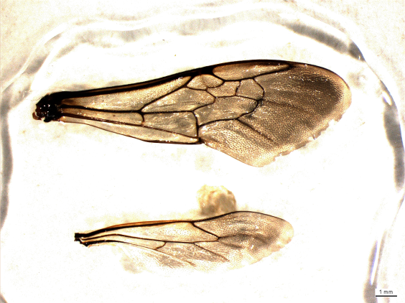

**Bee Wings in Entellan on a Microscope Slide**

Such preparations are faster and more practical than other slide preparations we have used and the slides keep for a long time. We have found the slides to be usable one or two years later and they may last much longer.

Do your preparation in a well-ventilated area as the solvents in Entellan can give you a headache.

While preparing the wing don’t breathe on the slide and be careful when you talk or laugh, because it can causes the wing to sink into the Entellan or disappear.

## Introduced and Alien Bee Species of North America (North of Mexico)

Information on distributions and status of the approximately 40 alien species come from the literature, active North American collectors, online collection data available via the Global Mapper on [www.discoverlife.org](http://www.discoverlife.org/), and John Ascher’s compilation of distributional data. Thanks for the contributions from Mike Arduser, John Ascher, Rob Jean, Jack Neff, Cory Sheffield, and Robbin Thorp.

Updated: January 2015

**Account Layout:** I = purposely introduced, A = accidental introduction or possibly natural colonization (although this would be unlikely for most), Genus, Species, Decade of Establishment, Probable Source Population, Current Status in North America north of Mexico

**Colletidae**

A *Hylaeus leptocephalus* 1900. Europe. Found throughout the U.S. and southern Canada. Particularly associated with gardens, urban and disturbed sites. Often found on *Melilotus* (sweetclover).

A *Hylaeus hyalinatus* 1990. Europe. Currently found in urban areas from New York City, southern Ontario, New Jersey, Pennsylvania. Has potential to spread throughout North America.

A *Hylaeus punctatus* 1980. Europe. Currently found in central California, Mid-Atlantic states, Ontario, Chicago region, Denver area. Has potential to spread throughout North America.

A near *Hylaeus* (*Prosopis*) *variegates* 1990. North Africa. Currently detected only in the Greater New York City region, the exact species name is unclear but being pursued.

**Andrenidae**

A *Andrena wilkella* 1900s. Europe and northern Asia. Common throughout the north-central and northeastern United States and southern Canada.

**Halictidae**

A *Lasioglossum eleutherense* 1990. Bahamas and Cuba. Four individuals found in the University of Miami Arboretum and a recent specimen from Biscayne National Park. Not expected to spread outside of Florida.

A *Lasioglossum leucozonium* 1900s. Europe and northern China. Despite its extensive range in Europe and Asia it is limited to the northern areas of central and eastern United States and southern Canada. Molecular work indicates that actual introduction could have been significantly earlier than 1900 when first detected.

A *Halictus tectus* 2000. Southern Europe to Mongolia. Currently known only from Philadelphia, PA, and the Baltimore, MD/Washington, DC region. Appears to prefer highly disturbed sites with European weeds.

A *Lasioglossum zonulum*?. Europe and SE China. A species similar to *L. leucozonium*. Recently thought to possibly be an introduced rather than a native species. Records in North America go back many years.

**Megachilidae**

A *Anthidium manicatum* 1960. Europe, North Africa, Near East, south-central and southeastern South America. Currently found predominantly in northeastern United States, upper Midwest, and southern Canada, however, now established in the central Rockies and the West Coast where it is well established in California. Likely to spread throughout North America. Associated with large urban and suburban gardens, particularly planted with *Stachys* (hedgenettle).

A *Anthidium oblongatum* 1990. Europe and the Near East. Currently common in northeastern United States and southern Canada and moving into the central states and provinces, scattered records now exist for Colorado and Washington state. Found in most open habitats. Has potential to spread throughout North America.

A *Chelostoma campanularum* 1960. Europe and the Near East. Found in Upstate New York, Connecticut, and southern Ontario. Has potential to spread throughout northern North America.

A *Chelostoma rapunculi* 1960. Europe and the Near East. Found in Upstate New York and southern Ontario. Has potential to spread throughout northern North America.

A *Coelioxys coturnix* 2000. Southwestern Europe, North Africa, India. Currently found in the Baltimore, MD/Washington, DC corridor west to southern Pennsylvania and Allegany County, MD and also recorded in southern New England. Has potential to spread throughout the range of *Megachile rotundata* (its presumed host).

A *Heriades truncorum* 2010. Europe and the Near East. Two females and a male found in Washington County, MD in 2013. A common and spreading hole-nester in at least parts of Europe, should be watched for in trap nests throughout North America.

A *Hoplitis anthocopoides* 1960. Europe. Uncommonly found from West Virginia and Maryland to southern Ontario. Potential spread perhaps limited to the range of its reported preferred pollen source, Common Viper's Bugloss (*Echium vulgare*).

A *Lithurgus chrysurus* 1970. Europe, Near East, North Africa. Found in the Phillipsburg, NJ area and a 50-mile radius in Pennsylvania and New Jersey, but in 2011 noted well to the west near State College, PA. Until 2007 there were no recent records, but perhaps due to no one making an effort to look. Apparently oligolectic on Spotted Knapweed (*Centaurea stoebe* ssp. *micranthos*) and burrows into wood to make a nest. This species has the potential to be much more destructive than *Xylocopa virginica* to wooden buildings. Noted nesting in old firewood piles, timber frame covered bridges, and in wooden shingles.

A *Megachile apicalis* 1930. Europe, North Africa, Near and Middle East. Western and eastern United States. Relatively few records in the East but widespread in California and parts of the Pacific Northwest where it specializes on Yellow Star-thistle (*Centaurea solstitialis*)*,* and is often moved around with *Megachile rotundata* pollinator tubes.

A *Megachile concinna* 1940. Africa. West Indies, Mexico, uncommon throughout the southern and western United States.

A *Megachile ericetorum* 2000. Europe, Near East, China. Now established in southern Ontario and recent records from Rochester, NY. Should be expected to spread.

A *Megachile lanata* 1700-1800. India and China. Introduced into the West Indies and northern South America where it possibly made its way secondarily to Florida. Found throughout much of Florida but not likely to spread farther unless it is brought to the southwestern deserts.

A *Megachile rotundata* 1920-1940. Europe to China. Common throughout North America to northern Mexico. Available commercially, used in alfalfa seed production.

A *Megachile sculpturalis* 1990. Far eastern China, Korea, Japan. Eastern and central United States, Colorado, and southern Canada. May move throughout the continent as they use widely planted, introduced summer blooming leguminous trees and shrubs.

A *Osmia caerulescens* 1800s. Europe, North Africa, Near East, India. Northeastern and Northcentral United States and southern Canada. Appears to be less common than it once was, at least towards the south. Few recent records for the Mid-Atlantic area despite a great deal of collecting, but still common in upstate New York.

I *Osmia cornifrons* 1960. Eastern China, Korea, and Japan. Introduced to pollinate tree fruit crops. Feral populations established in the Mid-Atlantic and Northeastern United States, with some establishment noted for the Pacific Northwest. Available commercially.

I *Osmia cornuta* 1980. Europe, North Africa, Near East. Introduced as a pollinator of tree fruit crops in California, but its establishment has not been documented.

A *Osmia taurus* 2000. Eastern China, Japan. Mid-Atlantic area and Appalachian Mountains, spreading north and south. Males in particular are very similar to *O. cornifrons* and may be confused. Appears to be rapidly spreading and often abundant.

A *Pseudoanthidium nana* 2000. Europe and the Near East. Currently detected in New York, NY, Baltimore, MD, and western Maryland. So far, only found in the most industrial, disturbed, and urban sites.

**Apidae**

I *Apis mellifera* 1620. Originally from northern Europe, later more from Mediterranean region. Feral colonies present throughout North America. Colony numbers and persistence recently have declined following the introduction of parasitic mites in the 1980s and 1990s.

I *Anthophora plumipes* 1980. Europe and southern China. Introduced at the USDA Beltsville, MD Honey Bee Laboratory. Numbers were initially low, but this species is now found commonly in early spring throughout the Washington, DC metropolitan area where it nests in the ground under porches or in the dirt of uprooted trees and frequents planted azaleas (*Rhododendron* spp.) and other garden flowers. Records now exist for Frederick County, MD and nearby Pennsylvania and spread from there is expected. This species has the potential to spread throughout North America.

A *Ceratina cobaltina* 1970. Mexico. While it is possible this is simply a disjunct Texas population, specimens for this distinctive Mexican species were only recently discovered in Travis and Hidalgo Counties, TX.

A *Ceratina dallatorreana* 1940. Mediterranean region. Central California.

I *Ceratina smaragdula* 1960. Pakistan, India, SE Asia. Introduced into California but not found since its introduction, however abundant in the Hawaiian Islands.

A *Centris nitida* 2000. Southwestern United States, Texas, Mexico, Central America and northwestern South America. Recently discovered in southern Florida. Not expected to spread outside of Florida.

A *Euglossa dilemma* 2000. Mexico and Central America. Recently discovered in southern Florida. Currently found only on the eastern side of the state. Expected to spread to the western side but not invade much further north.

A *Xylocopa tabaniformis parkinsoniae* 1990. South Texas. Recently appears to have left its historical haunts along the Rio Grande and now found commonly in urban areas of Central Texas, perhaps translocated there via firewood, but possibly colonized naturally.

## Mini-summary of the Genera of Eastern North American Bees

(See information at the end of the document for an explanation of the codes and formatting)

**H *Agapostemon***(4) N SpSUFL|NE|MAc|DS|MW|GL|OQ|AC 7-13mm Largest of the bright metallic green bees. Bright green; strongly arched basal vein; raised line (carina) completely encircling the rear face of the propodeum. Some species surprisingly difficult to separate without experience, particularly males. *Augochlorella, Augochlora, Augochloropsis*

**An *Andrena***(120) N SPsufl|NE|MAa|DS|MW|GL|OQ|AC 5-18mm Prominent facial fovea on females; most black, some males and a few females with yellow on clypeus. Several species are willow (*Salix* spp.) specialists and a few species have a reddish abdomen. Many subtle characters available to separate species, but when using guides score these very conservatively as there are more opportunities for error when the species number is high and the number of questions long; double check against species accounts and the complete scoring for the species. *Melitta, Colletes*

**Mg *Anthidiellum***(2) N spSUfl |ne|MAu|DS|GL|mw| - | - | 5-10mm Dry habitats, often associated with legumes. Small, round, fast, chubby, black with strong yellow markings and dark wings. Scutellum extends backwards over metanotum and propodeum as a thin flat shelf. *Trachusa, Stelis, Anthidium, Dianthidium, Pseudoanthidium*

**Mg** ***Anthidium***(4) N spSUfl |ne|MAu|DS|GL|MW|OQ|ac| 8-17mm Gardens and fields. Two introduced species are spreading throughout the region, both are common in gardens, the two native species are very uncommonly encountered, usually only in high-quality habitat. Moderate-sized, stocky bees, fast fliers with strong yellow markings, particularly noticeable on the abdomen. Females have multiple teeth on their mandibles. *Trachusa, Stelis, Anthidium, Dianthidium, Pseudoanthidium*

**Ap *Anthophora***(6) N SPSUfl |ne|MAu|DS|GL|MW|oq|AC| 8-19mm The introduced *A. plumipes* is spreading rapidly out of the Washington, DC area and should be expected elsewhere soon. An early spring bee and occurs in woodlands as well as urban and field habitats. The other species are usually uncommon late spring to summer species that occur in mixed habitats. Some species look superficially like bumble bees by body shape, while others look like the eucerines. The hairless internal cells of the forewing narrow the possibilities down to *Anthophora* and the rarer *Habropoda* and *Melecta* genera. *Habropoda*, *Melecta, Xeromelecta, Florilegus, Tetraloniella, Melissodes, Svastra, Peponapis, Melitoma, Eucera*

**Ap *Anthophorula***(2) N suFL |-|-|ds|gl|mw|-|-| 4-9mm Open habitats. Very rare bees that have only been recorded from Indiana (last collected in Indiana in 1962), Virginia, and Mississippi. Similar to *Exomalopsis* in appearance and formerly included in that group, males have yellow or white on clypeus and labrum, which are dark in *Exomalopsis*. Very small bees, about the size of *Lasioglossum*, both males and females extremely hairy, particularly the hind legs. *Exomalopsis*

**Ap *Apis mellifera***(1) NSPSUFL |NE|MAa|DS|GL|MW|OQ|AC| 9-20mm Note that this species is relatively uncommon in pan traps. Long hair on eyes and the unique hind leg architecture is a giveaway. *Colletes*

**Mg *Ashmeadiella***(2) N spSU |-|-|DS|GL|mw|-|-| 4-11mm Uncommon to rare bees told from *Hoplitis* by the carina or raised line that defines the edge of narrow front section of the mesepisternum from the main side section. *Chelostoma, Heriades, Osmia, Hoplitis*

**H** ***Augochlora pura***(1) N SPSUFL |NE|MAc|DS|GL|MW|OQ|AC| 5-9mm Open habitats and wooded. Most often confused with *Augochlorella* spp. Told by minutely truncate tip of marginal cell, the female’s large dark forked tip of the mandible, and the suture pattern of the clypeus. Also, female *Augochlora* have a keel or projection on the 1st sternum, which is not present in *Augochlorella*. *Augochlorella*, *Augochloropsis, Agapostemon*

**H *Augochlorella***(3) N SPSUFL |NE|MAa|DS|GL|MW|OQ|AC| 3-10mm Fields and other open habitats. Most often confused with *Augochlora pura*. Told by the lack of a minutely truncate tip to the marginal cell. The female’s mandible tip with a subapical tooth similar to most other halictids. *Augochlora, Agapostemon, Augochloropsis*

**H *Augochloropsis***(3) N SPSUFL |ne|MAu|DS|GL|MW|oq|-| 6-12mm This bright green group regularly occurs in low numbers in most collections. The D-shaped, non-oval tegula is distinctive in both sexes. *Agapostemon, Augochlorella, Augochlora*

**Ap *Bombus***(28) p SPSUFL |NE|MAc|DS|GL|MW|OQ|AC| 7-29mm Common throughout all environments. In non-parasitic females the flattened tibia with a shiny, hairless area on the outer tibia face, surrounded by long hairs is distinctive. Under the microscope the lack of a jugal lobe is definitive, but often difficult to determine. *Ptilothrix, Xylocopa, Centris, Anthophora, Habropoda*

**An *Calliopsis***(3) N spSUfl |NE|MAc|DS|GL|MW|OQ|AC| 4-10mm Open fields. The very common *C. andreniformis* often inhabits heavily used playing fields and other human-impacted sites; other species extremely rare. The small size, two submarginal cells, the bright yellow legs of the male and the three vertical ivory-colored facial markings of the females are a distinctive combination. *Perdita, Andrena*

**C *Caupolicana***(2) N SUFL |-|-|DS|-|-|-|-| 18-22mm A rarely observed genus restricted to coastal dune areas in the Deep South and the sandy Central Florida Ridge. These fast-flying, large species are usually only active at dawn and dusk. The first recurrent vein usually joins or nearly joins the first submarginal crossvein.

**Ap** ***Cemolobus ipomoeae***(1) N SU |-|mar|DS|GL|MW|-|-| 10-17mm A large specialist on native morning glories (*Ipomoea* spp.), very rarely detected. The rim of the clypeus has two lateral projecting knobs and a central latitudinally-extended, projecting lobe. The other eucerines have uninterrupted clypeal rims. *Melitoma, Anthophora, Eucera, Melissodes, Tetraloniella, Melecta, Xeromelecta, Peponapis, Svastra, Florilegus*

**Ap *Centris***(3) N Spsufl |-|-|DS|-|-|-|-| 9-15mm An uncommon large, fast-flying bumble bee/*Anthophora*-looking group. Currently restricted to Florida and southern Georgia, but the introduced *C. nitida* could spread beyond the states. The males have a great deal of yellow on their clypeus and both the male and female have very robust rear legs, covered in thick hair. *Bombus, Ptilothrix, Xylocopa*

**Ap *Ceratina***(5) N SPSUFL |NE|MAc|DS|GL|MW|OQ|AC| 2-9mm Found in most habitats. Small metallic steel blue to dark green bees with white markings on their clypeus (one tiny species nearly jet black), that tend to keep their abdomens more upright than other species. Abdomen parallel-sided, shaped like a plastic “spring water” bottle. Abdomen of the females comes to a distinct point, and in the same region the males have a small projecting plate or flange.

**Mg *Chelostoma***(3)N SPSU |ne|MAu|DS|GL|MW|oq|-| 4-9mm Small, exceedingly slender black bee. T1 does not have a carina and propodeum lacks pits beneath the metanotum. *Ashmeadiella, Heriades, Osmia, Hoplitis*

**Mg** ***Coelioxys***(22) P SPSUFL |NE|MAc|DS|GL|MW|OQ|AC| 5-17mm Similar to appearance to *Megachile,* who they parasitize, but usually narrower. Most females with a clearly pointed and extended abdomen tip. The tip of most male abdomens with a unique set of spines or projections. The tips of the axillae extend out and back from the edge of the scutellum. *Megachile, Lithurgus*

**C *Colletes***(35) N SPSUFL |NE|MAu|DS|GL|MW|OQ|AC| 6-15mm General body shape often similar to a honey bee. Face heart-shaped due to the angling inward of the compound eyes. Distinctive that lower portion of the second recurrent vein arches out toward wing tip. *Apis*

**Mg *Dianthidium***(3) N SPSUFL |ne|mar|DS|GL|MW|oq|-| 5-12mm Uncommonly detected group in the East; found primarily in deep sandy areas (this is not the case in the West). Close in aspect to some *Stelis* but much less heavily pitted on mesepisternum. Has a rounded scutellum, aroliae, and a carina that runs part way down from the pronotal lobe partially down the mesepisternum. *Paranthidium, Anthidium, Anthidiellum, Trachusa, Stelis, Pseudoanthidium*

**H** ***Dieunomia***(3) N SUFL |-|mar|DS|GL|-|-|-| 8-19mm An uncommon genus. The usual bent vein of the basal vein is only weakly present. Two submarginal cells. Larger than almost all the other halictid species other than *Nomia*. An overall dark bee without many distinctive features in the female. The male has greatly dilated mid tarsi*.* *Andrena, Halictus*

**H *Dufourea***(3) N SU |NE|MAr|ds|GL|mw|OQ|AC| 5-11mm Very uncommon bees. Antennal bases well below middle of face and separated from clypeus by not much more than diameter of an antennal socket; clypeus short and wide, its upper margin not much arched up into face; labrum nearly as long as clypeus; pre-episternal groove present. *Dieunomia, Halictus, Lasioglossum*

**Ap *Epeoloides pilosula***(1) P SU |ne|mar|-|gl|mw|oq|ac| 5-12mm A parasite of *Macropis*, not seen for years but recently spotted in Nova Scotia and Connecticut. Lacks the dense patches of appressed scutum hairs of *Triepeolus* and *Epeolus*. The marginal cell is separated from the wing margin and its apex is gradually bent away from the wing margin (the marginal cell touches the wing margin and has an apex that is on the wing margin and is more abruptly truncate than in most other similar bees). *Triepeolus, Epeolus, Ericrocis*

**Ap** ***Epeolus***(19) N SPSUFL |NE|MAr|DS|GL|MW|OQ|AC| 5-12mm Uncommon to rare robust bee with strong patterns of black and white on the thorax and abdomen, often with amber patches of integument present. Upon close inspection these patterns are made up of tiny fat hairs that lie prostrate across the surface of the integument. Can look remarkably like *Triepeolus*, but almost always smaller, otherwise the differences are technical and are addressed in the guides. *Triepeolus, Epeoloides, Ericrocis*

**Ap *Ericrocis lata***(1) P SPSUFL |-|-|DS|-|-|-|-| 9-14mm Known only from Florida where very rare and not seen for many years. Most similar to *Xeromelecta*, has prominent patches of light hair on the abdomen and thorax and a distinctly pointed rear of the abdomen. A dramatic bee. *Epeolus, Triepolus, Epeoloides*

**Ap** ***Eucera***(7) N SPSU |NE|MAu|DS|GL|MW|OQ|AC| 8-19mm Moderately common to uncommon bees, not as common as the similar, and often mistaken for, *Melissodes*, but to be expected in any large collection. Unlike *Melissodes*, these are most common in the spring. Identification of males depends on a careful examination of the triangular projections on the sides of T7. Care must be taken to look closely among the hairs for the complete lack of these angles. Females have completely oval tegula, unlike *Melissodes*. Other eucerine groups need to be evaluated in the guides. *Melissodes, Tetraloniella, Melecta, Xeromelecta, Cemolobus, Anthophora, Florilegus, Xenoglossa, Peponapis, Svastra*

**Ap *Euglossa dilemma***(1)N |-|-|DS|-|-|-|-| 11-44mm A recently discovered introduction, currently only occurring in South Florida. Bright green in color, does not have the arched basal vein of the green halictids and has no arolia between its tarsal claws.

**Ap *Exomalopsis***(2) N SPSUFL |-|-|DS|-|-|-|-| 4-9mm Extremely rare. Only a few specimens known, and only from Florida. Smaller than honey bees, similar to *Anthophorula*, males have dark clypeus and labrum, extremely hairy, particularly for something so small. *Anthophorula*

**Ap** ***Florilegus condignus***(1) N spSU |-|MAu|DS|GL|mw|-|-| 7-14mm Uncommon in general, but may be locally common near wetlands with Pickerelweed (*Pontederia cordata*). Often mistaken for *Melissodes* but see the guides for details on how to separate. *Melissodes, Melecta, Eucera, Tetraloniella, Melitoma, Svastra, Anthophora, Peponapis*

**Ap** ***Habropoda laboriosa***(1) N SP |ne|MAu|DS|GL|MW|-|-| 11-18mm An early spring bumble bee-like species, often associated with blueberries (*Vaccinium* spp.). Technically closer to some of the more uncommon *Anthophora* species than bumble bees. The shape and configurations of the marginal/submarginal cells are key to telling this species. *Anthophora*

**H** ***Halictus***(6) N SPSUFL |NE|MAc|DS|GL|MW|OQ|AC| 5-14mm Common field and urban species. Most often confused with *Lasioglossum*, particularly *H. confusus* specimens because of this species’ metallic body. This confusion will extend to *H. tectus* a new metallic invasive that has been detected in Philadelphia, PA and the Baltimore, MD/Washington, DC areas. The cross veins of the submarginal cells are all the same width, though this can take some time to be able to become familiar with; the hair bands on terga originate from the rim of the segment rather than from the base and are uniform and complete. Additionally the bottom of basal vein is usually more strongly arched than *Lasioglossum* and this group has a larger, more robust feel in direct comparison.*Dieunomia, Lasioglossum, Dufourea*

**Mg *Heriades***(4) N SPSUFL |NE|MAu|DS|GL|MW|OQ|AC| 4-9mm Dark black, small size, narrow aspect along with a row of deep rectangular cells below the metanotum and T1 with a raised line (carina) surrounding the concave surface area is a distinctive combination. *Ashmeadiella, Chelostoma, Osmia, Hoplitis*

**Mt** ***Hesperapis***(2) N SUFL |-|-|DS|GL|-|-|-| mm Very uncommon bees, restricted to coastal barrier islands in the Gulf of Mexico and dunes of the Great Lakes. Abdomen noticeably flattened and integument soft compared to other groups. *Calliopsis*

**Ap** ***Holcopasites***(3) P SPSUFL |NE|MAr|DS|GL|MW|OQ|AC| 2-9mm An uncommon and minute group of parasitic species. Males unique (and therefore confusing) in that they have only 12 antennal segments unlike all other genera with 13. Abdomens red in the most common Eastern species, with bright white patches of hair, often in small regular patches.

**Mg** ***Hoplitis***(10) N SPSU |NE|MAc|DS|GL|MW|OQ|AC| 4-14mm Black, somewhat elongate bees with parallel-sided abdomen. Similar to some of the black-colored *Osmia* but have in this case long parapsidial lines, in *Osmia* these lines don’t run for more than 5 pit diameters. *Ashmeadiella, Osmia, Chelostoma, Heriades*

**C** ***Hylaeus***(25) N SPSUFL |NE|MAc|DS|GL|MW|OQ|AC| 2-11mm Black, small, narrow, with relatively few hairs and no scopa as this genus carries pollen internally. Most females have elongate, thin, diamond-shaped yellow or ivory markings between the eye and clypeus/antennae while the males usually have more extensive yellow markings, with yellow throughout the area below the antennae.

**H *Lasioglossum***(126) p SPSUFL |NE|MAc|DS|GL|MW|OQ|AC| 2-12mm A diverse group of largely small bees. Species have one or two of the outer submarginal crossveins weakened. The weak veins are SLIGHTLY thinner and therefore appear a bit fainter; a subtle character that takes time to detect consistently. This character is most noticeable in females but less so in males where it can be difficult at times to detect and consequently males may key out to the genus *Sphecodes* or *Halictus*. Body type varies from all black to the common slightly metallic dark green and blue forms. The genus *Halictus* almost always has a hair fringe on the rims of the abdominal tergites that extends over the base of the next tergite. *Lasioglossum*, when a fringe or band of hair is present, has hair that is absent from the rim but is located at the very base of the segment and runs underneath the preceding segment. The effect is that in both groups the band of hairs appear in about the same location so an inspection under the microscope is necessary to determine where the band*’s* true location lies. *Lasioglossum* specimens are, on average, a bit smaller and slighter in build than *Halictus*. *Halictus, Dieunomia, Dufourea, Sphecodes*

**Mg *Lithurgus***(3) N SPSU |-|mar|DS|gl|-|-|-| 8-19mm Uncommon but similar to *Megachile* in appearance. Females have prominent projections or lobes arising just below their antennae and the males and females have the middle tooth of the mandible longest and most prominent. Labrum is longer than broad*.* A pygidial plate is present in both sexes, though spine-like in the female.  *Megachile*

**Mt** ***Macropis***(4) N SPSUfl |NE|MAr|DS|GL|MW|OQ|AC| 5-12mm Rare bees, apparently much less common than in the past. Associated with yellow loosestrife (*Lysimachia* spp.) plants.

**Mg** ***Megachile***(44) N SPSUFL |NE|MAc|DS|GL|MW|OQ|AC| 5-21mm Bees in this genus are generally larger than other species where the female has scopa under its abdomen. These are common wide-bodied bees, most with narrow white bands of hair on their abdomens. Has no arolia between the tarsal claws. Usually fly quickly between flowers, often producing an audible hum*. Lithurgus, Coelioxys*

**Ap** ***Melecta pacifica***(1) P SPSU |-|MAr|DS|GL|-|-|-| 10-15mm Very rare. Somewhat similar to eucerines, but separation technical in females. Males have two small cones or obvious spikes projecting backwards out of the scutellum. See genera guide. *Xeromelecta, Anthophora, Tetraloniella, Svastra, Eucera, Melissodes, Melitoma, Florilegus, Peponapis, Xenoglossa, Cemolobus*

**Ap** ***Melissodes***(27) N SPSUFL |NE|MAc|DS|GL|MW|OQ|AC| 6-18mm Most common in summer and early fall. All very hairy, females with thick long scopa, fast fliers, robust, bumble bee-like bodies. Males have extremely long antennae. Females told from other eucerines by the shape of the front of the tegula, however, this is often hidden by dense hair and must be scraped off with a pin tip in order to see. *Melecta, Xeromelecta, Anthophora, Xenoglossa, Peponapis, Florilegus, Melitoma, Eucera, Svastra, Tetraloniella, Cemolobus*

**Ap *Melitoma taurea***(1) N SPSUfl |-|MAc|DS|GL|MW|-|-| 7-15mm Strong black and white bands on abdomen, not as hairy as *Melissodes* and *Eucera*. Unique in having a tongue that even when folded reaches to the abdomen. *Melecta, Xeromelecta, Anthophora, Xenoglossa, Peponapis, Florilegus, Melissodes, Eucera, Svastra, Tetraloniella, Cemolobus*

**Mt** ***Melitta***(3) N SPSU |NE|MAr|DS|GL|MW|-|-| 7-14mm  *Andrena-*like, very rarely encountered. Scopal hairs on female only on tibia not on femur and trochanter like *Andrena*; females also lack facial foveae. Males lack a basitibial plate. *Andrena*

**Ap** ***Neolarra cockerelli***(1) P SPSUFL |-|-|DS|-|MW|-|-| 1-6mm Extremely rare, not seen in years. Probably the smallest bee in the East. Has but one submarginal cell.

**Ap *Nomada***(70) P SPSUFL |NE|MAc|DS|GL|MW|OQ|AC| 2-17mm Wasp like, in their reduced body hair and thin legs. Both sexes usually with extensive yellow and red/orange markings, females more so. Abdomen usually held slightly above horizontal. Setae on the apical end of the hind tibia often very useful in identification, more so in females than males. *Sphecodes*

**H** ***Nomia***(2) N SPSUFL |-|MAr|DS|gl|MW|-|-| 7-20mm Unique in that the terga have short bands along the rim that are enamel-like and mother-of-pearl colored with a strong green reflectance. Males have hind tibia that are dilated, sometimes greatly so. *Dieunomia*

**Mg** ***Osmia***(29) N SPSU |NE|MAc|DS|GL|MW|OQ|AC| 5-17mm Stubby, most are dark metallic blue or green, a few of the larger species are brown. Has a nearly absent or limited parapsidial line on thorax that is either just an enlarged pit or travels in a few cases only a very short distance. *Hoplitis, Ashmeadiella, Heriades, Chelostoma*

**An** ***Panurginus***(3) N Spsu |-|MAu|DS|-|MW|-|-| 5-10mm Small, uncommon, black species with relatively unpitted scutums, the males often having yellow on their faces. Two submarginal cells with the recurrent vein intersecting directly with the cross vein between the two submarginal cells. Close to *Pseudopanurgus*, but told apart by vein patterns. *Pseudopanurgus, Perdita, Protandrena*

**Mg** ***Paranthidium jugatorium***(1) N SUFL |-|MAr|DS|gl|MW|-|-| 6-11mm Uncommonly encountered. Similar to *Dianthidium* and *Trachusa*, see guide for details*. Dianthidium, Stelis, Anthidium, Anthidiellum, Trachusa*

**Ap** ***Peponapis pruinosa***(1) N SPSUFL |NE|MAc|DS|GL|MW|OQ|AC| 9-16mm Often confused with *Melissodes*, but has rounded tegulae. The female’s basitarsus is sparse compared to *Eucera* and *Melissodes*. *Melecta, Xeromelecta, Anthophora, Xenoglossa, Florilegus, Melitoma, Eucera, Svastra, Tetraloniella, Cemolobus, Melissodes*

**An** ***Perdita***(26) N SPSUFL |NE|MAu|DS|GL|MW|OQ|AC| 5-8mm Among the smallest of bees. Most males and females have patterns of white or pale yellow on their face, thorax and abdomen. Short, truncate, marginal cell. Uncommonly collected but can be common in sandy localities on Asteraceae. *Pseudopanurgus, Panurginus, Protandrena*

**An** ***Protandrena***(3) N SPSUfl |-|MAr|DS|GL|MW|-|-| 7-10mm A very uncommon group, best told by keying them out through the guide. Females with extensive yellow on clypeus.

**Mg** ***Pseudoanthidium nanum***(1) N sp?SUFL |ne|mar|-|-|-|-|-| 5-8mm Industrial and urban habitats. One introduced species currently (2010) found in the Mid-Atlantic and the Northeast, but expected to spread. Ports and industrial areas should be searched for new records. Small, stocky bees, fast fliers with strong yellow markings, particularly noticeable on the abdomen, this species is smaller than bees in the genus *Anthidiellum*, the smallest native species. Females have multiple teeth on their mandibles. *Trachusa, Stelis, Anthidium, Dianthidium, Anthidiellum*

**An** ***Pseudopanurgus***(15) N SPSUFL |NE|MAu|DS|GL|MW|OQ|AC| 3-10mm Similar to *Panurginus*. Small, dark bees, with two submarginal cells. Males have often extensive amounts of yellow on their faces. Can be difficult to differentiate species. *Panurginus, Protandrena, Perdita*

**Ap** ***Ptilothrix bombiformis***(1) N SUFL |-|MAc|DS|GL|MW|-|-| 10-20mm Bumble bee-like, longer than normal legs that have long hooked claws, hair short and tightly packed, rounded crown to the head and lack of arolia pad between tarsal claws. *Bombus, Xylocopa*

**H** ***Sphecodes***(41) P SPSUFL |NE|MAu|DS|GL|MW|OQ|AC| 2-13mm Many species have a bright red abdomen contrasting with dark black bodies, has a strongly bent base of the basal vein (note that males are often all black). Similar to *Lasioglossum* but females lack scopa, wings have no weak veins, most species have strongly sculptured propodeums. *Nomada, Lasioglossum*

**Mg** ***Stelis***(12) P SPSUFL |NE|MAu|DS|GL|MW|OQ|AC| 3-12mm Uncommon, small to medium-sized. Variable in look, varying from small and black to larger specimens with extensive yellow and sometimes red markings. Females lack scopa. *Dianthidium, Anthidium, Anthidiellum, Paranthidium, Trachusa, Pseudoanthidium*

**Ap** ***Svastra***(5) N SPSUFL |-|MAu|DS|GL|MW|oq|-| 10-21mm Uncommon, large, eucerine group. Both males and females have distinct, but often difficult to find, flattened hairs with spoon-shaped tips interspersed between the scutum and scutellum and along the base of T2. *Melecta, Xeromelecta, Anthophora, Xenoglossa, Peponapis, Florilegus, Melitoma, Eucera, Melissodes, Tetraloniella, Cemolobus*

**Ap** ***Tetraloniella***(2) N SPSUfl |-|-|DS|GL|mw|-|-| 6-12mm A very uncommon eucerine species, see guide for technical identification details. *Melecta, Xeromelecta, Anthophora, Xenoglossa, Peponapis, Florilegus, Melitoma, Eucera, Svastra, Melissodes, Cemolobus*

**Mg** ***Trachusa***(5) N spSUFL |-|MAr|DS|GL|MW|-|-| 7-16mm Uncommon species. Females lack scopa. *Dianthidium, Anthidium, Anthidiellum, Stelis, Paranthidium, Pseudoanthidium*

**Ap** ***Triepeolus***(24) P SPSUFL |NE|MAu|DS|GL|MW|OQ|AC| 6-18mm Like black-and-white oriental rug, swirling patterns on abdomen and thorax that under close inspection are made up of minute fat little hairs that are lying down across the surface. Told from the very similar *Epeolus* by features on the rear of the abdomen. *Epeolus, Epeoloides, Ericrocis*

**Ap** ***Xenoglossa***(2) N SPSUFL |-|MAr|DS|GL|MW|-|-| 12-19mm Similar to *Peponapis* told apart by antennae and mandible characters. *Melecta, Xeromelecta, Anthophora, Melissodes, Peponapis, Florilegus, Melitoma, Eucera, Svastra, Tetraloniella, Cemolobus*

**Ap** ***Xeromelecta***(2) P SPSUFL |-|-|-|GL|-|-|-| 6-17mm Rare. Similar to *Melecta*, see guide for technical details. *Melecta, Melissodes, Anthophora, Xenoglossa, Peponapis, Florilegus, Melitoma, Eucera, Svastra, Tetraloniella, Cemolobus*

**Ap** ***Xylocopa***(2) N SPSUFL |NE|MAc|DS|GL|MW|OQ|-| 13-24mm Large, bumble bee-like, with flattened faces. Males have prominent white facial markings, both with a very long marginal cell, hind wing with a jugal lobe, black abdomen with few hairs and slightly iridescent surface readily visible. *Bombus, Ptilothrix*

**Example Account Followed by an Explanation of Formatting:**

**Ap** ***Triepeolus***(24) P SPSUFL |NE|MAu|DS|GL|MW|OQ|AC| 6-18mm Like black and white oriental rug, swirling patterns on abdomen and thorax that under close inspection are made up of minute fat little hairs that are lying down across the surface. Told from the very similar *Epeolus* by features on the rear of the abdomen. *Epeolus, Epeoloides, Ericrocis*

**Ap** = Family of Bees

***Triepeolus*** = Genus

(24) = Number of species east of the Mississippi

P = Nest Parasitism

SPSUFL = Seasonal Occurrence

|NE|MAu|DS|GL|MW|OQ|AC| = Regional Occurrence

6-18mm = Size range

Like … = Genus notes

*Epeolus*, *Epeoloides*, *Ericrocis* = Similar Genera

**Explanation of Codes**

**Families of Bees**: An Andrenidae, Ap Apidae, C Colletidae, H Halictidae, Mg Megachilidae, Mt Mellitidae

**Nest Parasitism**: N no species parasitic, P all species parasitic, p some species parasitic, most not

**Seasonal Occurrence**: SP Spring, SU Summer, FL Fall. Lowercase indicates that group only uncommonly occurs during that season.

**Regional Occurrence**: NE New England, MA Middle Atlantic, DS Deep South, GL Great Lakes, MW Mid-West, OQ Ontario and Quebec, AC Atlantic Canada. Lower case indicates that this genus only occurs rarely in the region. A hyphen indicates the genus is absent in that region. The third letter following the mid-Atlantic code indicates the commonness status of that group in the mid-Atlantic area.

Many thanks to Mike Arduser, John Ascher, Rob Jean, John Pascarella, and Cory Sheffield for their corrections and additions to this section.

## Pronunciation Guide to the Bee Genera of the United States and Canada (and Selected Subgenera)

Created: Fall 2003 – Modified March 2015

This pronunciation guide is designed to help the beginning bee biologist. What are presented appears to be the most commonly understood pronunciation of the bee genera (and a few important subgenera) occurring in North America north of Mexico. You can expect to hear a number of differing pronunciations as you talk with researchers and taxonomists, as pronunciation is governed by cultural rules rather than strict definitions. Suggestions for changes or additions are encouraged and can be sent to Sam Droege ([sdroege@usgs.gov](mailto:sdroege@usgs.gov)).

***Acanthopus*** /a-CAN-tho-puss/

***Agapanthinus*** /ag-uh-PAN-thin-us**/**

***Agapostemon*** /ag-uh-PAHST-eh-mon/

***Agapostemonoides*** /ag-uh-pahst-em-OH-noy-dees/

***Aglae*** /AG-lee/

***Aglaomelissa*** /ag-lay-oh-mel-ISS-uh/

***Ancylandrena*** /ann-sill-ann-DREE-nuh/

***Ancyloscelis*** /ann-sill-oh-SELL-iss/

***Andinaugochlora*** /ann-din-aug-oh-KLOR-uh/

***Andrena*** /ann-DREE-nuh/

***Anthedonia*** /ann-theh-DOE-knee-yuh/

***Anthemurgus*** /ann-theh-MURG-us/

***Anthidiellum*** /ann-thid-e-ELL-um/

***Anthidium*** /ann-THID-ee-yum/

***Anthodioctes*** /ann-thoh-dee-OCK-tees/

***Anthophora*** /ann-THAH-for-uh/

***Apis*** /A-piss/

***Ashmeadiella*** /ash-MEAD-ee-el-uh/

***Atoposmia*** /ate-op-OZ-me-yuh/

***Augochlora*** /awe-go-KLOR-uh/

***Augochlorella*** /awe-go-klor-EL-uh/

***Augochloropsis*** /awe-go-klor-OP-sis/

***Aztecanthidium*** /Az-tech-ann-THID-ee-yum/

***Bombus*** /BOM-bus/

***Brachynomada*** /brack-ee-no-MOD-duh/

***Caenaugochlora*** /seen-aug-oh-KLOR-uh/

***Caenohalictus*** /seen-oh-hal-ICK-tus/

***Calliopsis*** /cal-LEE-op-sis/

***Caupolicana*** /kaup-po-lih-CAN-uh/

***Cemolobus*** /sea-moh-LOW-bus/

***Centris*** /SEN-tris/

***Cephalotrigona*** /seph-al-oh-trig-OH-nuh/

***Ceratina*** /ser-uh-TIE-nuh/

***Chelostoma*** /chel-AHST-oh-mah/

***Chilicola*** /chill-LICK-oh-luh/

***Chlerogella*** /clair-oh-GELL-uh/

***Coelioxoides*** /seal-ee-ox-OID-ees/

***Coelioxys*** /seal-ee-OX-ees/

***Colletes*** /koh-LEE-teez/

***Conanthalictus*** /koh-nanth-hal-ICK-tuss/

***Crawfordapis*** /kraw-ford-A-piss/

***Ctenioschelus*** /ten-ee-oh-SHELL-us/

***Deltoptila*** /delt-op-TIL-uh /

***Diadasia*** /die-uh-DAY-zee-uh

***Dialictus*** /die-uh-LICK-tuss/

***Dianthidium*** /die-ann-THID-ee-um/

***Dieunomia*** /die-u-NOH-mee-uh/

***Dinagapostemon*** /dine-ag-uh-PAHST-eh-mon/

***Dioxys*** /die-OX-eez/

***Doeringiella*** /dew-er-rinj-ee-EL-uh/

***Dolichostelis*** /dole-ih-koe-STEEL-iss/

***Duckeanthidium*** /duck-ee-ann-THID-ee-um/

***Dufourea*** /dew-four-EE-uh/

***Epanthidium*** /epp-ann-THID-ee-um/

***Epeoloides*** /e-pee-oh-LLOYD-eez/

***Epeolus*** /e-pee-OH-lus/

***Epicharis*** /ep-EE-care-us/

***Ericrocis*** /air-ih-KROE-sis/

***Eucera*** /u-SIR-uh/

***Eufriesea*** /u-FREE-jee-uh/

***Eulaema*** /u-LEE-ma/

***Eulonchopria*** /u-lon-chaw-PREE-uh/

***Evylaeus*** /ev-uh-LEE-us/

***Exaerete*** /ex-ee-RAY-tee/

***Exomalopsis*** /ex-oh-mal-LOP-sis/

***Florilegus*** /flor-ih-LEG-us/

***Frieseomelitta*** /freeze-ee-oh-mel-IT-tuh/

***Gaesischia*** /jee-sish-SHEE-uh/

***Geotrigona*** /jee-oh-trig-OH-nuh/

***Habralictus*** /hab-rah-LICK-tuss/

***Habropoda*** /hab-roh-PO-duh/

***Halictus*** /ha-LICK-tuss/

***Hemihalictus*** /hem-ee-hah-LICK-tuss/

***Heriades*** /her-EYE-ah-deez/

***Hesperapis*** /hes-per-A-piss/

***Heterosarus*** /het-er-o-SAUR-us/

***Hexepeolus*** /hex-ee-PEE-oh-lus/

***Holcopasites*** /hole-koe-pah-SITE-eez/

***Hoplitis*** /hop-LIE-tuss/

***Hoplostelis*** /hop-low-STEE-liss/

***Hylaeus*** /hi-LEE-us/

***Hypanthidioides*** /hi-pan-thid-EE-oid-eez/

***Hypanthidium*** /hi-pan-thid-EE-um/

***Lasioglossum*** /laz-ee-oh-GLOSS-um/

***Leiopodus*** /lee-eh-oh-POHD-us /

***Lestrimelitta*** /less-trih-mel-IT-tuh/

***Lithurge*** /LIH-thurj/

***Macropis*** /ma-CROW-piss/

***Macrotera*** /ma-CROW-terr-uh/

***Martinapis*** /mar-TIN-a-piss/

***Megachile*** /meg-uh-KILE-ee/

***Megalopta*** /meg-uh-LOP-tah/

***Megaloptilla*** /meg-uh-lop-TILL-uh/

***Megandrena*** /meg-ann-DREE-nuh/

***Megommation*** /meg-ohm-MAY-shun/

***Melecta*** /mel-LECK-tuh/

***Melipona*** /mel-lih-POE-nuh/

***Melissodes*** /mel-ih-SOH-deez/

***Melissoptila*** /mel-lis-SOP-till-uh/

***Melitoma*** /mel-lih-TOE-mah/

***Melitta*** /mel-IT-tuh/

***Meliwillea*** /mel-lih-WILL-ee-uh/

***Mesocheira*** /meez-oh-KEER-uh/

***Mesoplia*** /meez-oh-PLEE-uh/

***Mesoxaea*** /meez-ox-EE-uh/

***Metapsaenythia*** /met-uh-see-NEE-thee-uh/

***Mexalictus*** /mex-al-LICK-tus/

***Micralictoides*** /mike-crugh-lick-TOY-deez/

***Microsphecodes*** /mike-crow-sfeck-CODE-eez/

***Monoeca*** /mon-EE-kuh/

***Mydrosoma*** /my-droh-SOH-muh/

***Nannotrigona*** /nan-oh-trig-GOH-nuh/

***Nanorhathymus*** /nan-oh-rath-THIGH-mus/

***Neocorynura*** /knee-oh-CORE-ey-nur-uh/

***Neolarra*** /knee-oh-LAIR-uh/

***Neopasites*** /knee-oh-pass-EYE-teez/

***Nesosphecodes*** /knee-zoh-sfeck-O-deez/

***Nogueirapis*** /no-GAYR-A-pis/

***Nomada*** /no-MOD-uh/

***Nomia*** /NO-mea/

***Odyneropsis*** /oh-dee-ner-OP-sis/

***Oreopasites*** /oh-ree-oh-pass-EYE-teez/

***Osiris*** /oh-SIGH-ris/

***Osmia*** /OZ-me-yuh/

***Oxaea*** /ox-AYE-ee-uh/

***Oxytrigona*** /ox-ee-trig-OH-nuh/

***Panurginus*** /pan-ur-JINE-us/

***Paragapostemon*** /pear-ag-uh-PAHS teh-mon/

***Paralictus*** /pear-uh-LICK-tuss/

***Paranomada*** /pear-uh-no-MOD-uh/

***Paranthidium*** /pear-uh-an-thid-EE-um/

***Paratetrapedia*** /pear-uh-tet-rah-PEE-dee-uh/

***Paratrigona*** /pear-uh-trig-OWN-uh/

***Partamona*** /par-tuh-MO-nuh/

***Peponapis*** /PEE-po-nay-piss/

***Perdita*** /per-DIH-tuh/

***Pereirapis*** /pear-ee-eye-RAPE-is/

***Plebeia*** /pleb-ee-EE-uh

***Protostelis*** /proe-toe-STEEL-iss/

***Protandrena*** /prot-an-DREE-nuh/

***Protodufourea*** /pro-toe-dew-four-EE-uh/

***Protosiris*** /pro-toe-SIRE-is/

***Protosmia*** /pro-TOZ-mee-uh/

***Protoxaea*** /pro-tox-EE-uh/

***Pseudaugochlora*** /sood-aug-oh-KLOR-uh/

***Pseudopanurgus*** /sue-doe-pan-UR-gus/

***Psithyrus*** /SITH-ih-russ/

***Ptilocleptis*** /till-oh-KLEP-tiss/

***Ptiloglossa*** /till-oh-GLOSS-uh/

***Ptilothrix*** /til-o-THRIX /

***Ptilotrigona*** /till-oh-trig-OH-nuh/

***Rhathymus*** /rath-THEE-mus/

***Rhinetula*** /rhine-ET-tule-uh/

***Rhopalolemma*** /rope-al-oh-LEM-uh/

***Scaptotrigona*** /scap-toe-trig-OH-nuh/

***Scaura*** /SCOUR-uh/

***Simanthedon*** /sigh-MAN-theh-don/

***Sphecodes*** /sfeck-OH-deez/

***Sphecodogastra*** /sfeck-kode-oh-GAST-ruh/

***Sphecodosoma*** /sfeck-kode-oh-SOH-ma/

***Stelis*** /STEEL-iss/

***Svastra*** /SVAS-tra/

***Syntrichalonia*** /sin-trick-uh-loan-EE-uh/

***Temnosoma*** /tem-no-SOH-mah/

***Tetragona*** /tet-rah-GOHN-uh/

***Tetragonisca*** /tet-rah-go-NISK-uh/

***Tetraloniella*** /tet-rah-LOAN-ee-el-uh/

***Tetrapedia*** /tet-rah-pee-DEE-uh/

***Thalestria*** /tha-LES-tree-uh/

***Thygater*** /thigh-GATE-er/

***Townsendiella*** /town-send-ee-EL-uh/

***Trachusa*** /trah-KOOS-uh/

***Trigona*** /trig-OH-nuh/

***Trigonisca*** /trig-oh-NIS-cuh/

***Triopasites*** /tree-oh-pass-EYE-teez/

***Xenoglossa*** /zee-no-GLOSS-uh/

***Xeralictus*** /zeer-ah-LICK-tus/

***Xeroheriades*** /zeer-oh-her-EYE-uh-deez/

***Xeromelecta*** /zeer-o-mel-LECK-tuh/

***Xylocopa*** /zile-low-COPE-uh/

***Zacosmia*** /zack-OZ-mee-uh/

***Zikanapis*** /zick-ann-A-piss/

## Glossary of Bee Taxonomic Terms

**Angulate** – forming an angle rather than a curve

**Anterior** – toward the head or on the head side of a segment being described

**Apex** – end of any structure

**Apical** – near or at the apex or end of any structure

**Appressed** – tight and flat against the body of the bee, usually used to describe hair

**Arcuate** – curved like a bow

**Areolate** –an area dissected by reticulating raised lines forming clear and strongly defined cells

**Arolia** – the pad between the claws found at the ends of some bees legs

**Bands** – Usually referring to bands of hair or bands of color that traverse across an abdominal segment from side to side

**Basad** (Basally) – toward the base

**Base** (Basal area) – on whatever part being described, this would be the section or the area at or near the point of attachment, or nearest the main body of the bee, the opposite end of which would be the apical area

**Basitarsus** – the segment of the tarsus that is the nearest to the bee’s body – usually the largest of all the tarsal segments

**Basitibial plate** – a small plate or saclike projection at the base of the hind tibia (like a bee knee pad)

**Bifid** – cleft or divided into 2 parts; forked

**Carina** – a clearly defined ridge or keel, not necessarily high or acute, usually appears on bees as simply a raised line

**Carinate** – keeled; having keels or carinae

**Caudad** – towards the tail, or on the tail side of a segment being described

**Cheeks** – the lateral part of the head beyond the compound eyes, includes the gena and the subgena

**Clypeus** – a section of the face below the antennae, demarcated by the epistomal sutures

**Conically** – cone shaped, with a flat base, tapering to what is usually a blunt or rounded top

**Convex** – the outer curved surface of a segment of a sphere, as opposed to concave

**Corbicula** – a hairless area or patch surrounded by longer hairs used to hold and transport pollen. Bumble bees and honey bees have this on their tibia, while *Andrena* have a patch on the sides of their propodeum

**Costa** – a wing vein

**Coxae** – the basal segment of the leg

**Cubital** – a wing vein

**Denticle** – a small tooth-like projection

**Disc** – a generic term for the middle surface of a plate (usually in reference to an abdominal segment) as opposed to what might be going on along the sides

**Distal** – away from the body or a description of a place on a segment that is farthest from the place of attachment with the body of the bee

**Dorsum** – in general, the upper surface

**Echinate** – thickly set with short, stout spines or prickles

**Emarginate** – a notched or cut out place in an edge or margin, can be dramatic or simply a subtle inward departure from the general curve or line of the margin or structure being described

**Fasciae** – a transverse band or broad line, in bees often created by a band of light colored hairs on the abdomen

**Ferruginous** – rusty, red-brown, orange-brown

**Flagellum** – the third and remaining part of the antenna beyond the pedicel and scape, containing most of the antennal segments

**Fore** – usually refers to the first pair of legs, the ones closest to the head

**Fovea** – a depressed region of cuticle, in bees this depressed area is usually only very slightly hollow and usually on the face

**Fulvous** – a brownish-yellow-tawny color to orange-brown

**Fuscous** – dark brown, approaching black; a plain mixture of brown and red

**Gena** – The cheek or the region below the eye seen when viewing the head from the side and holding the head so that the flat of the face is at right angles to your line of site – like a carpenter would sight down a piece of wood

**Glabrous** – a surface without any hairs

**Glossa** – part of the tongue

**Gradulus** – a line that runs from side to side on abdominal segments of some bees that is formed by the step between two regions that differ in height, often that difference is only apparent upon very close inspection

**Hyaline** – transparent, glassy

**Hypoepimeral** – Located near the top of the mesepisternum, it is the raised, mound-like area just below the attachment of the front wing and often contains slightly different pitting and reticulating patterns than the rest of the mesepisternum

**Hypostoma** – the notched region underneath the head and behind the mandible that holds the folded tongue

**Imbricate** – lined with microscopic inscribed lines that form a fish scale-like pattern

**Impressed area** – almost always refers to the apical part of the upper abdominal segments, these areas often being very slightly (often very difficult to detect) lower than the basal part of the segment

**Impunctate** – not punctate or marked with punctures or pits

**Infuscate** – smoky gray-brown, with a blackish tinge

**Inner** – usually refers to legs and refers to the part that faces the body

**Integum** – the outer layer of the bee; the skin or cuticle

**Intercubital** – a wing vein

**Interstitial** – when describing veins, it refers to the end of one approximating the beginning of another, as in a grid intersection

**Labrum** – abutting the clypeus in front of the mouth

**Macula** (Maculation) – a spot or mark

**Maculate** – spotted or made up of several marks

**Malar space** – the shortest distance between the base of the mandible and the margin of the compound eye often completely absent in bees

**Mandibles** – bee “jaws,” so to speak, usually crossed and folded in front of the mouth

**Marginal cell** – a wing cell located on the front edge (margin) of the wing

**Mesally** (Medially) – pertaining to, situated on, in, or along the middle of the body or segment

**Mesepisternum, Mesopleura, or Mesothorax** – the second or middle segment of the thorax bearing the middle legs and the forewings, the pronotum is the first segment

**Metapleura** – thorax segment bearing the hind legs and hind wings

**Notaulices** – a pair of lines on some bees that appear on either side of the scutum near the base of the wings

**Ocelli** – the three simple eyes or lenses that sit at the top of the head of bees

**Ochraceous** – pale yellow

**Outer** – usually refers to legs and specifically to the surfaces facing away from the body

**Papillae** (Papilate) – very tiny, short, hard cone-like projections usually in bees only found on the wing or legs and often having small hairs arising from the top

**Pectinate** – comb-like, having large comb-like teeth that are clearly separate from one another

**Petiolate** – having a stalk

**Piceous** – glossy brownish-black in color, pitch-like

**Pleura** – the lateral or side areas of the thorax, excluding the lateral surfaces of the propodeum

**Plumose** – feather-like

**Pollex** – a thumb; the stout fixed spur at the inside of the tip of the tibia

**Posterior** – toward the tail end or on the tail end of a segment being described

**Preapical** – referring to a section of a bee that is physically found just before the outermost (or apical) end of the section or segment

**Pronotum** – a collar-like segment on the thorax and directly behind the head; extends down the sides of the thorax toward the first pair of legs

**Propodeum** – the last segment of a bees thorax (although you wouldn’t know it to look at it, it is considered anatomically part of the abdomen)

**Prothoracic** – of, or pertaining to, the prothorax

**Protuberant** – rising or produced above the surface or the general level, often used as a term to define a single or a pair of small bumps

**Proximal** – that part nearest the body

**Pubescent** – downy; clothed with soft, short, fine, loosely set hair

**Pygidial plate** – unusually flat area (a plate) surrounded by a ridge or line and sometimes sticking well off of the end of the bee. If present, found on the sixth upper abdominal segment in females, seventh in males

**Reflexed** – bent up or away

**Repose** – in a retracted physical state

**Reticulate** – made up of a network of lines that creates a set of netlike cells, similar to areolate except perhaps more of a regular network of cells – undoubtedly both have been used to describe the same patterns at times

**Rugose** – a wrinkled set of bumps that are rough and raised well above the surface

**Scape** - the first or basal segment of the antenna

**Scopa** – a brush; a fringe of long dense and sometimes modified hairs designed to hold pollen

**Scutellum** – shield-shaped plate behind scutum

**Scutum** – the large segment on top of the thorax located between the wings and behind the head

**Serrate** – notched on the edge, like a serrated knife

**Setose** – covered with setae or stiff, short hairs

**Sinuate** – a margin with wavy and strong indentations

**Spatulate** – shaped like a spatula

**Spicule** – small needlelike spine

**Spinose** – armed with thorny spines, more elongate than echinate

**Sterna** – the plates on the underside of the abdomen

**Stigma** – a thickened, colored spot or cell in the forewing just behind the costal cell

**Striae** – a set of parallel lines (usually raised) and can be thick or thin

**Subapical** – located just behind the apex of the segment or body part

**Subcontiguous** – not quite contiguous or touching

**Subequal** – similar, but not necessarily exactly equal, in size, form, or length

**Submarginal cells** – one or more cells of the wing lying immediately behind the marginal cells

**Subrugose** – a bit bumpy, but not forming an extensive set of wrinkled bumps

**Sulcus** – groove; more of an elongate hole or puncture in the skin of the bee

**Supra** – above, beyond or over

**Supraclypeal area** – the region of the head between the antennal sockets and clypeus, demarcated on the sides by the subantennal sutures

**Suture** – a groove marking the line of fusion of two distinct plates on the body or face of a bee

**Tarsus** – the leg segments at the end of the bee’s leg, attached to the tibia

**Tegula** – the usually oval, small shield-like structure carried at the extreme base of the wing where it attaches to the body

**Tergum** – the segments on the top side of the abdomen

**Tessellate** – small, very fine lines that make up a network of squares like a chessboard on the surface of the skin. Can often be very faint markings that appear like fingerprints on the shiny surface of the skin

**Testaceous** – brownish-yellow

**Tibia** – segment of the leg, between the femur and the tarsus

**Tomentose** – cove red with tomentum

**Tomentum** – a form of pubescence composed of short matted, woolly hair

**Transverse** – across the width of the body or segment rather than the length, in other words at right angles to the head-to-abdomen axis of the body

**Trochanter** – the segment of the insect leg between the coxa and the femur

**Truncate** – cut off squarely at the tip

**Tubercle** – a small knoblike or rounded protuberance

**Undulate** – wavy

**Venter** – the undersurface of a section of a bee or bee part, usually the abdomen

**Ventral** – pertaining to the undersurface of the abdomen

**Vertex** – the top of the head

**Violaceous** – violet-colored

## Bee Body Part Figures – Drawn by Rebekah Nelson

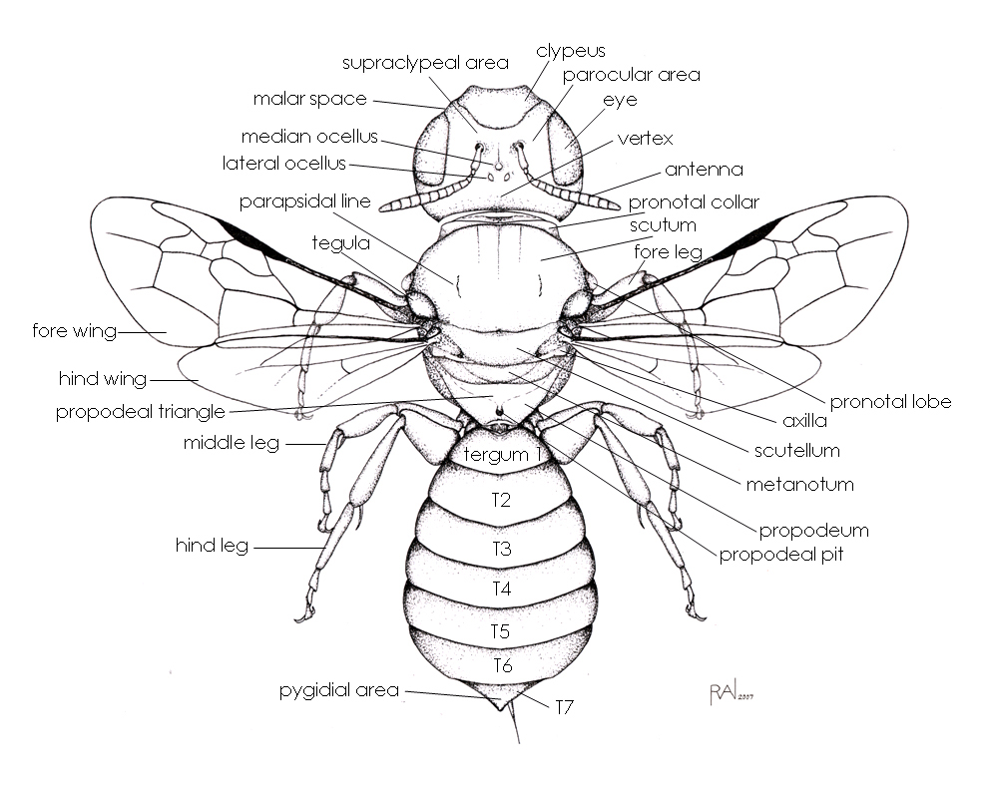

**Dorsal View**

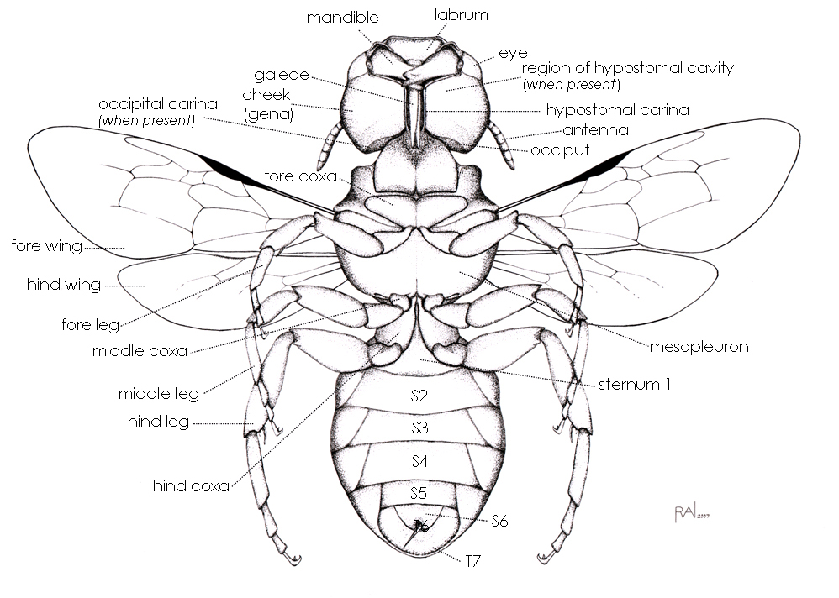

**Ventral View**

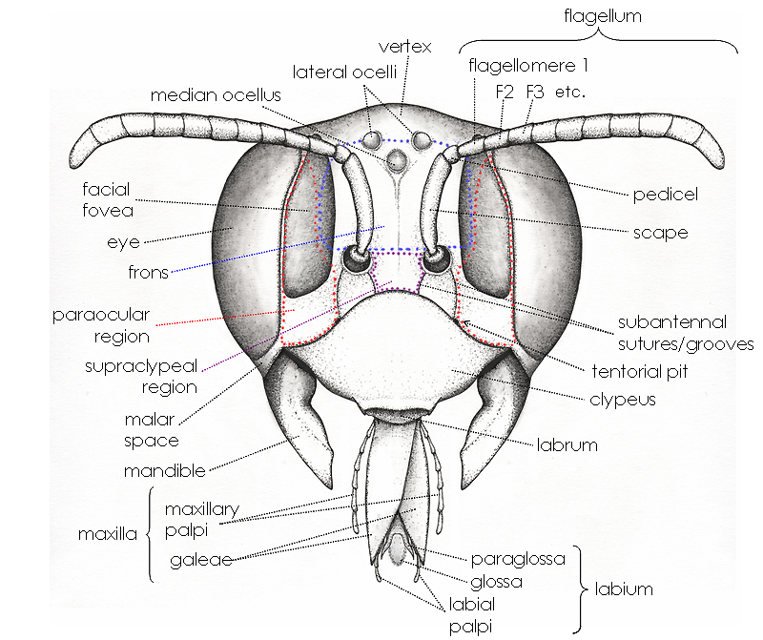

**Frontal View**

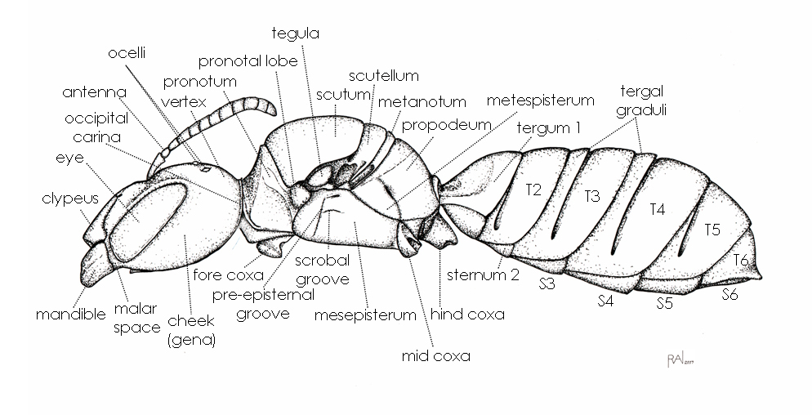

**Lateral View**

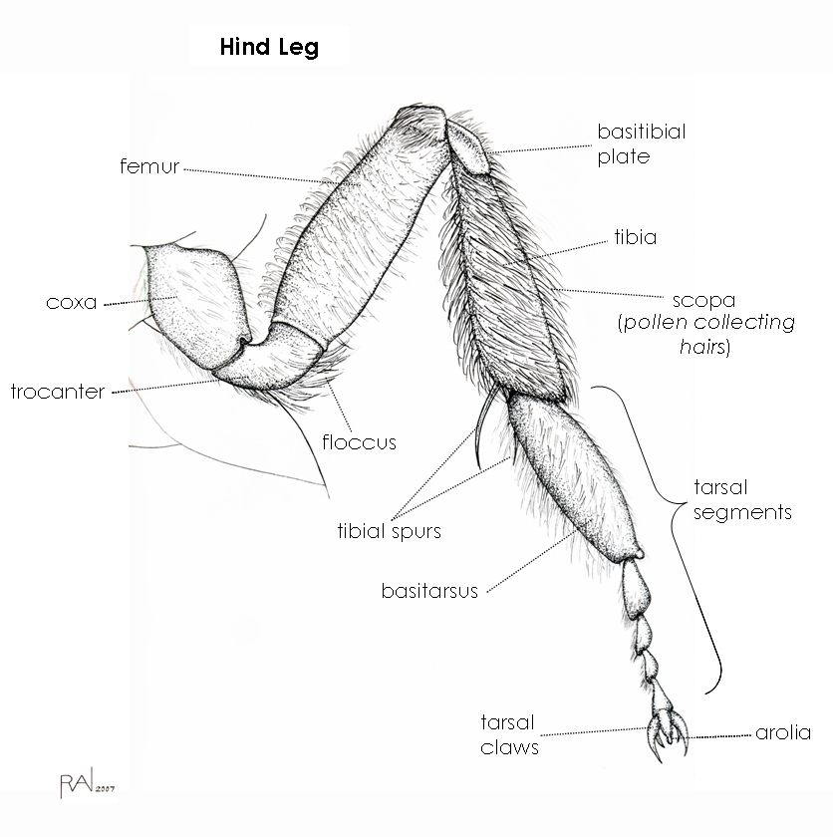

**Hind Leg**

